**Wikipedia English**

Recommending new Wikipedia articles to another Wikipedia article, based on the article’s similar hyperlinks with all the other articles.

**Modified the Input file**

Since in the input file we are not given the preference value. We will add the preference value as 1 for all the records in the file. We will use the below command to do that:

**awk '{$3+=1}1' oldInput.txt > newInput.txt**

And we are replacing the tab with the comma in the below file

**sed "s/\\t/\,/g" newInput.txt >> input.txt**

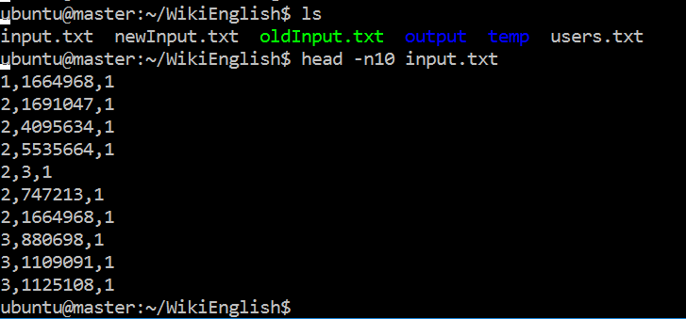

We are including **users.txt** file, which will have user value **3,** for which we are doing recommendation

Commands to use the mahout jar file and execute the jar on the Hadoop pseudo mode. We are sitting in a directory where Hadoop is.

1. We are going to use the mahout jar “**mahout-core-0.7-job.jar**” for running the recommendation for user based on the other users taste
2. We are going to use the **“scp” command** to send the file to the VM

***scp -i ec2_credentails.pem "WikiEnglish"*** ubuntu@publicDNS:/home/ubuntu

1. We are going to use the Hadoop command to put the file from local toh HDFS, we are going to put the **u.data file** which has user id, movie id, ratings and timestamp, all are tab separated

***bin/hadoop fs -put "../WikiEnglish/input.txt" WikiEnglish/input.txt***

1. We are going to put **users.txt file**  to the HDFS, this files consists of the users who recommendation is required to us. Our user file has 10 ids.

***bin/hadoop fs -put "../ WikiEnglish/users.txt" WikiEnglish/users.txt***

1. We are going to run the below command to get the recommendation for all the users present in the u.data file. The movies which are recommended to them are the one which they haven’t seen based on the similar users.

***hadoop jar mahout-core-0.7-job.jar org.apache.mahout.cf.taste.hadoop.item.RecommenderJob -s SIMILARITY_COOCCURRENCE --input WikiEnglish/input.txt --output output***

the output will be stored in the output directory.

1. To get the recommendation for the specific users, we are going to run the below command

***bin/hadoop jar mahout-core-0.7-job.jar org.apache.mahout.cf.taste.hadoop.item.RecommenderJob -Dmapred.input.dir= WikiEnglish/input.txt -Dmapred.output.dir=output --usersFile WikiEnglish/users.txt --booleanData false --similarityClassname SIMILARITY_COOCCURRENCE***

**AWS**

I am using 6 instances of **t2.large** with 150 GB storage. It has 8 GB RAM and 2 CPU. I increased the Ram allocation to 1GB and also changed the number of map task and reduce task as well by including the below line in **mapred-site.xml file**

***<property> <name>mapred.child.java.opts</name> <value>-Xmx1024m</value> </property>***

***<property><name>mapred.tasktracker.map.tasks.maximum</name><value>4</value></property>***

***<property><name>mapred.tasktracker.reduce.tasks.maximum</name><value>2</value></property>***

Other issues were unable to replicate the node, for that I switched off the safemode using the command:

***bin/Hadoop dfsadmin -safemode get***

***fsck***

The first command with switch off the safemode and fsck command will delete the files which were stuck while replicating the node. Due to replication error datanode was not able to start.

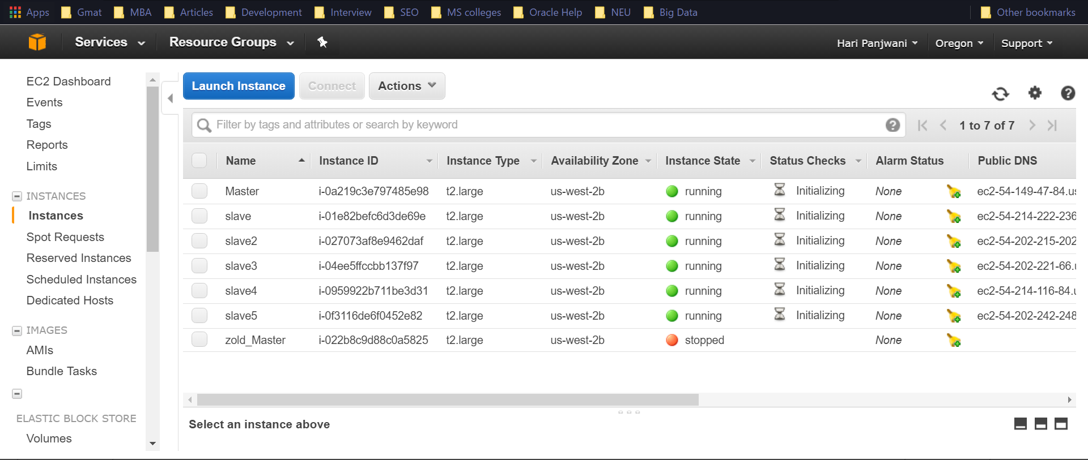

We need to open the ports so that datanode can talk to namenode and 5009 for vncserver

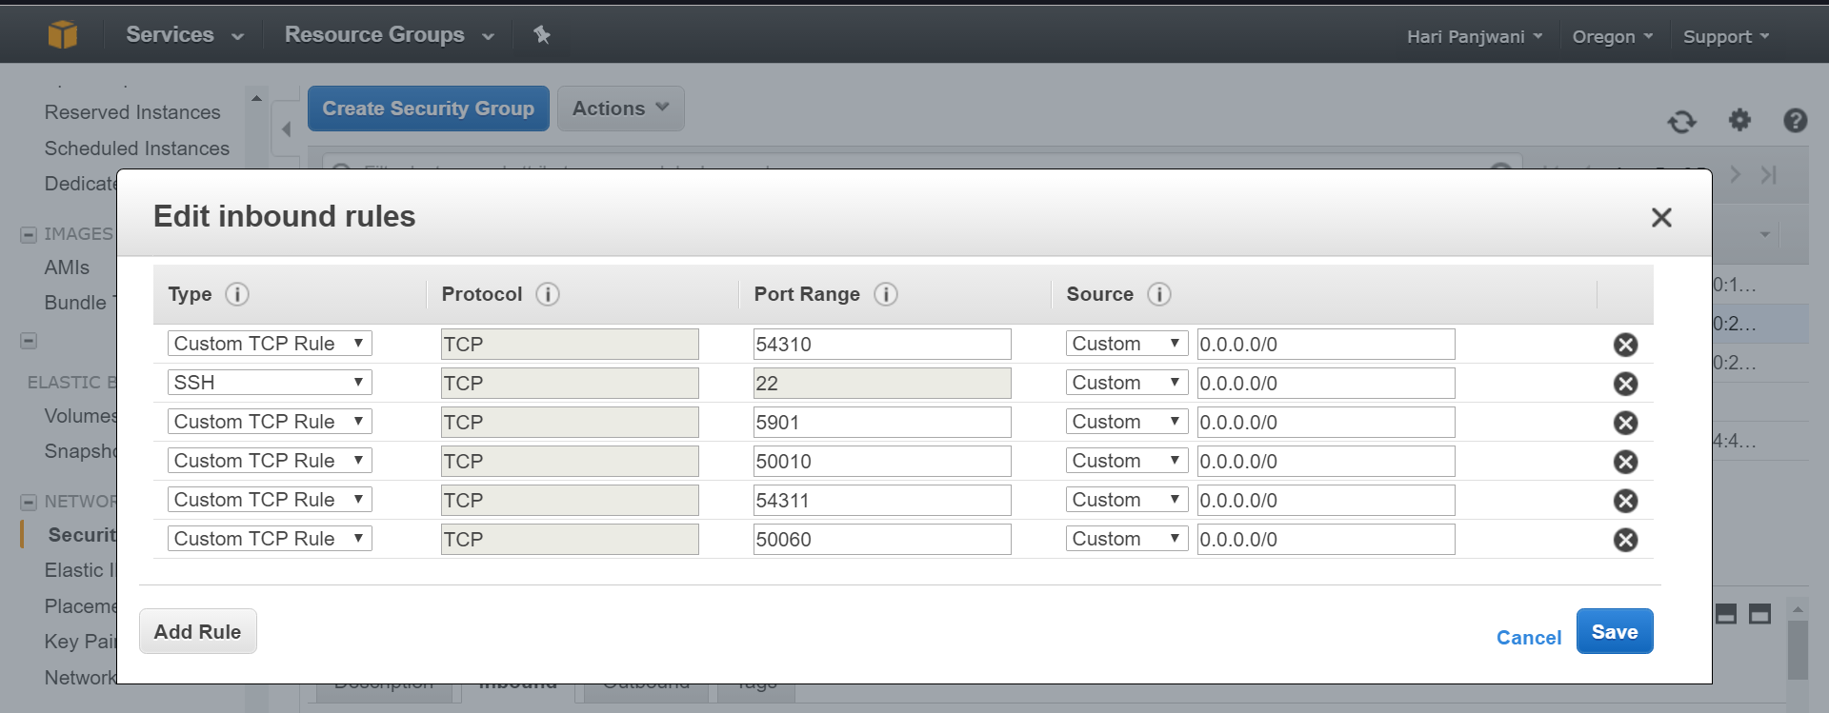

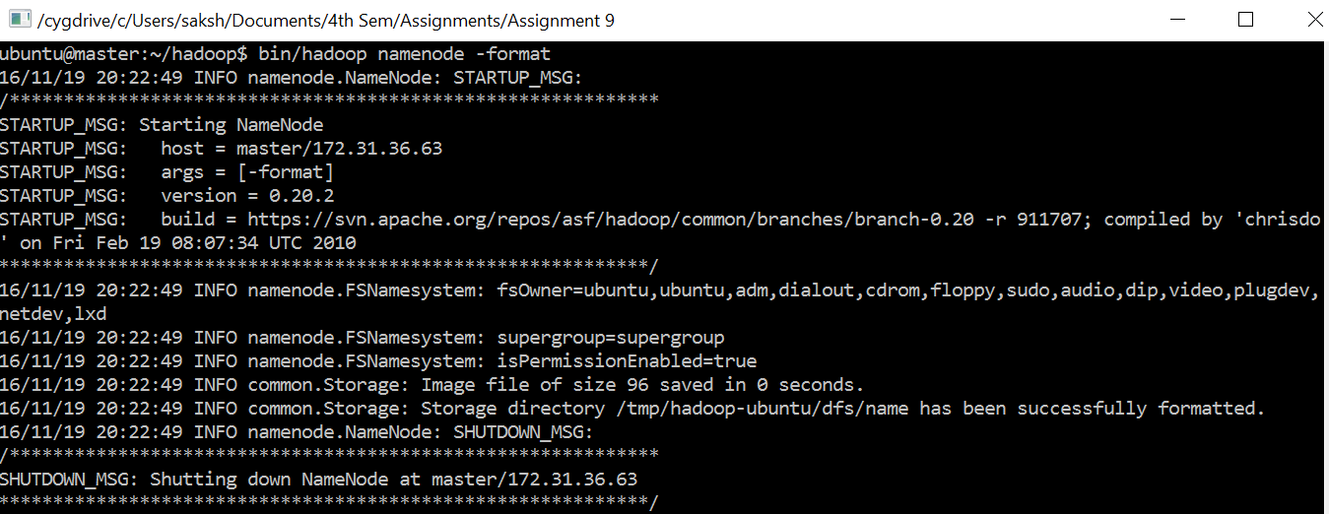

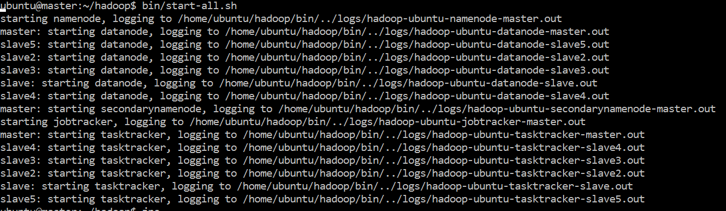

Master

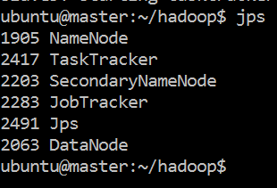

Slave 4

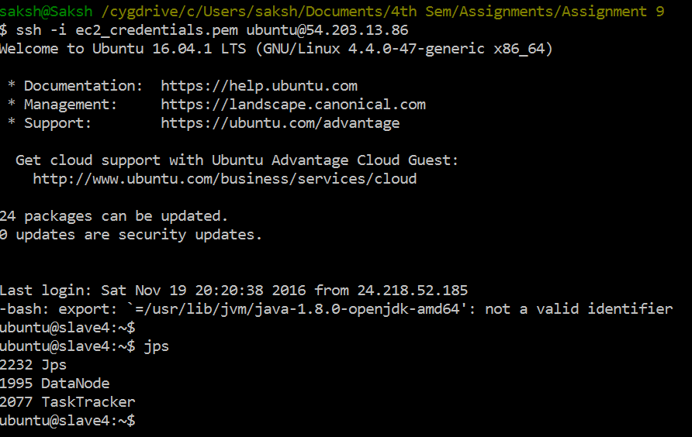

Slave 5

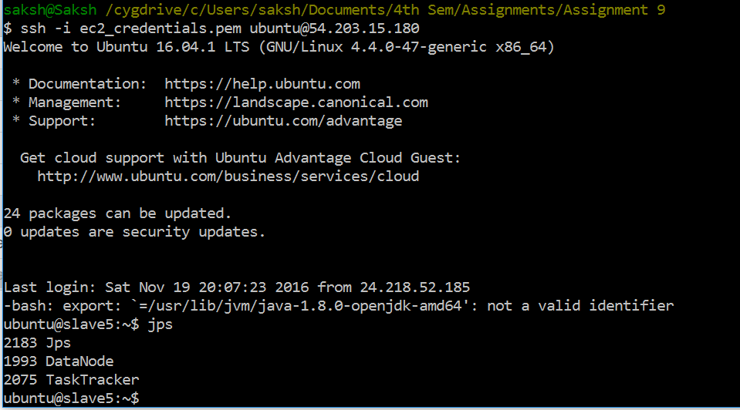

Slave 3

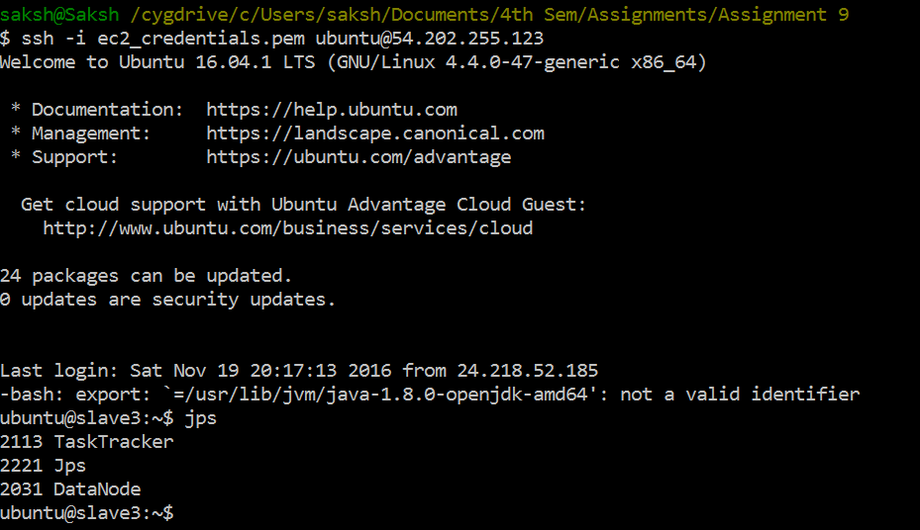

Slave 2

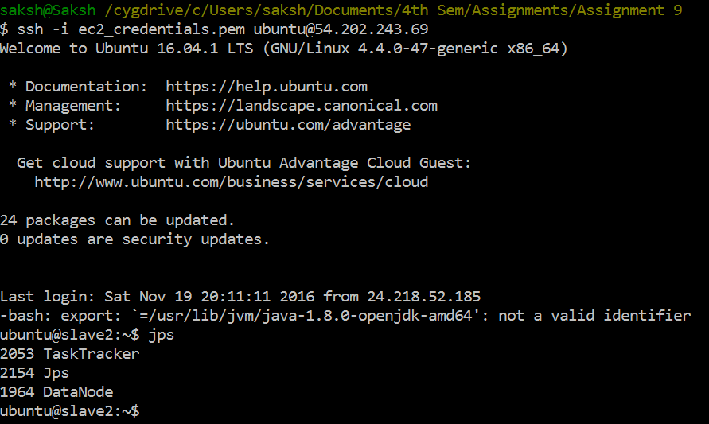

Slave 1

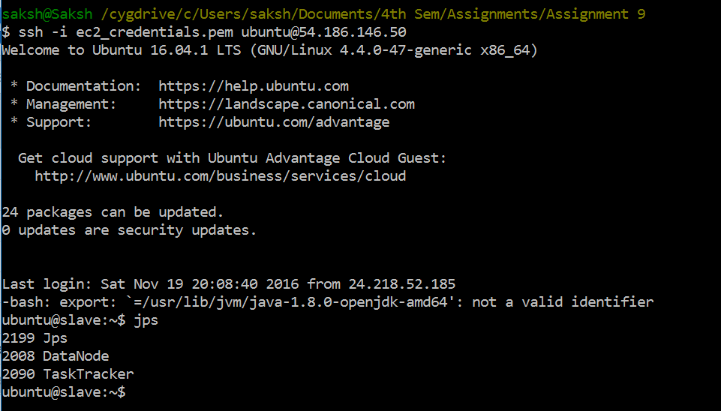

Localhost:50070

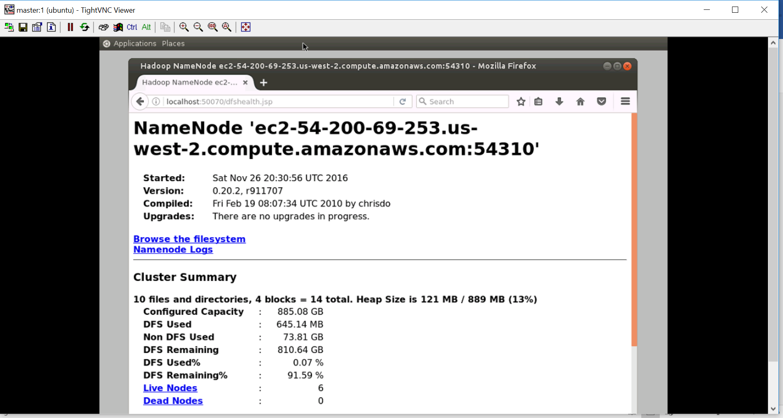

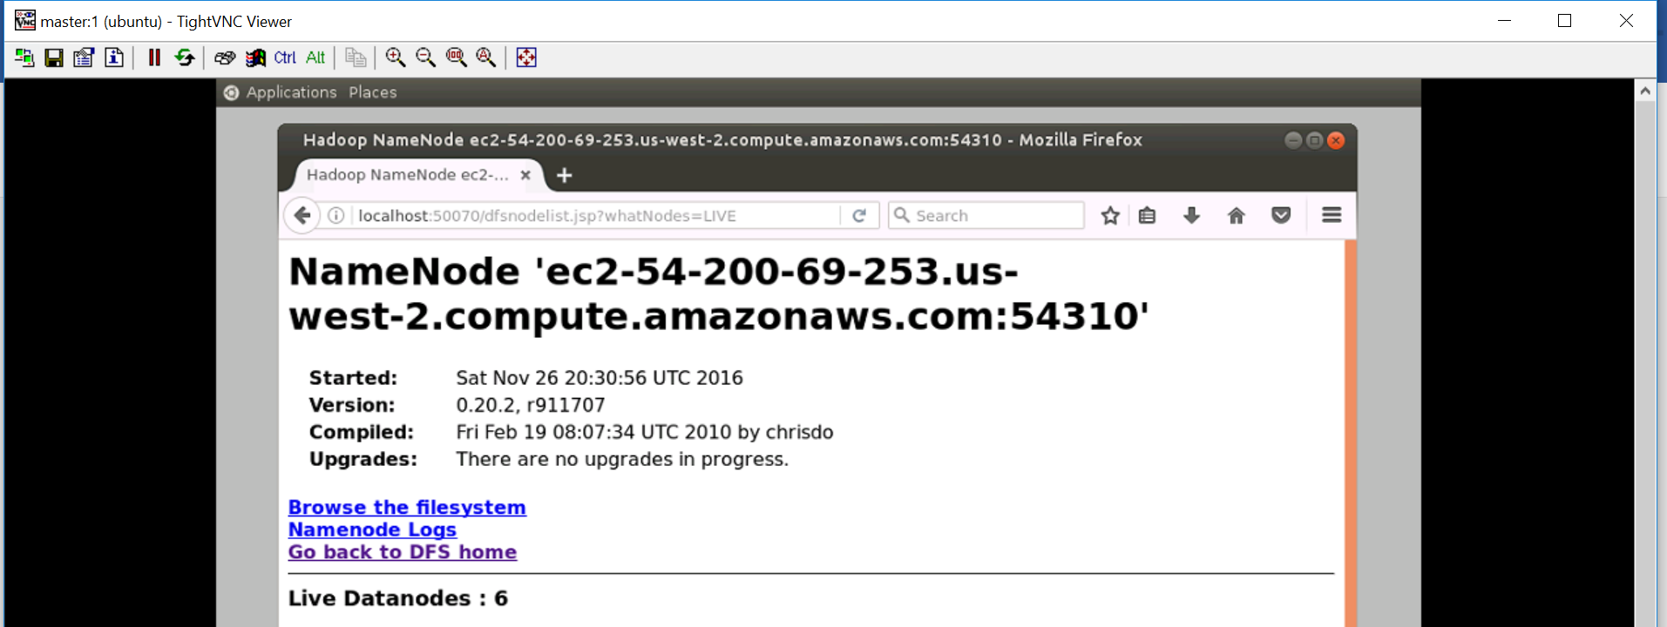

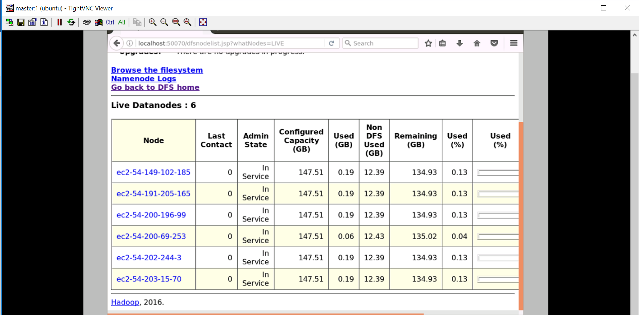

Localhost:50030

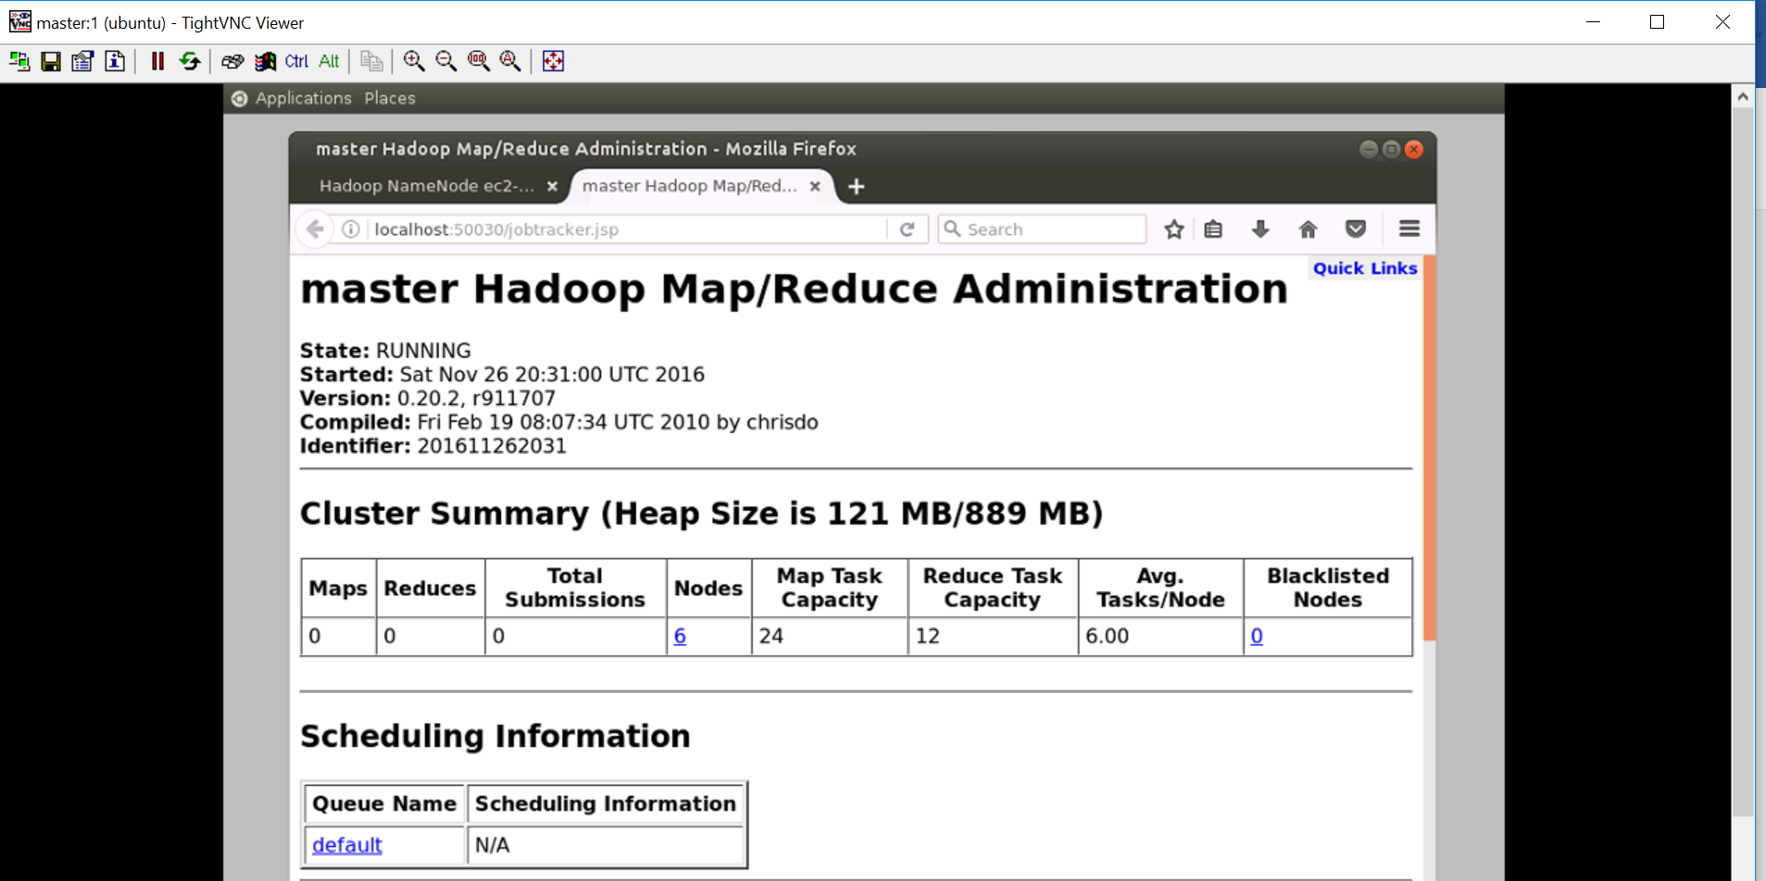

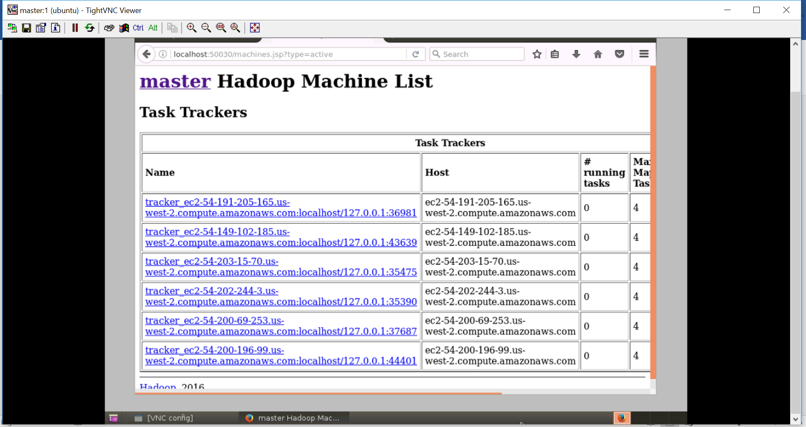

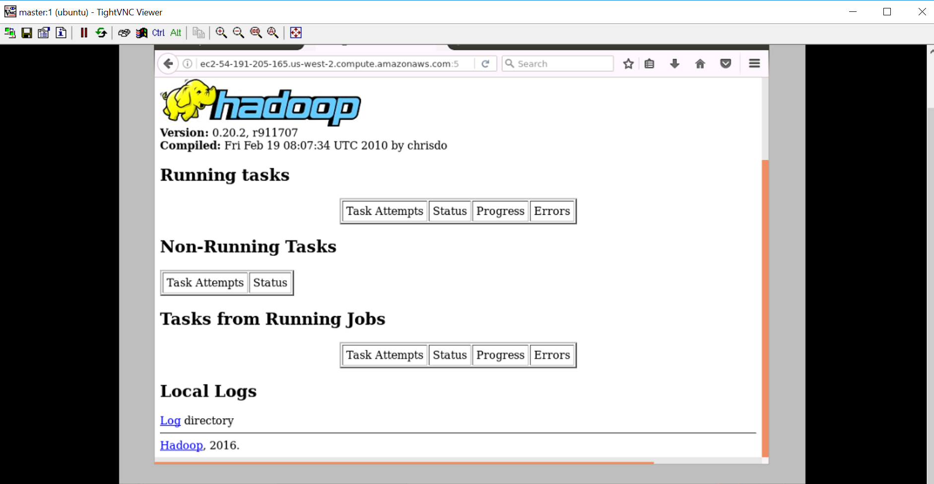

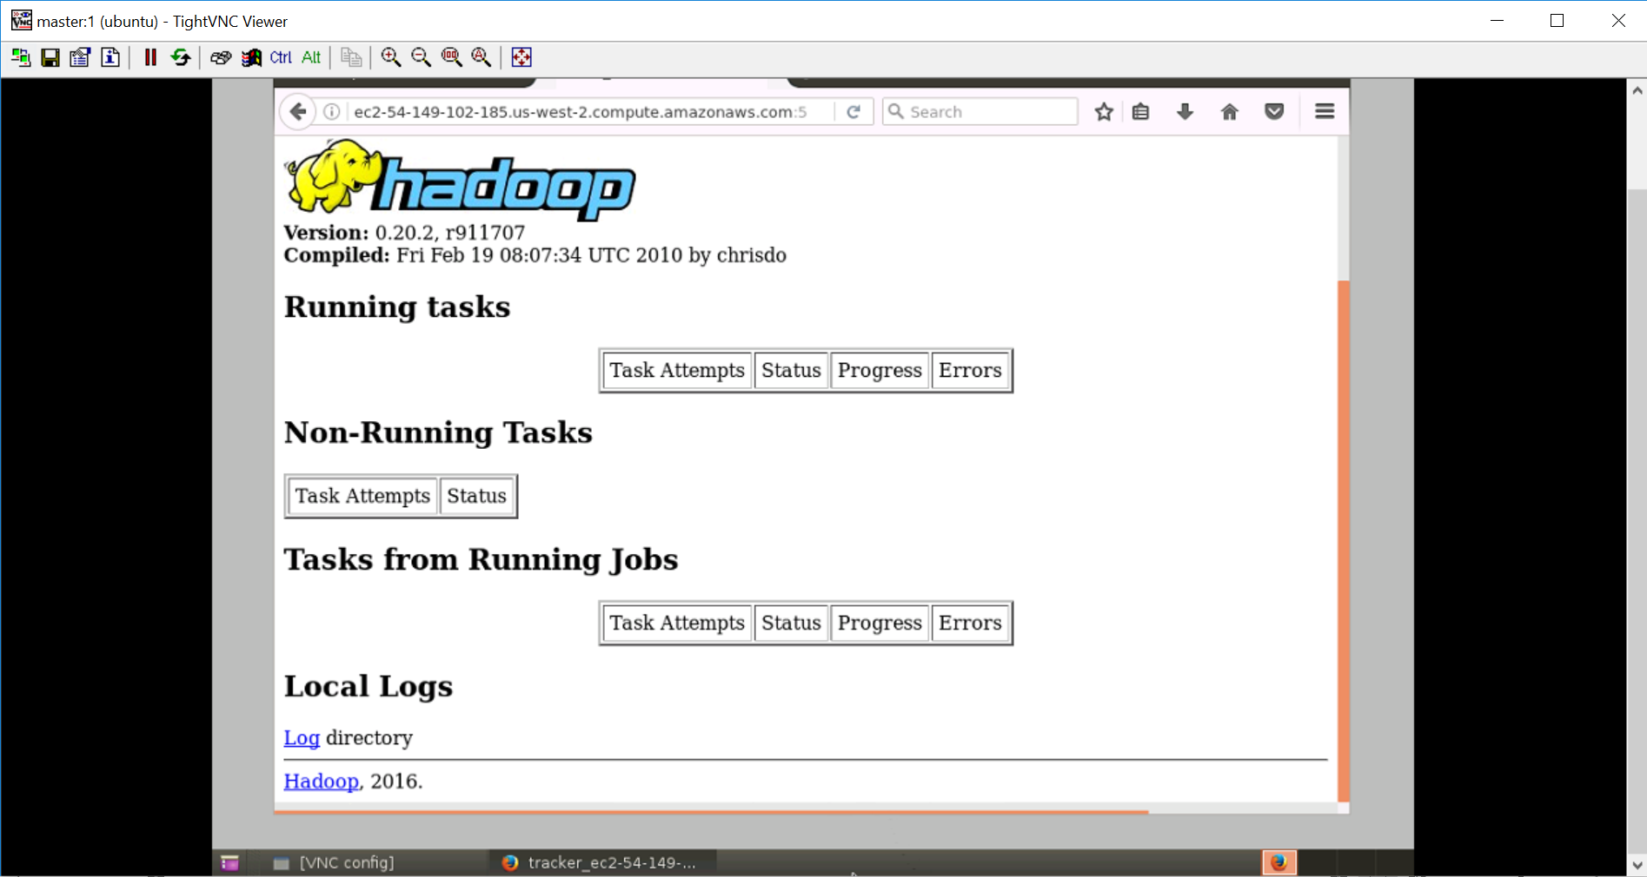

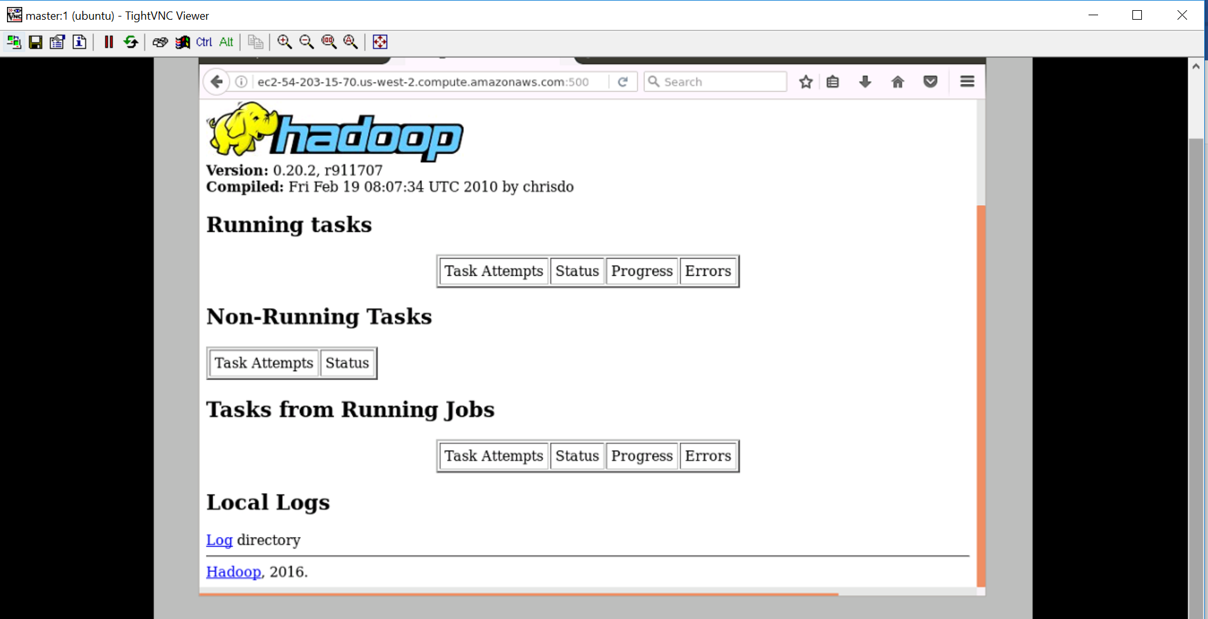

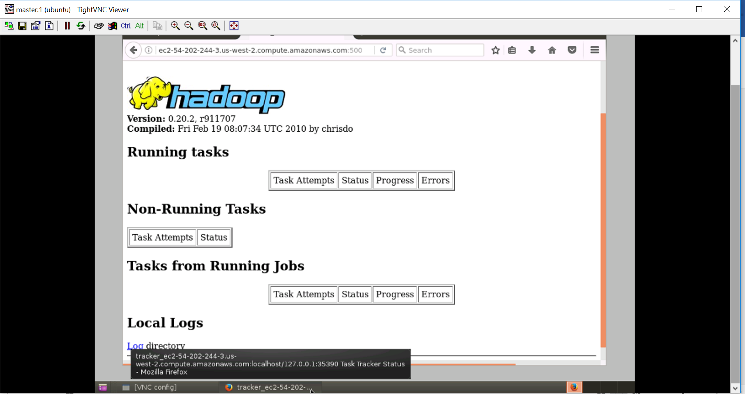

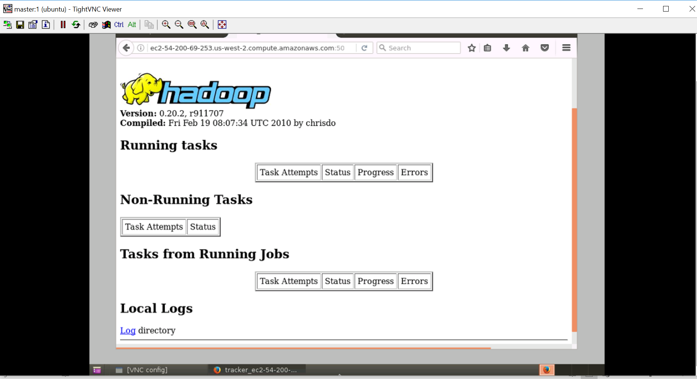

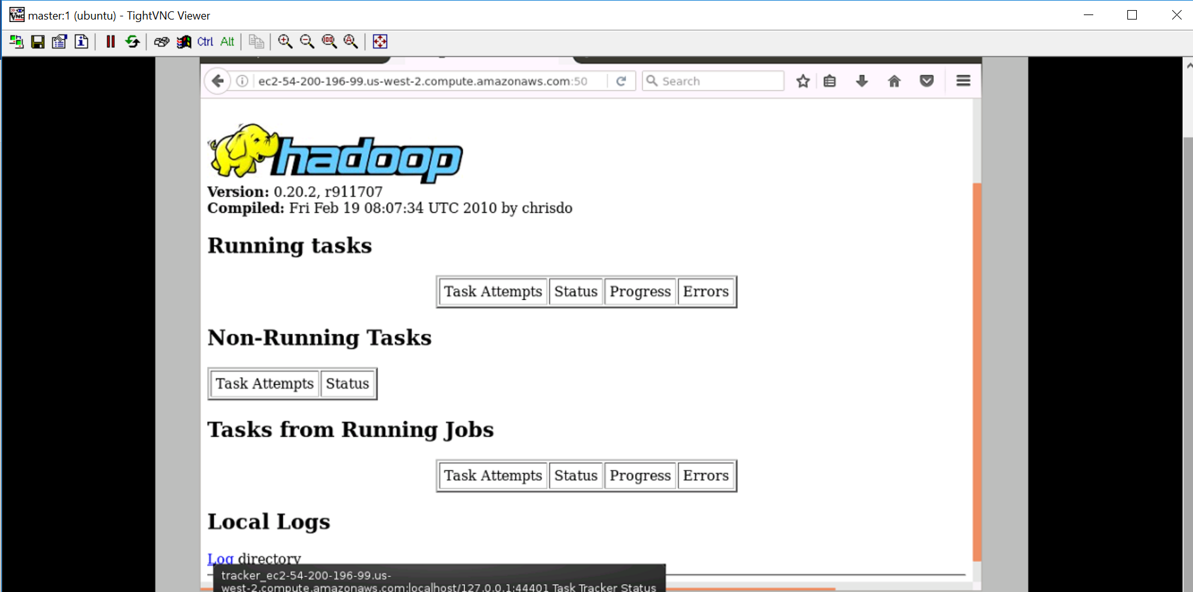

After Execution

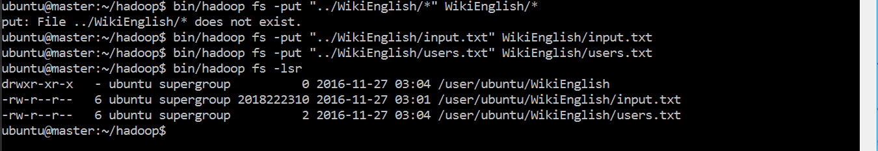

There are total 10 jobs which run, this is the start of the first job

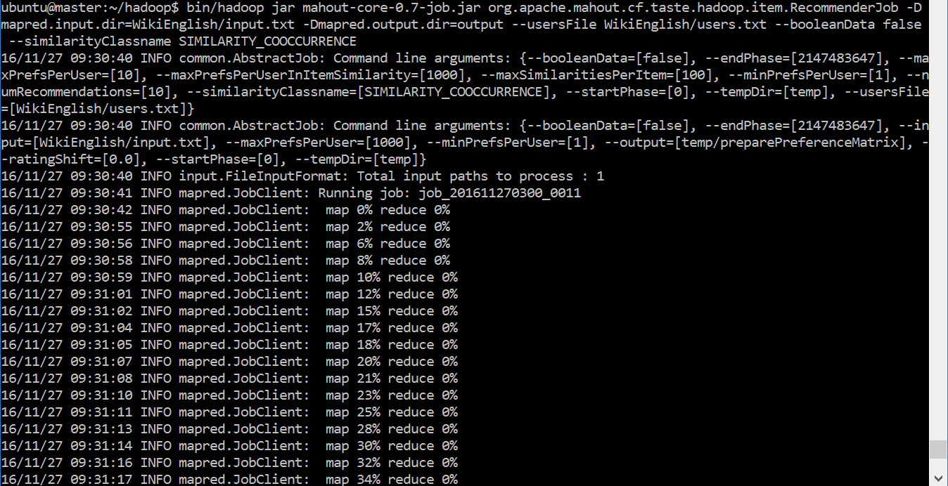

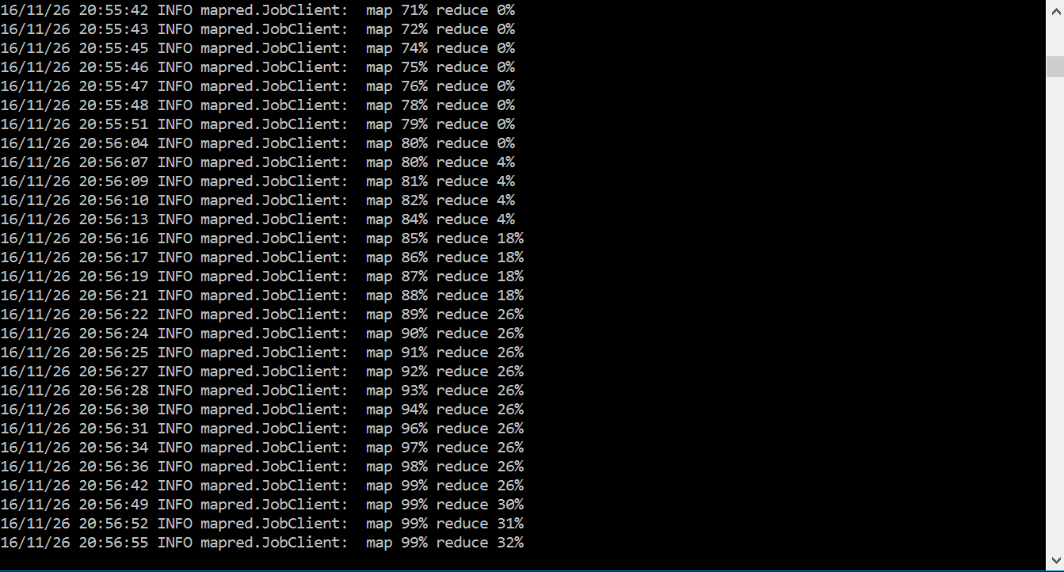

Localhost:50030

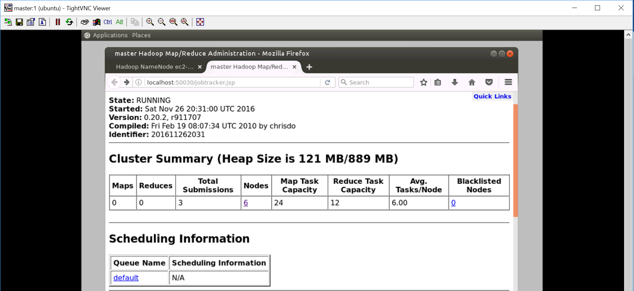

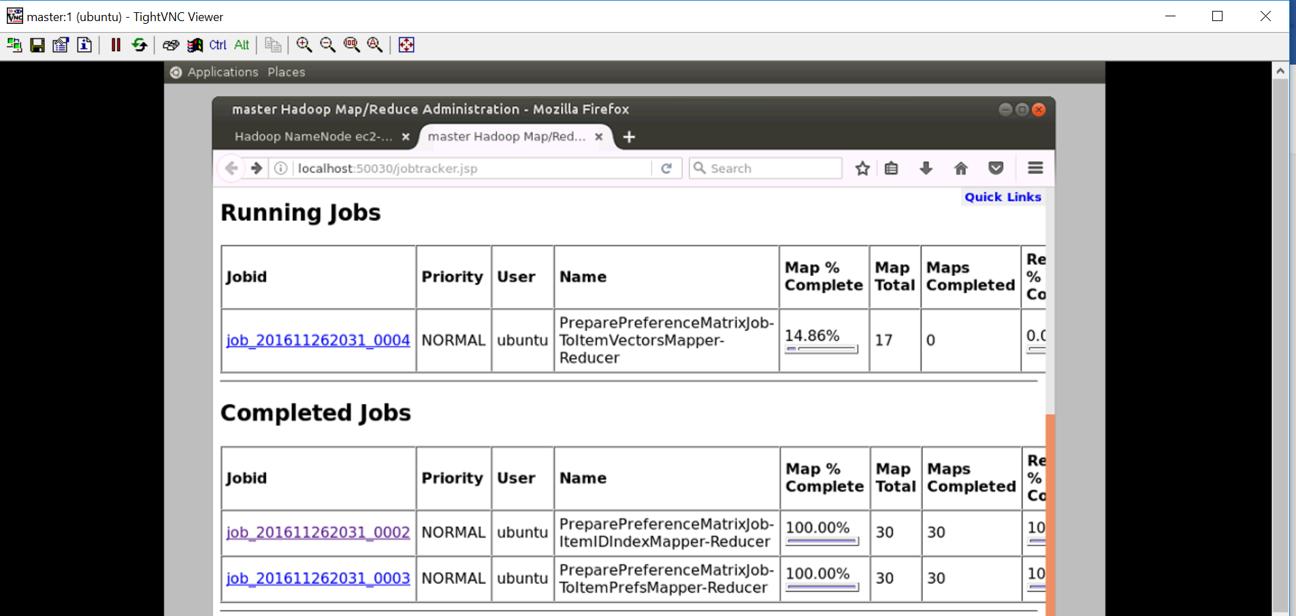

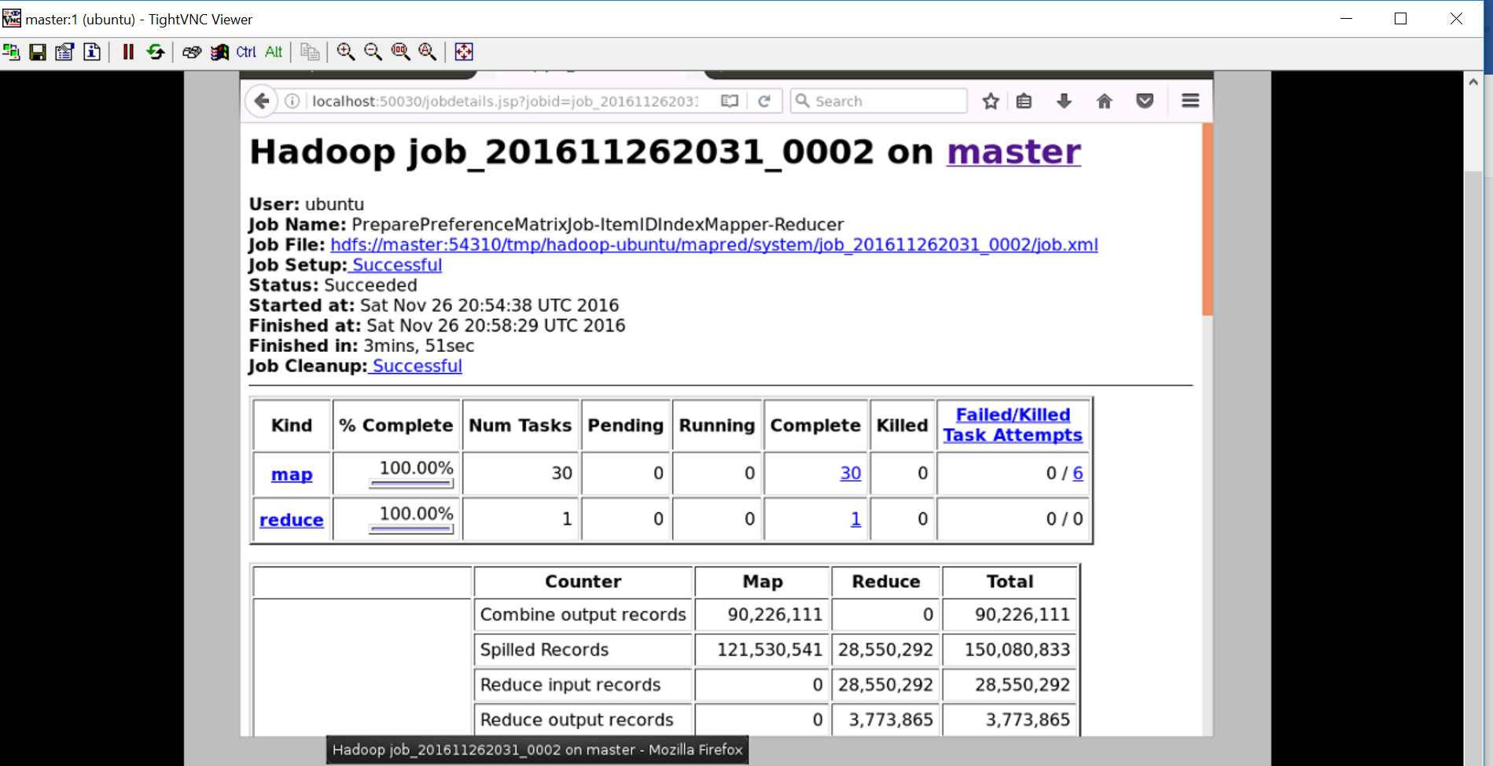

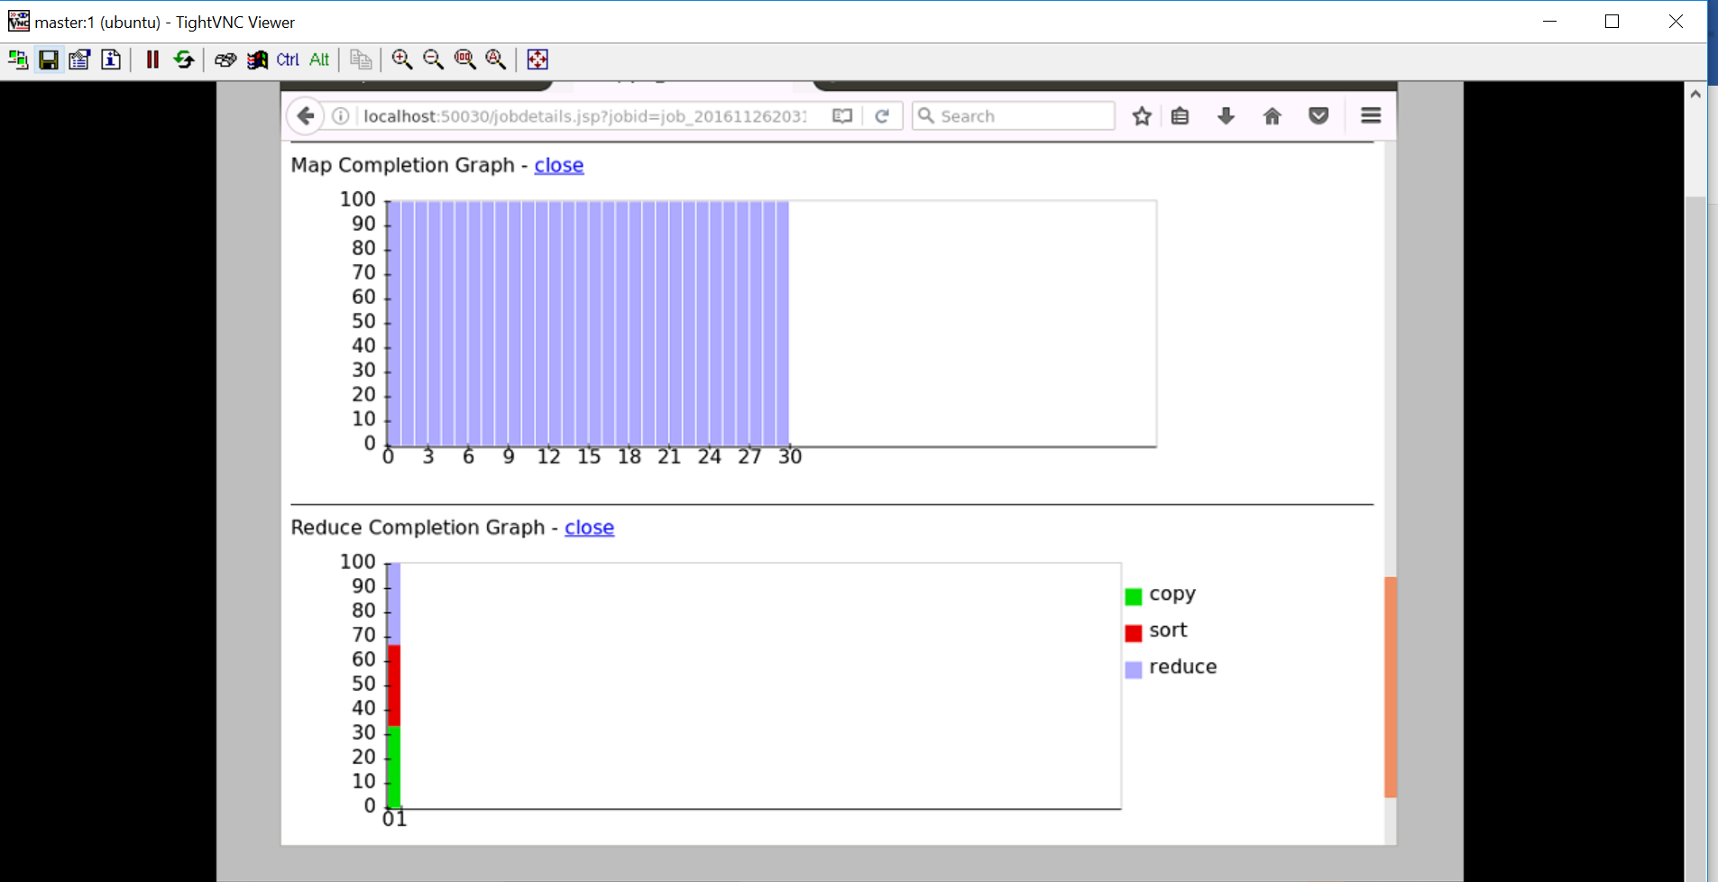

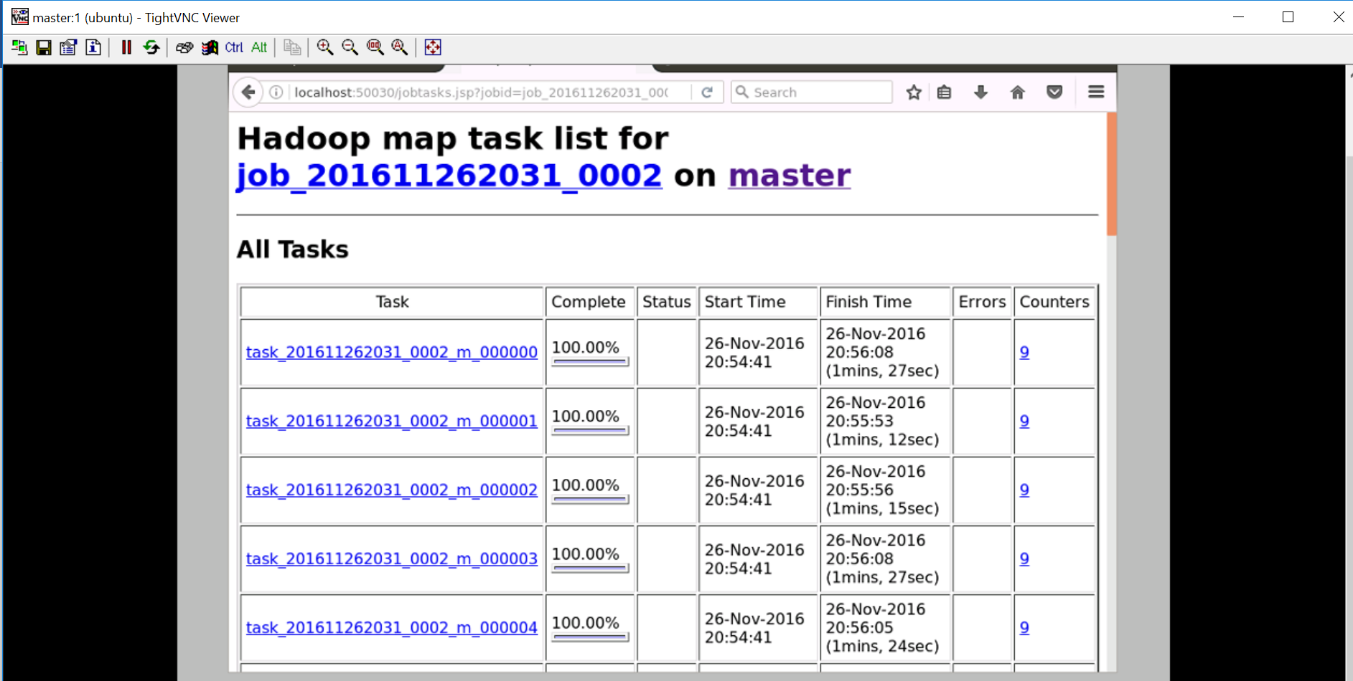

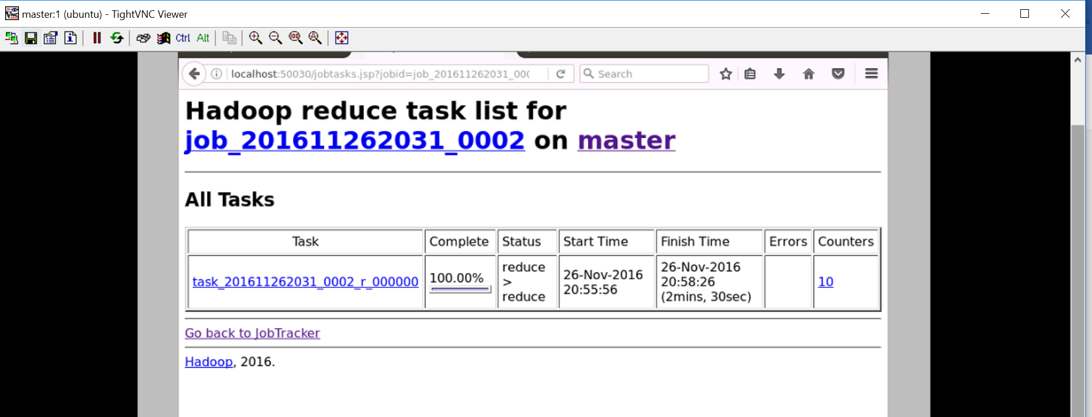

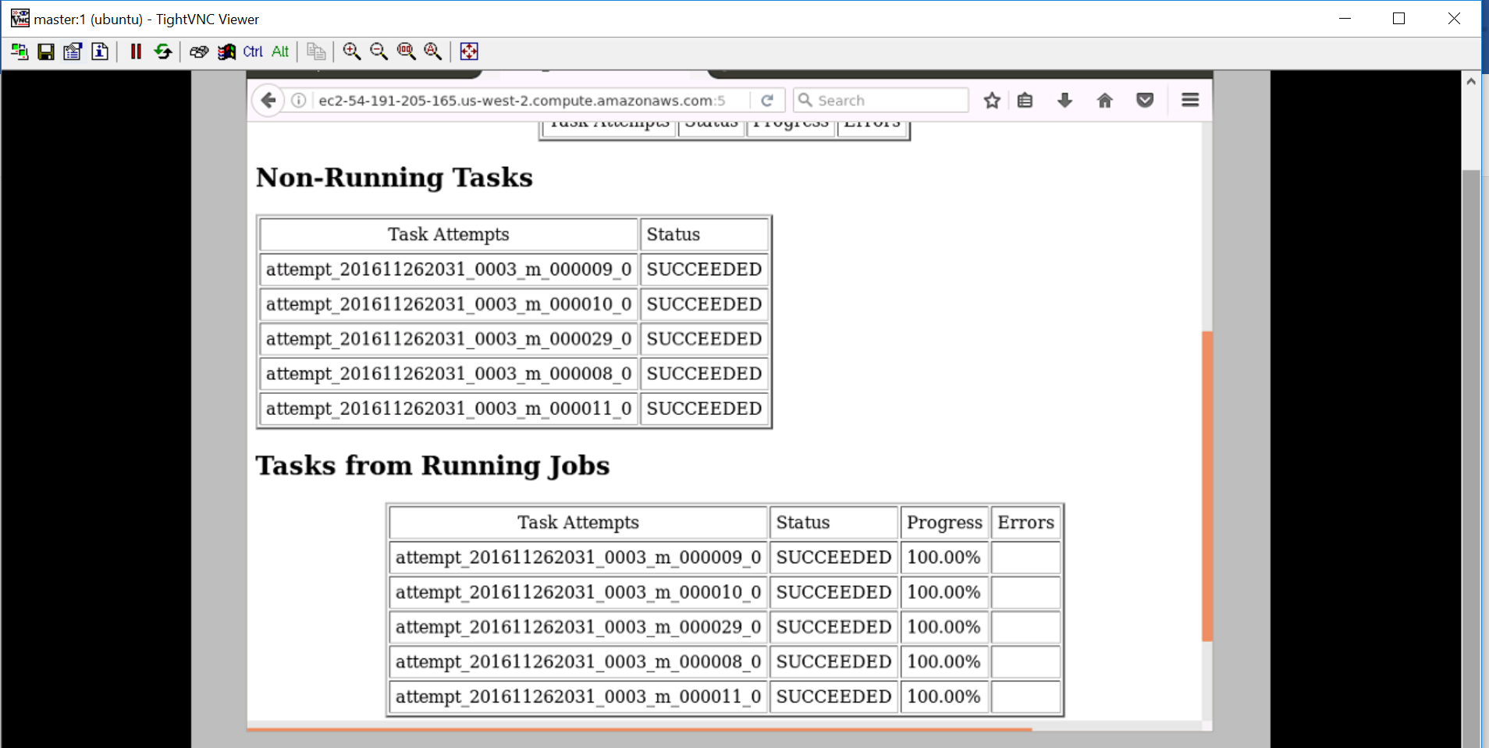

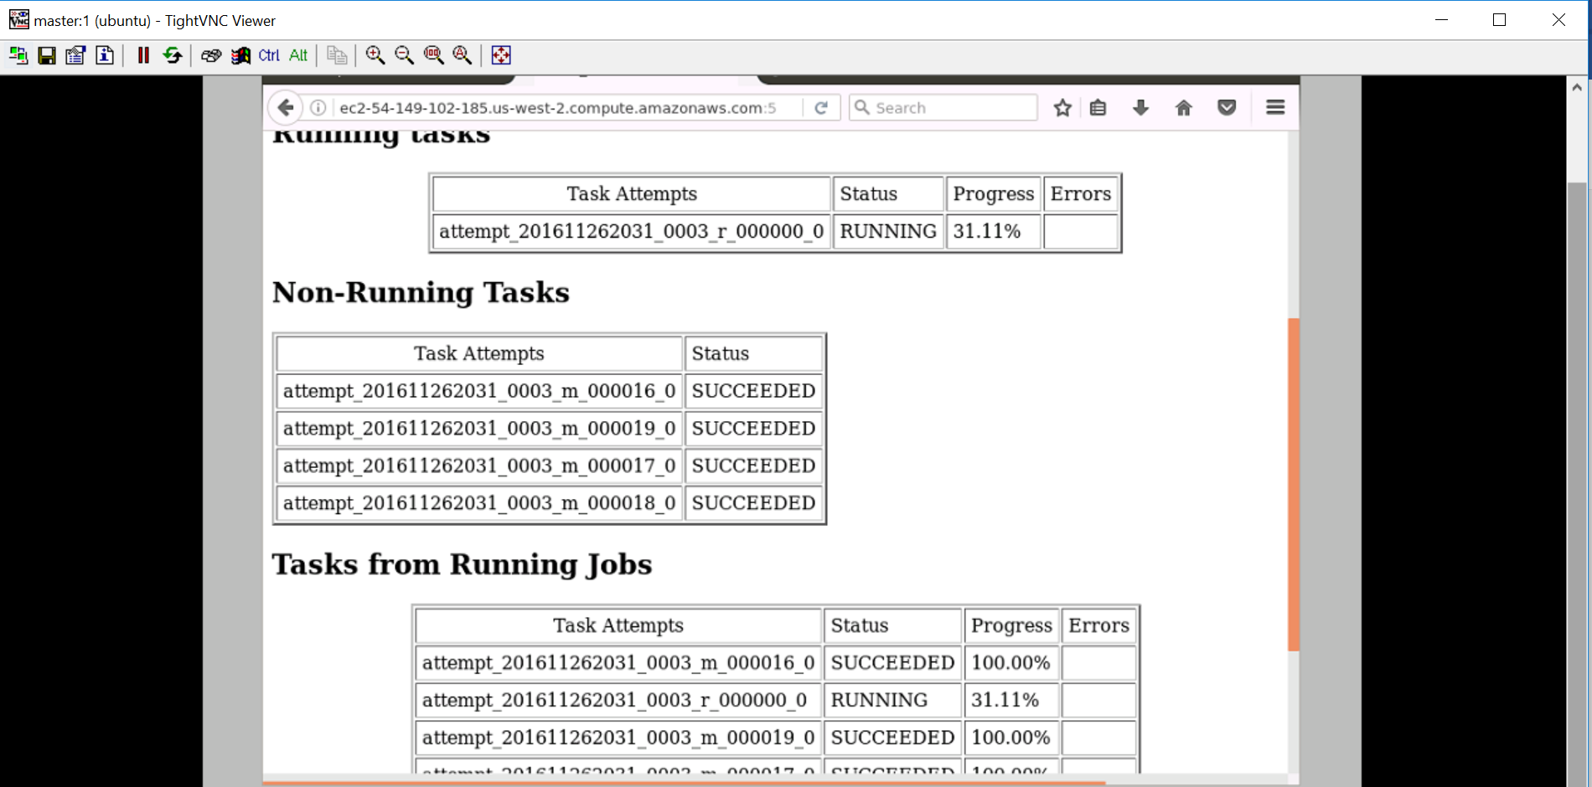

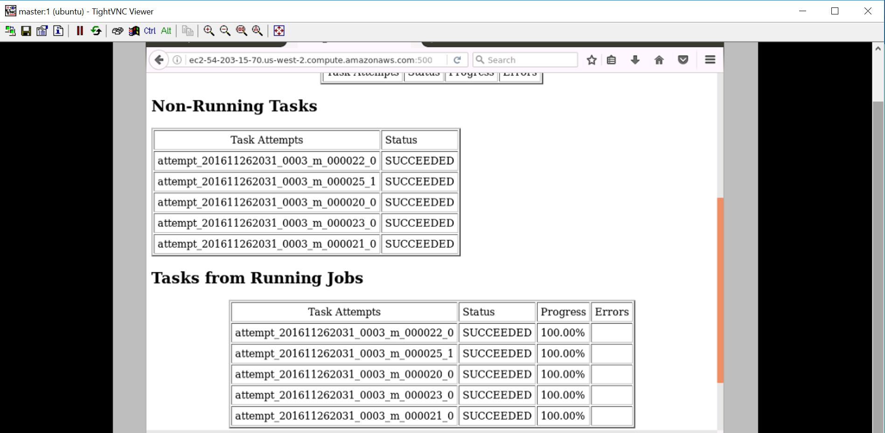

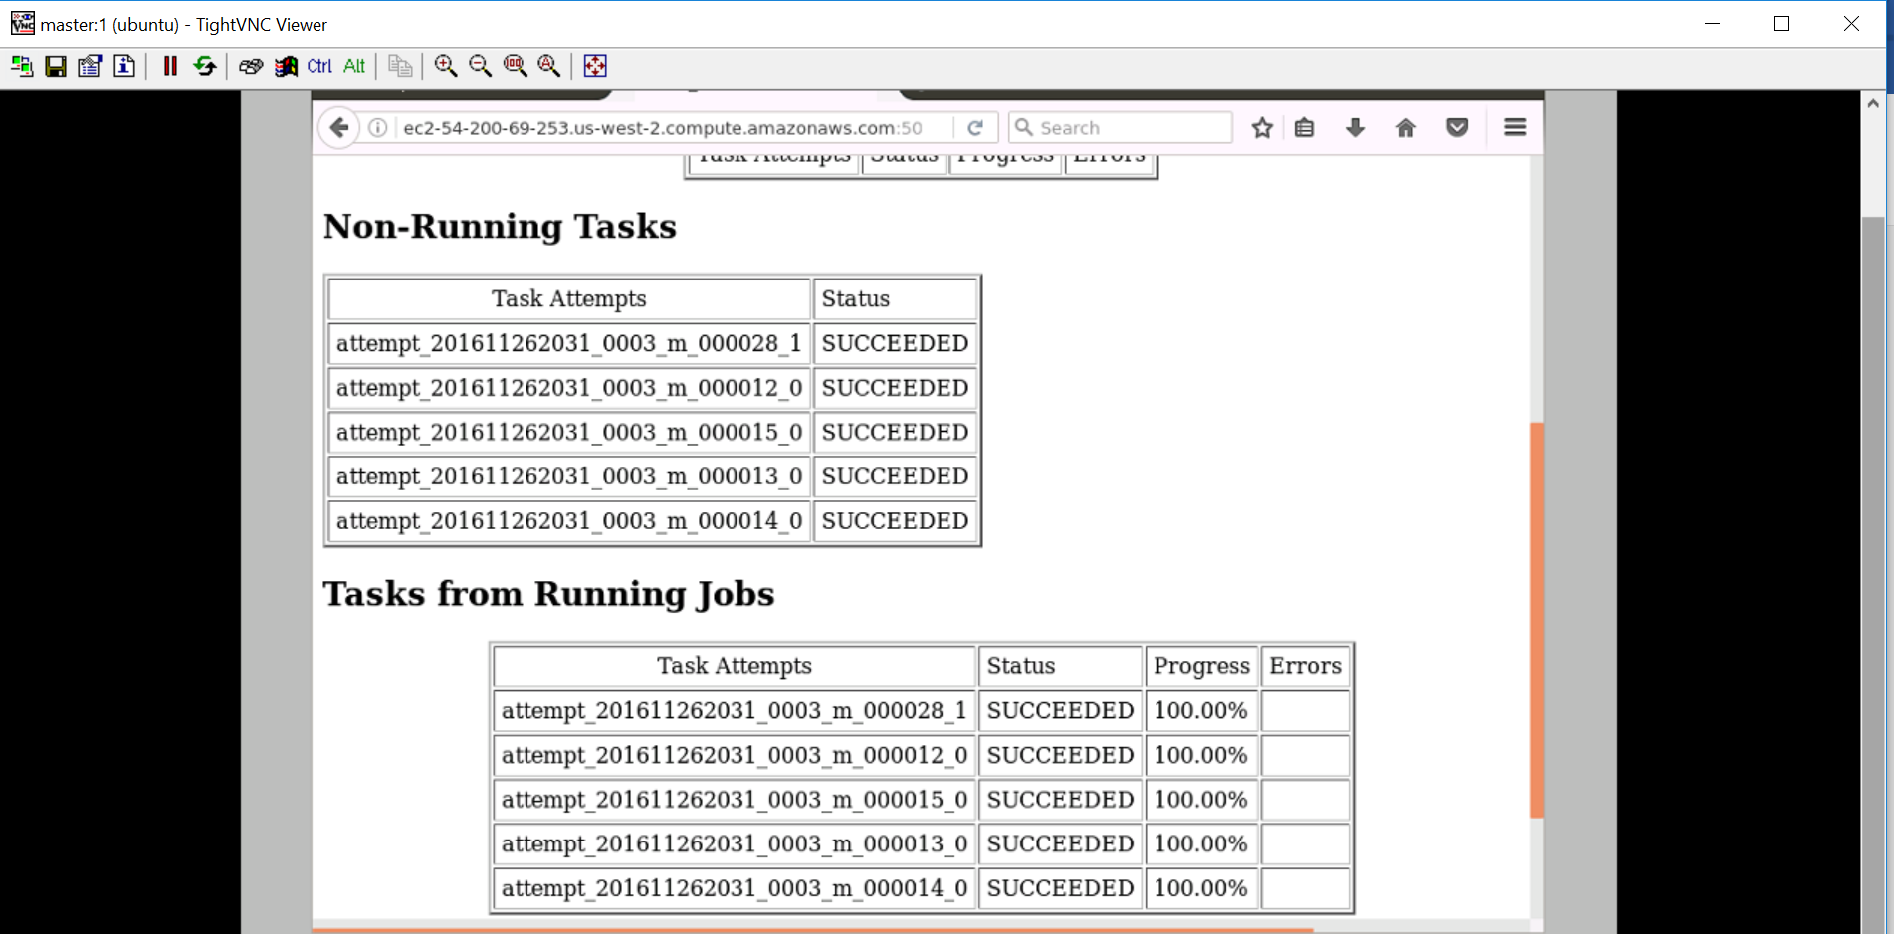

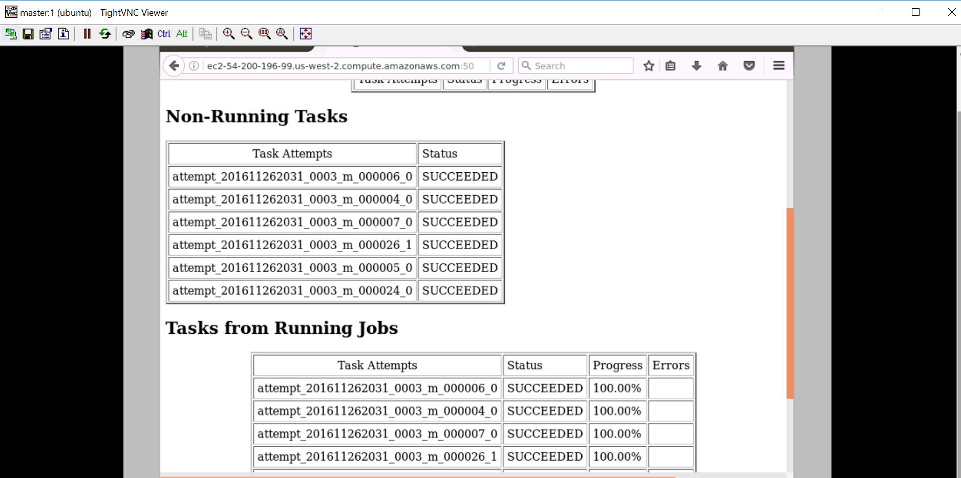

Localhost:50070

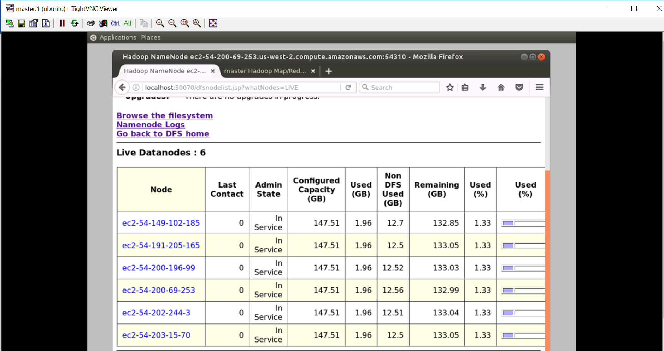

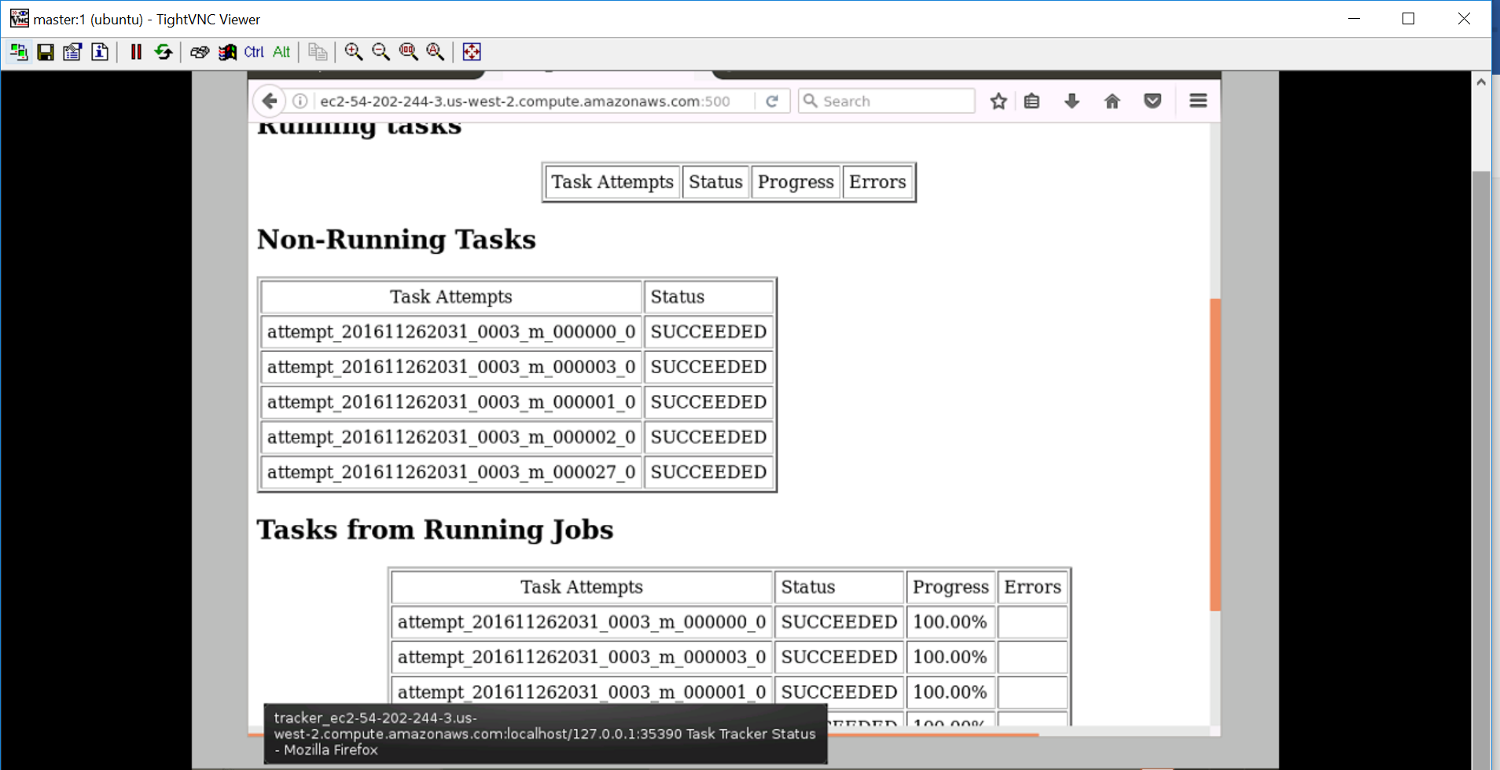

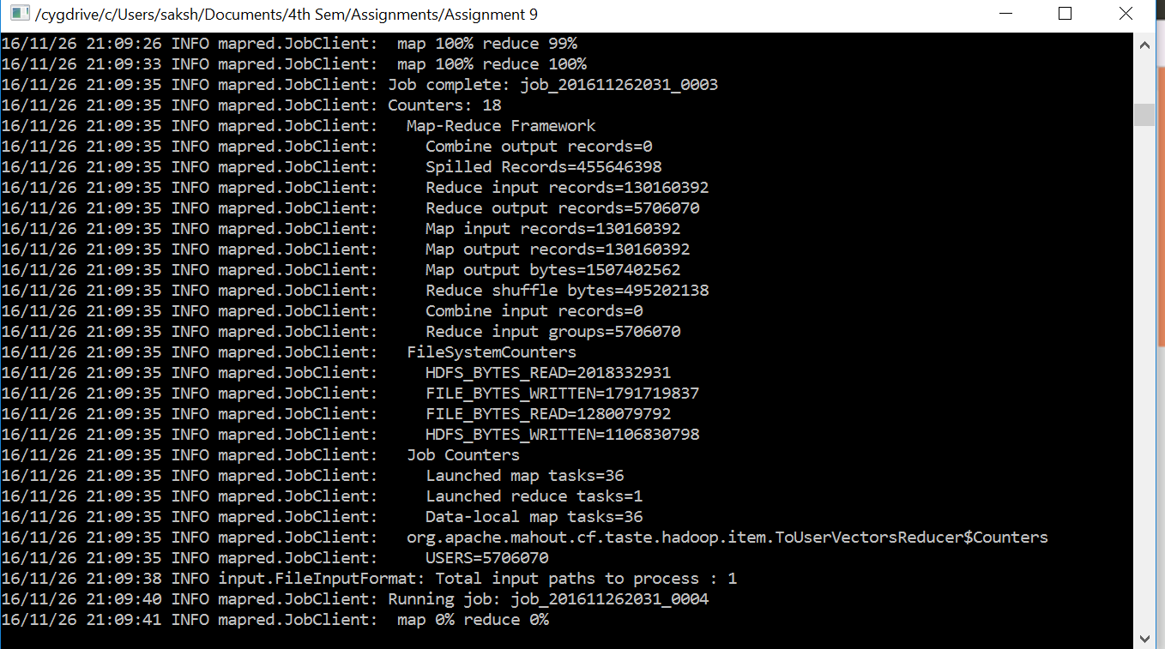

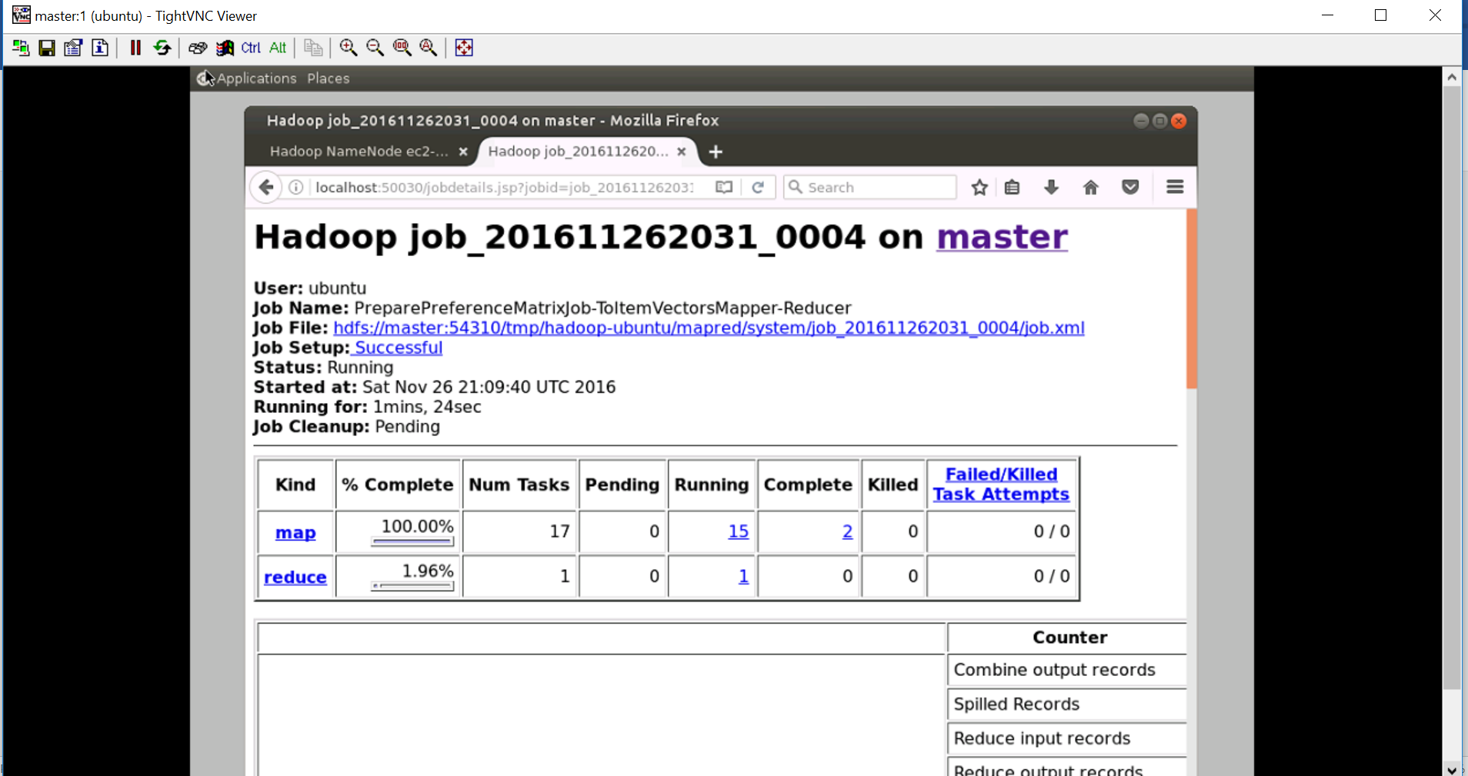

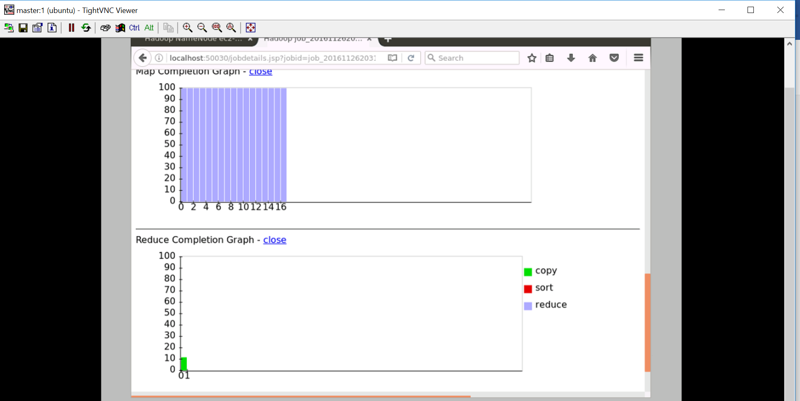

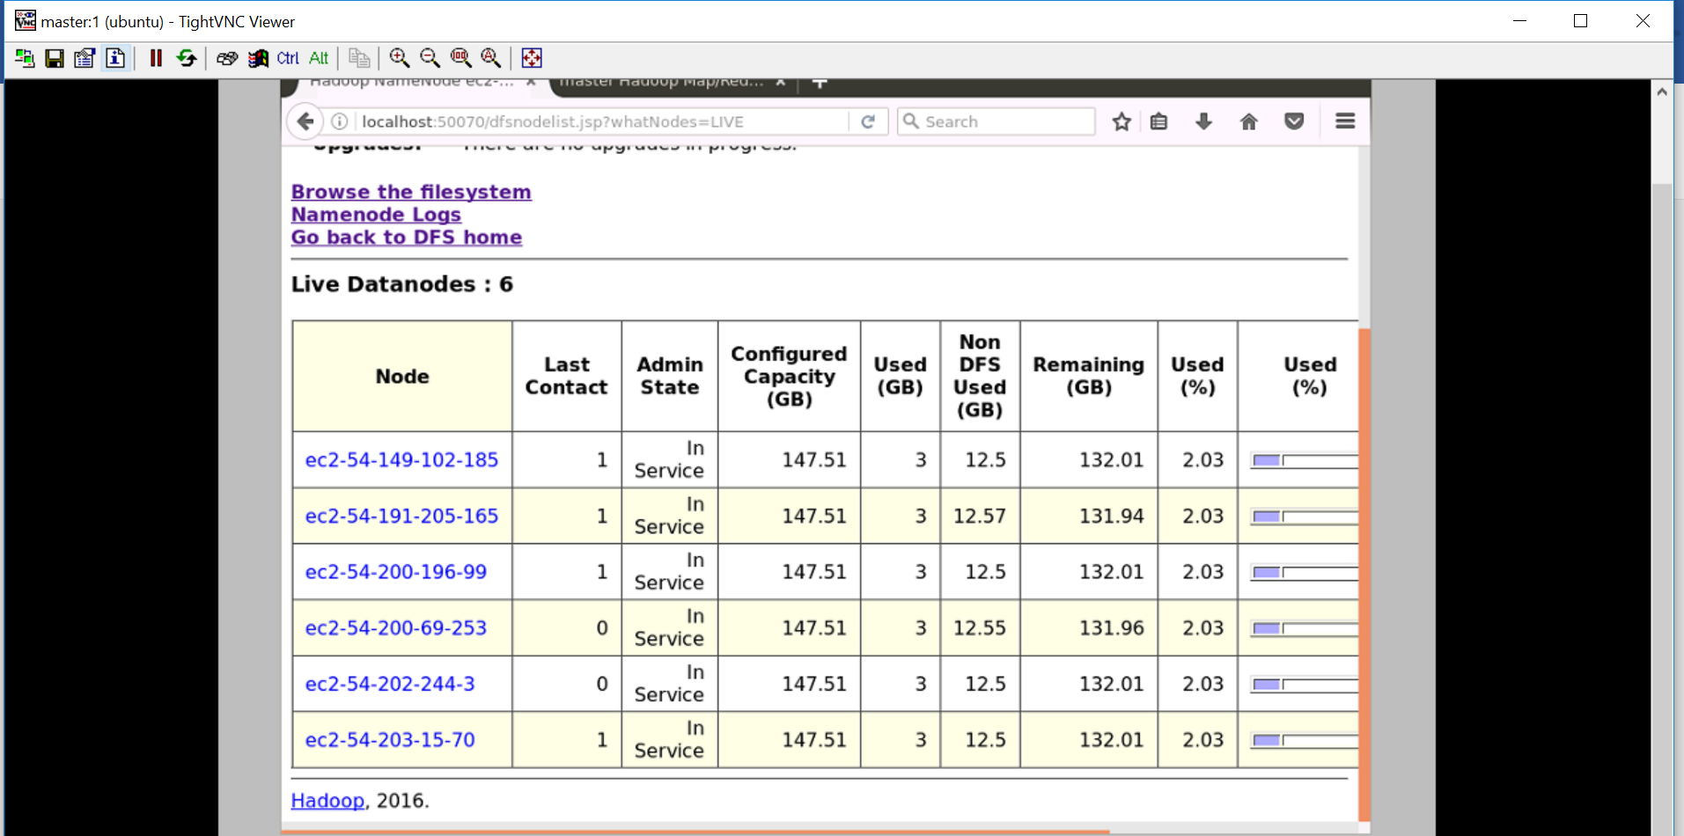

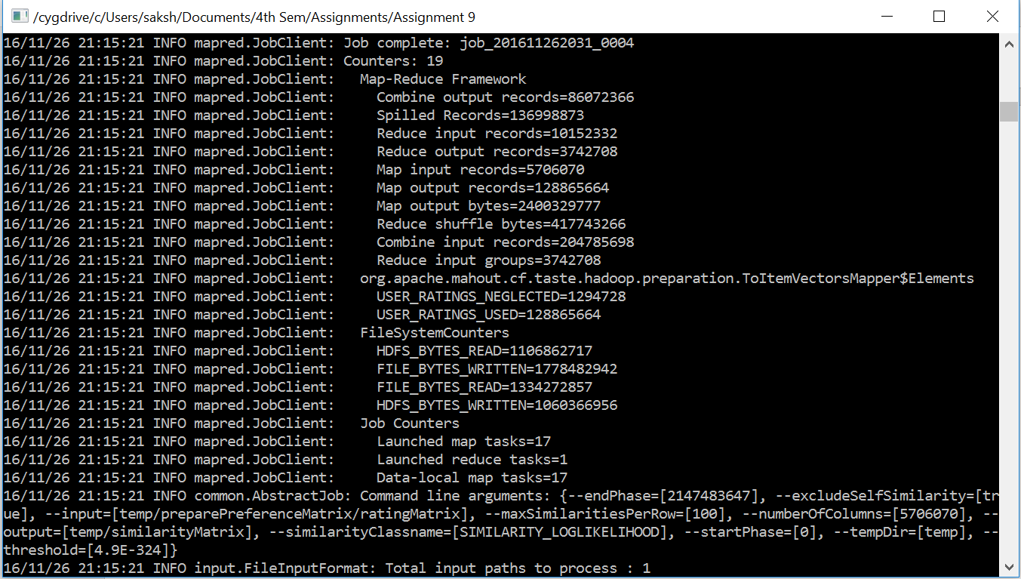

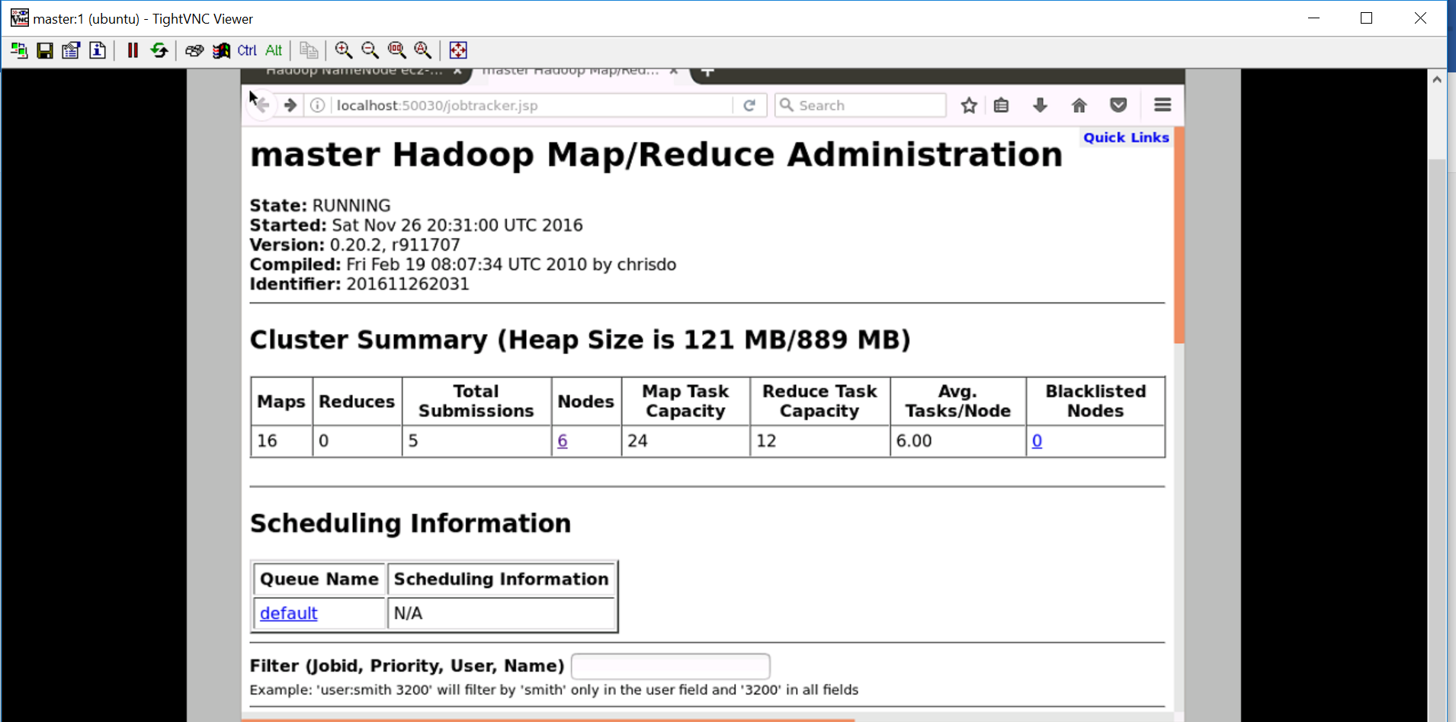

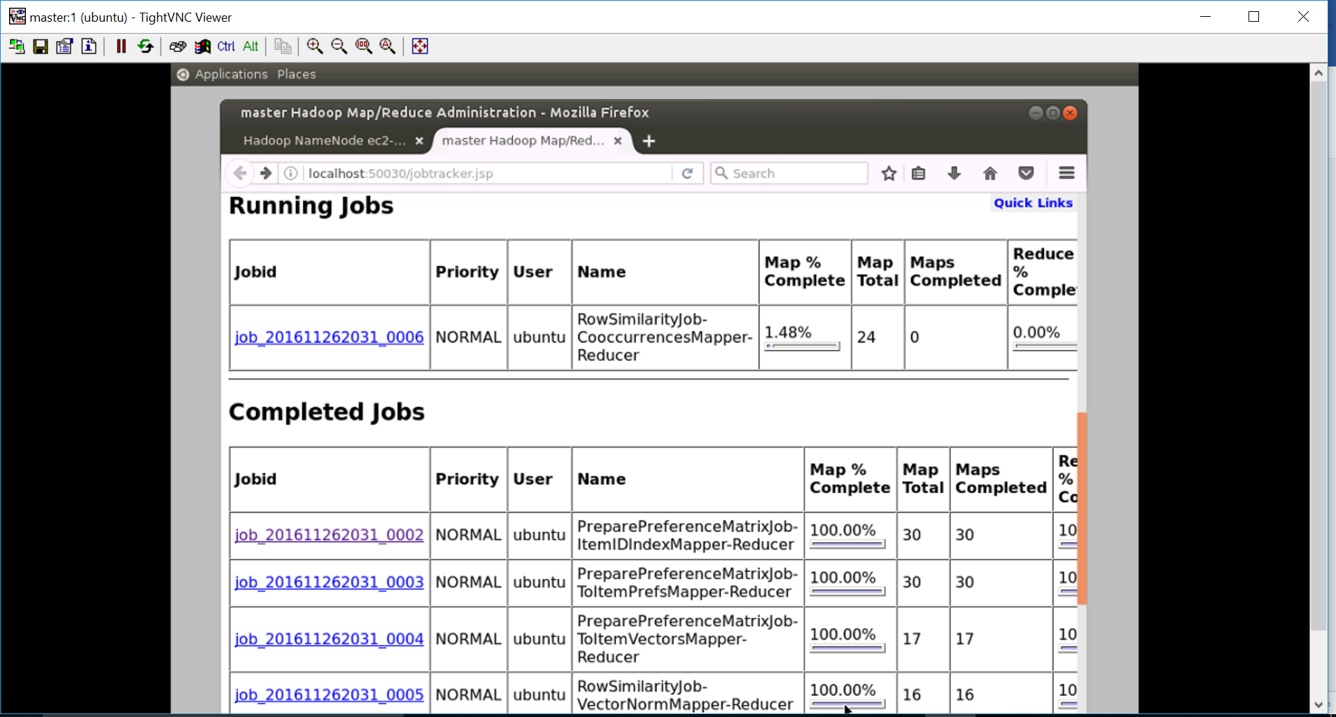

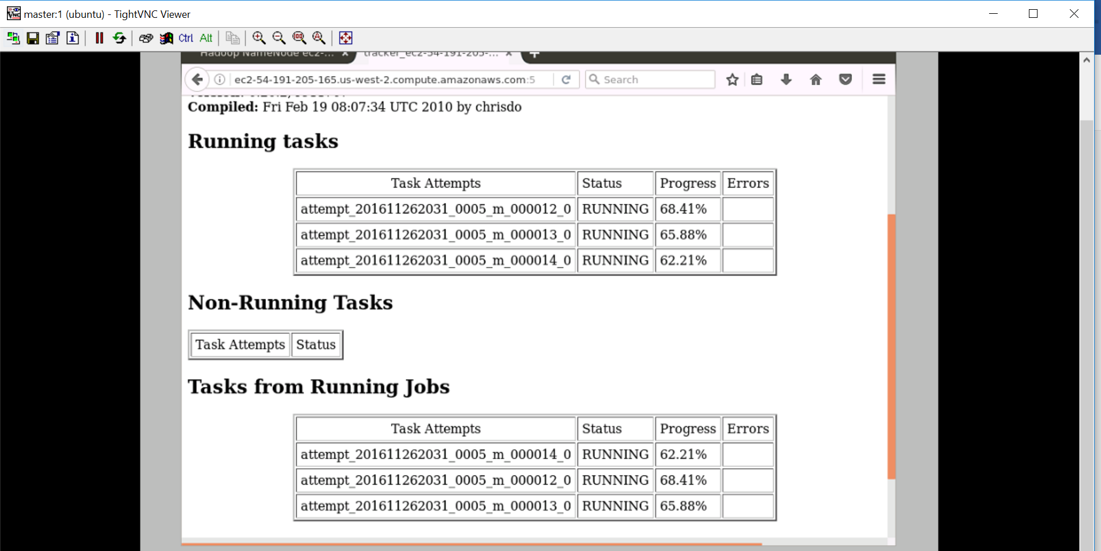

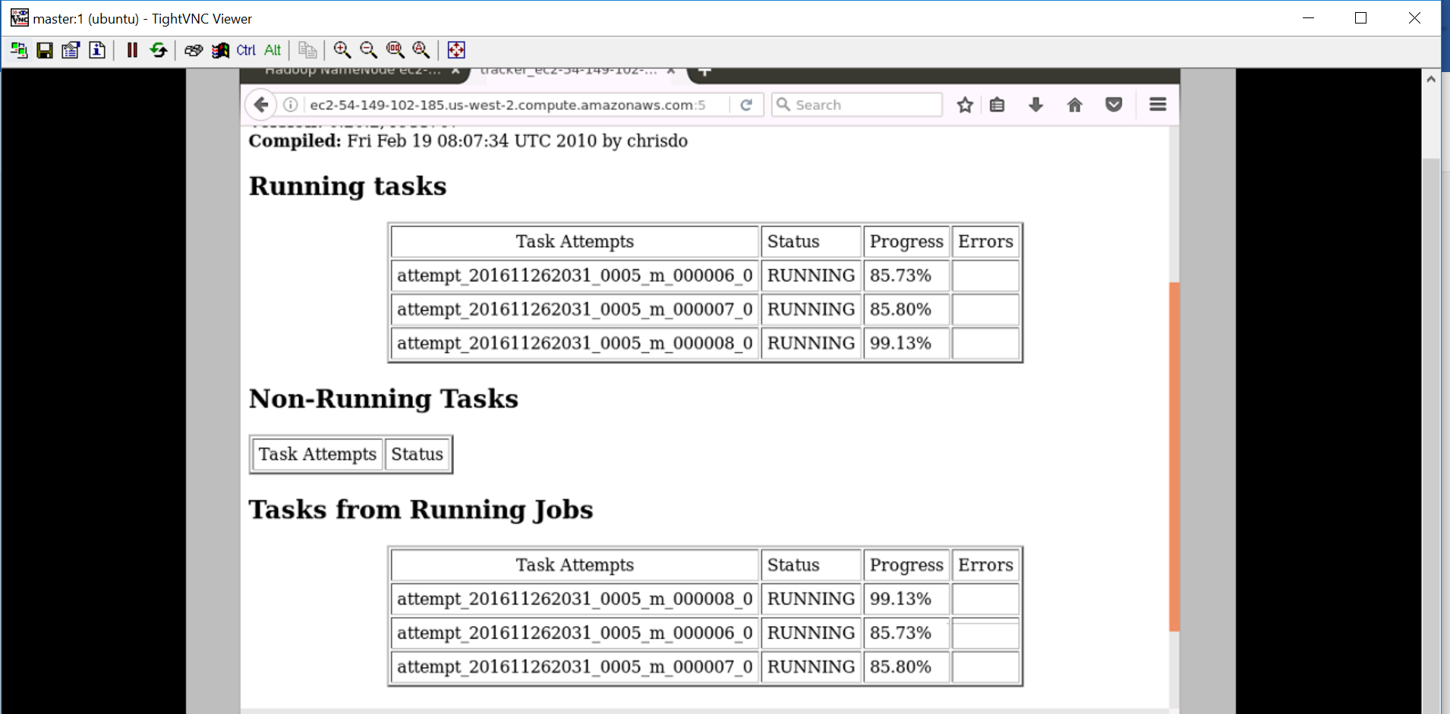

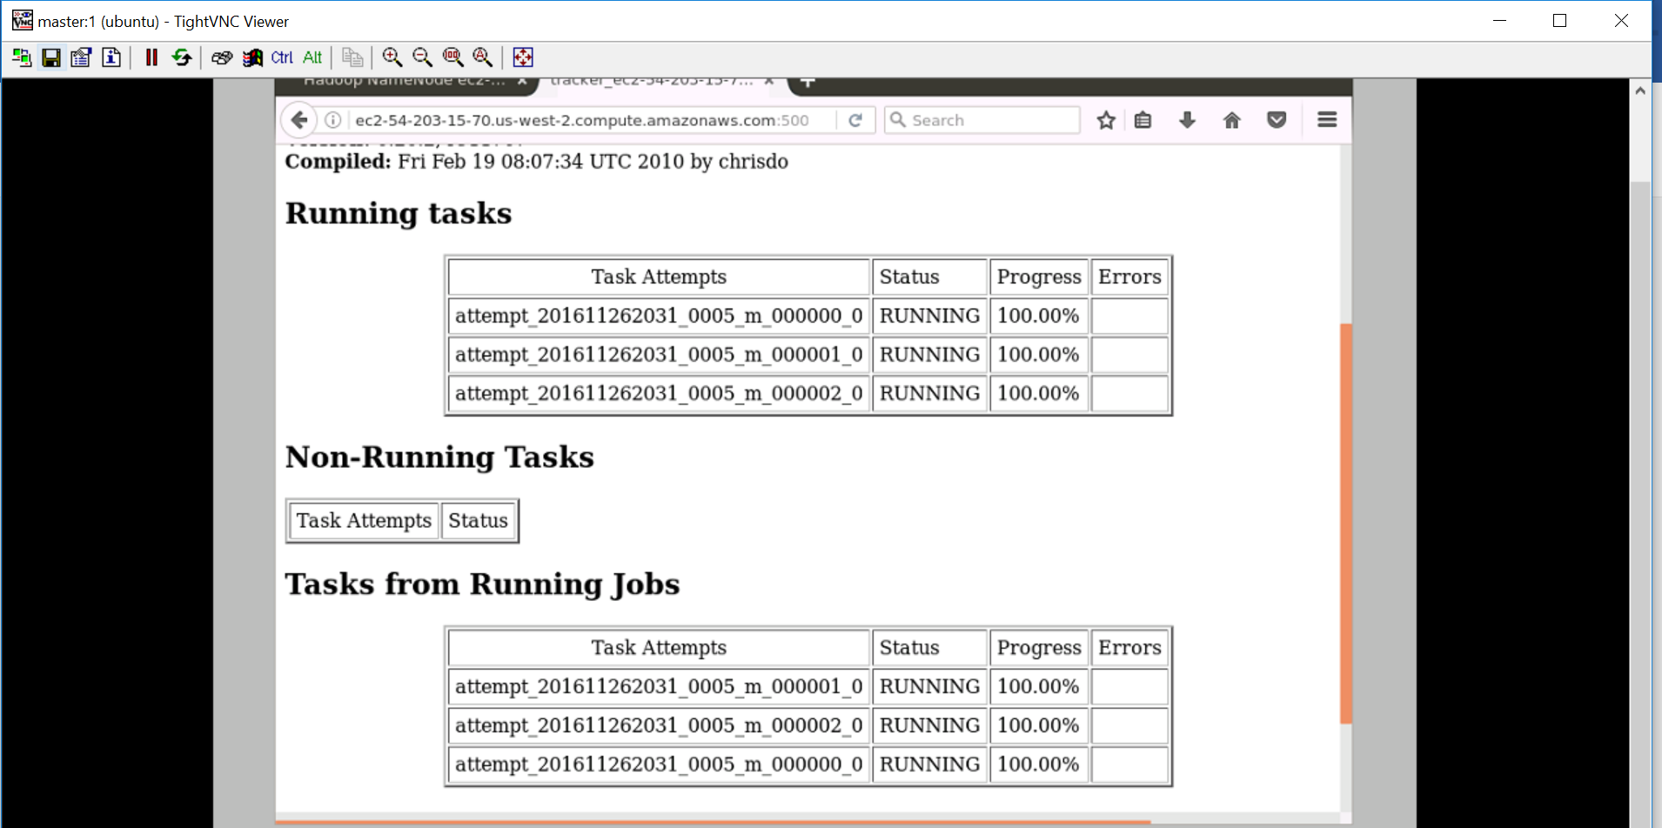

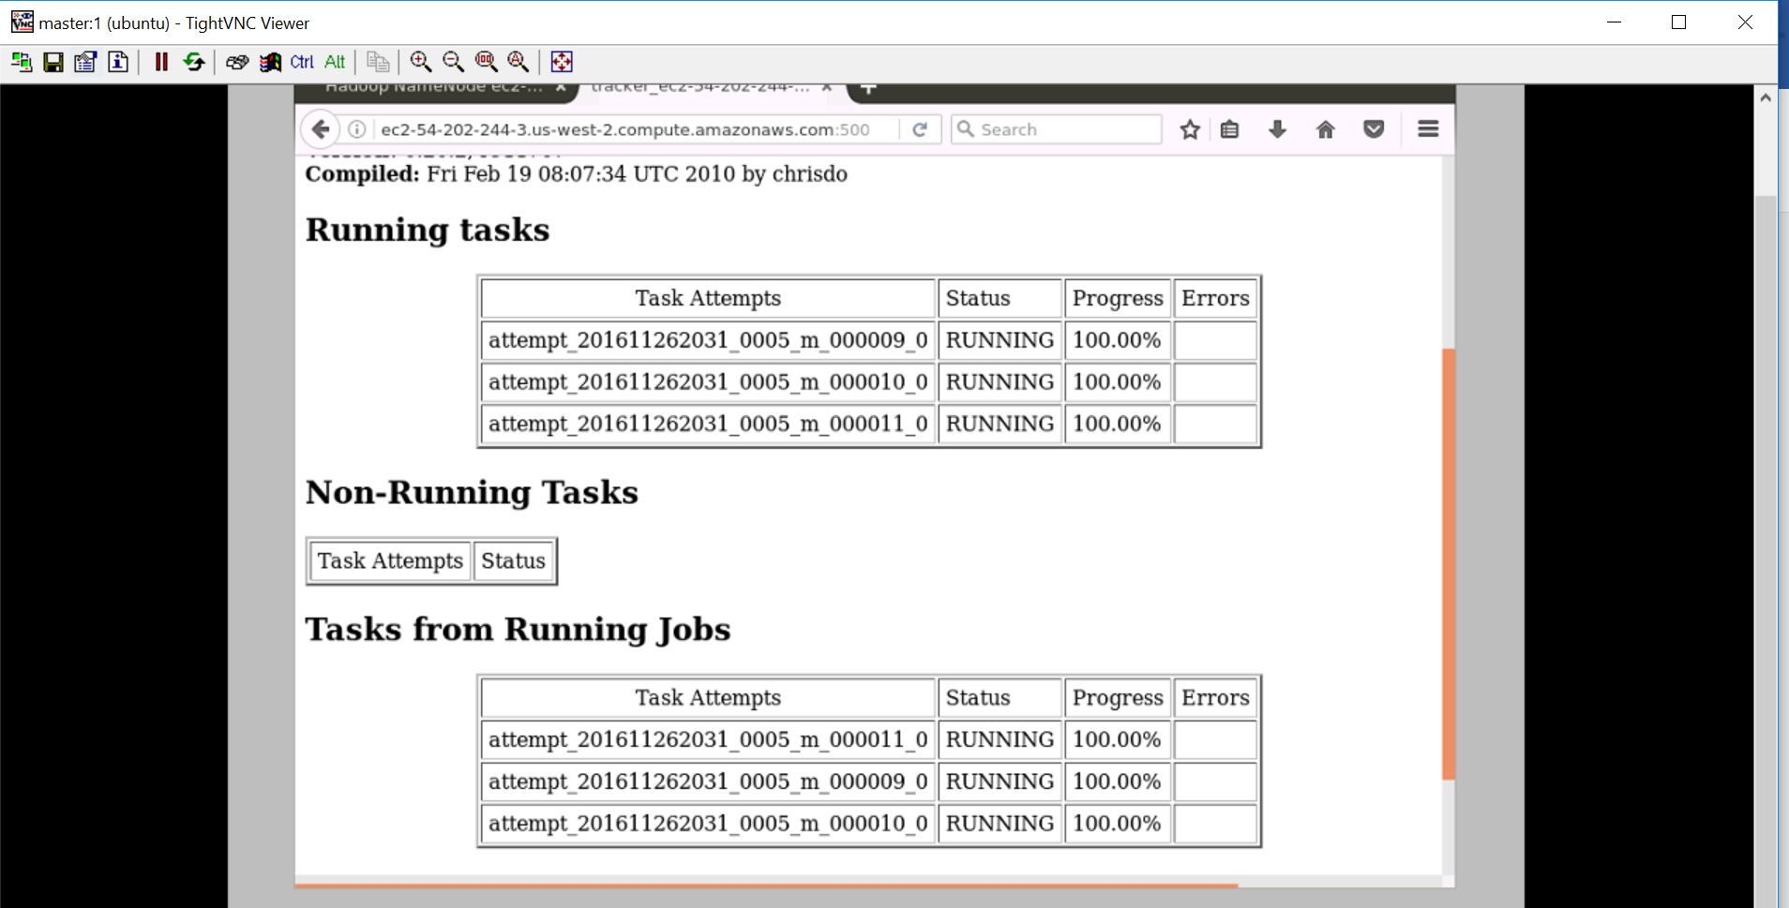

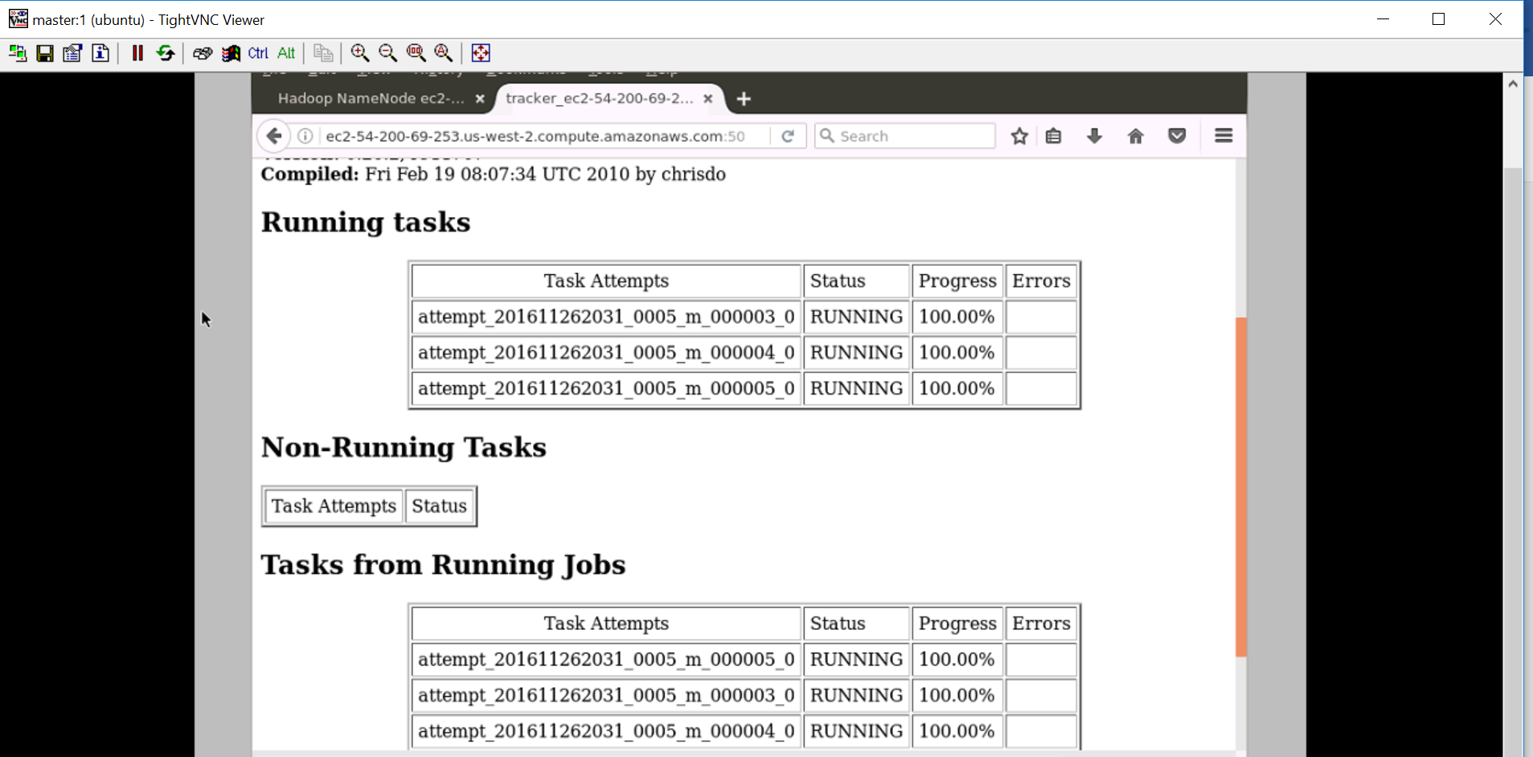

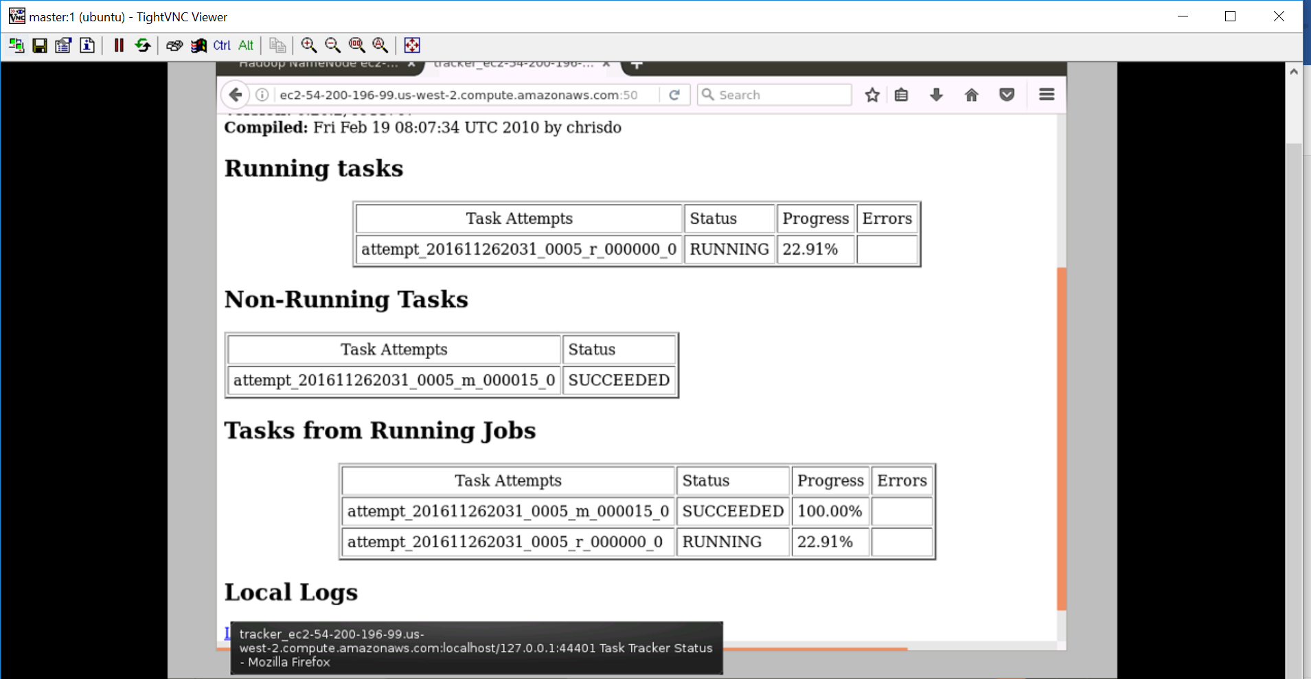

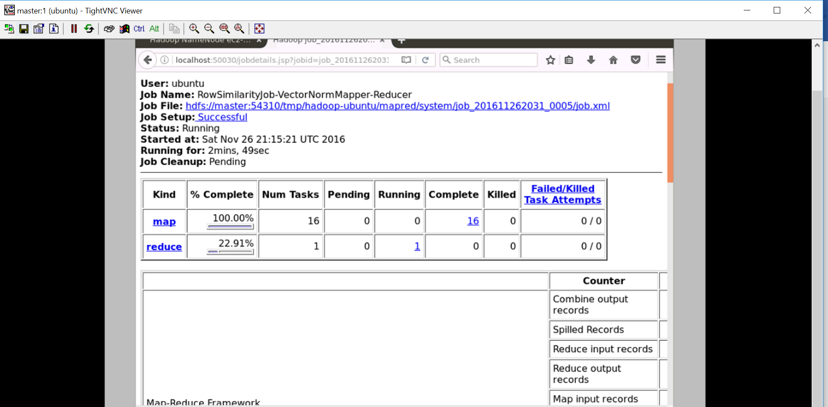

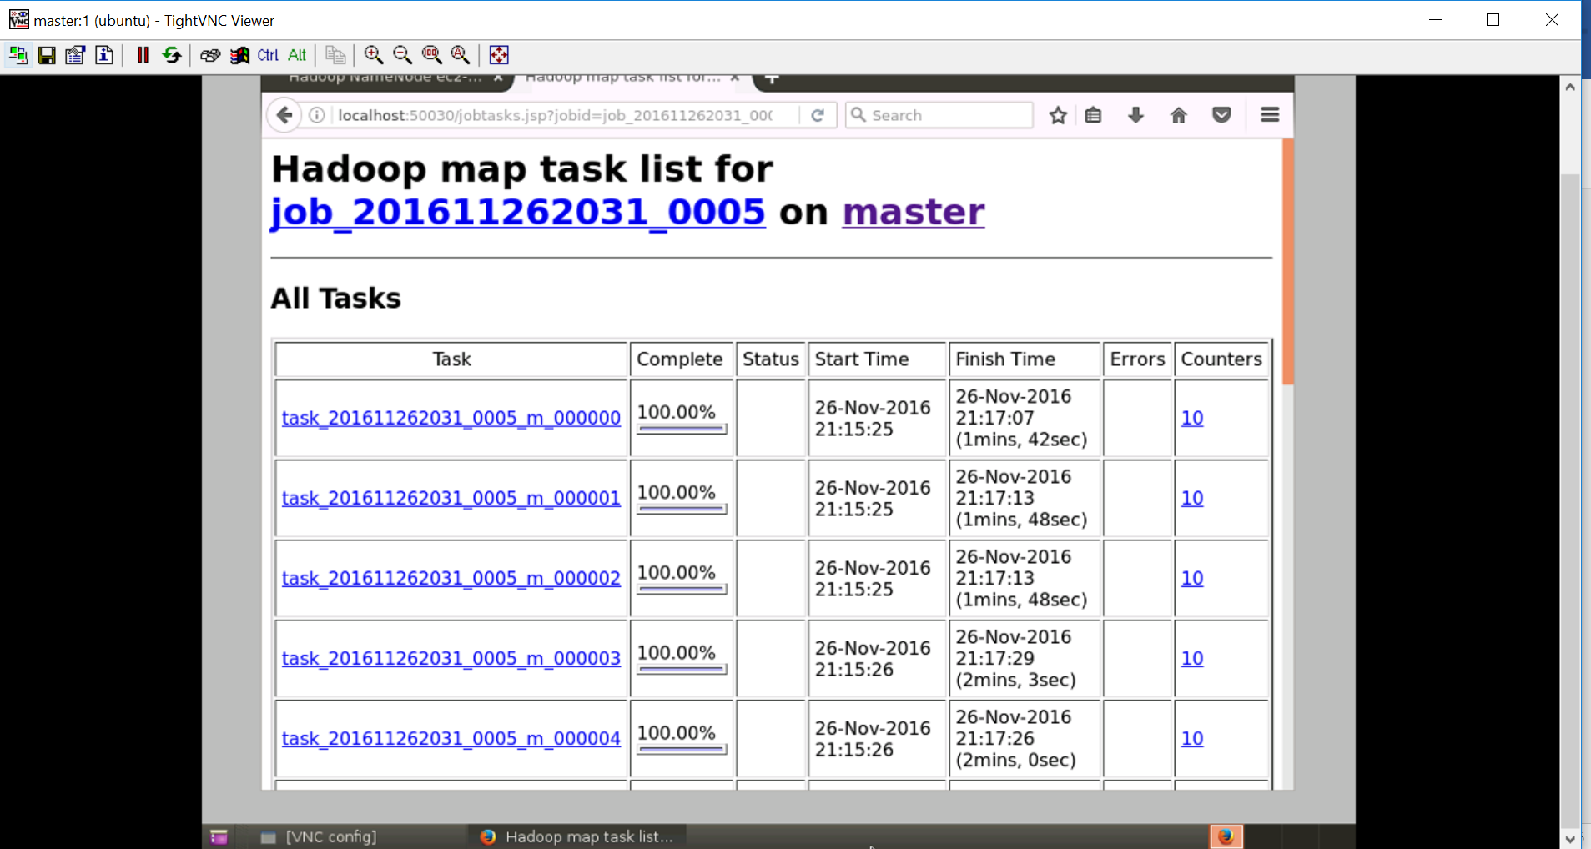

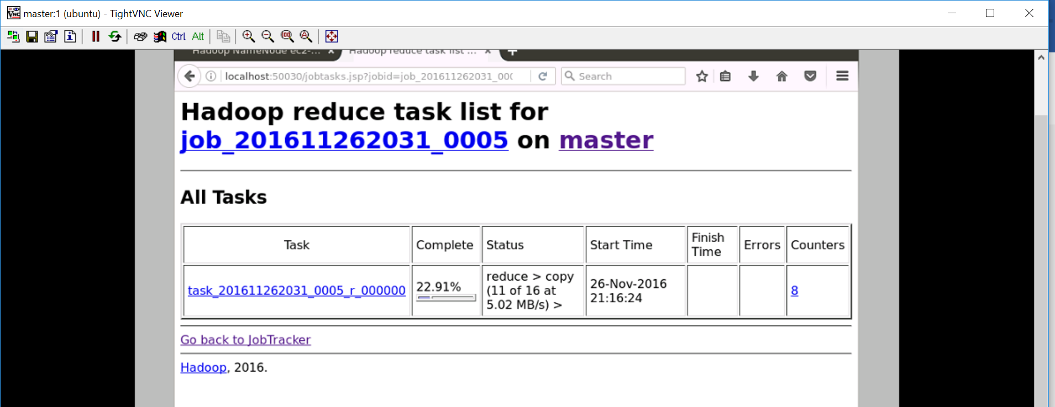

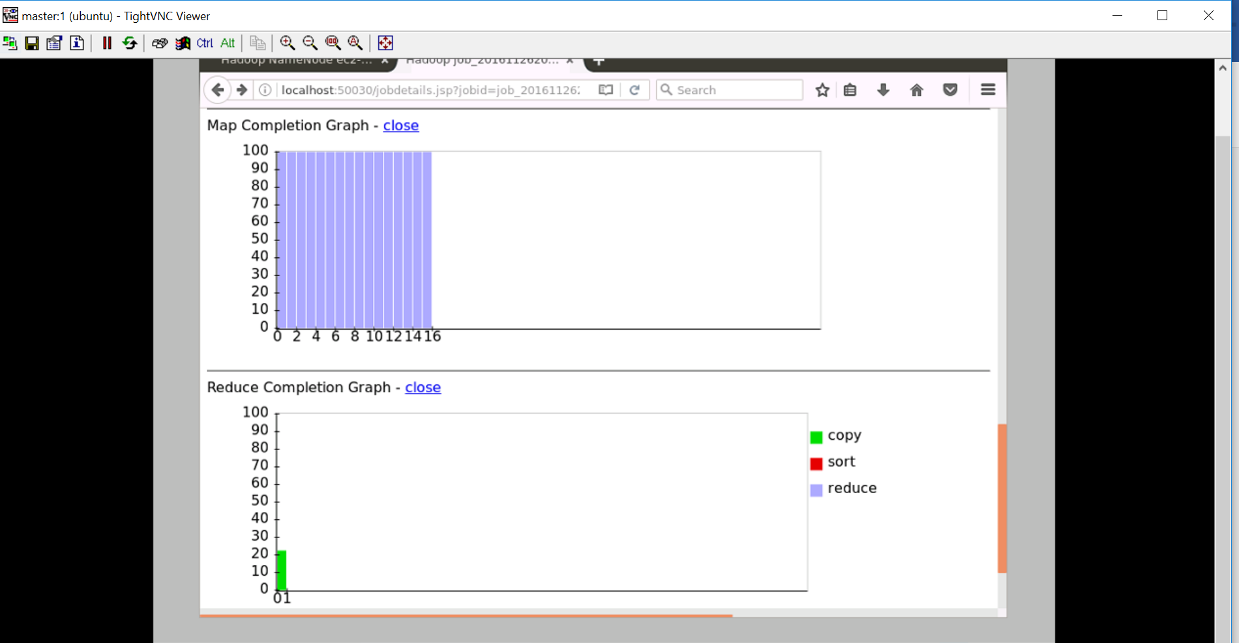

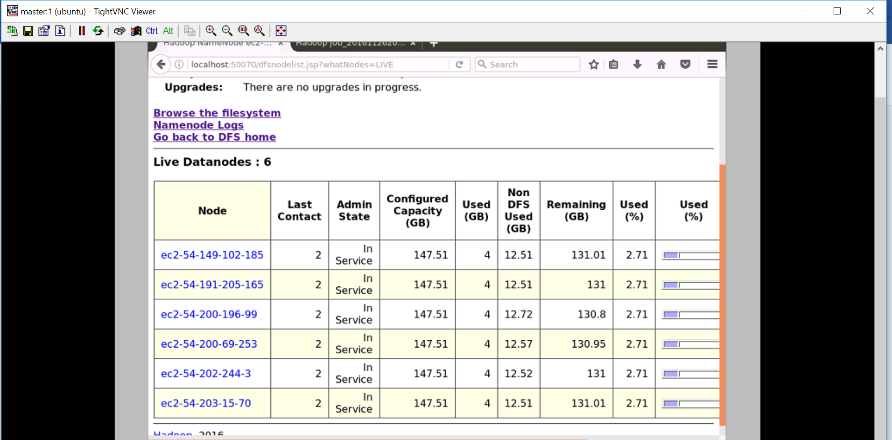

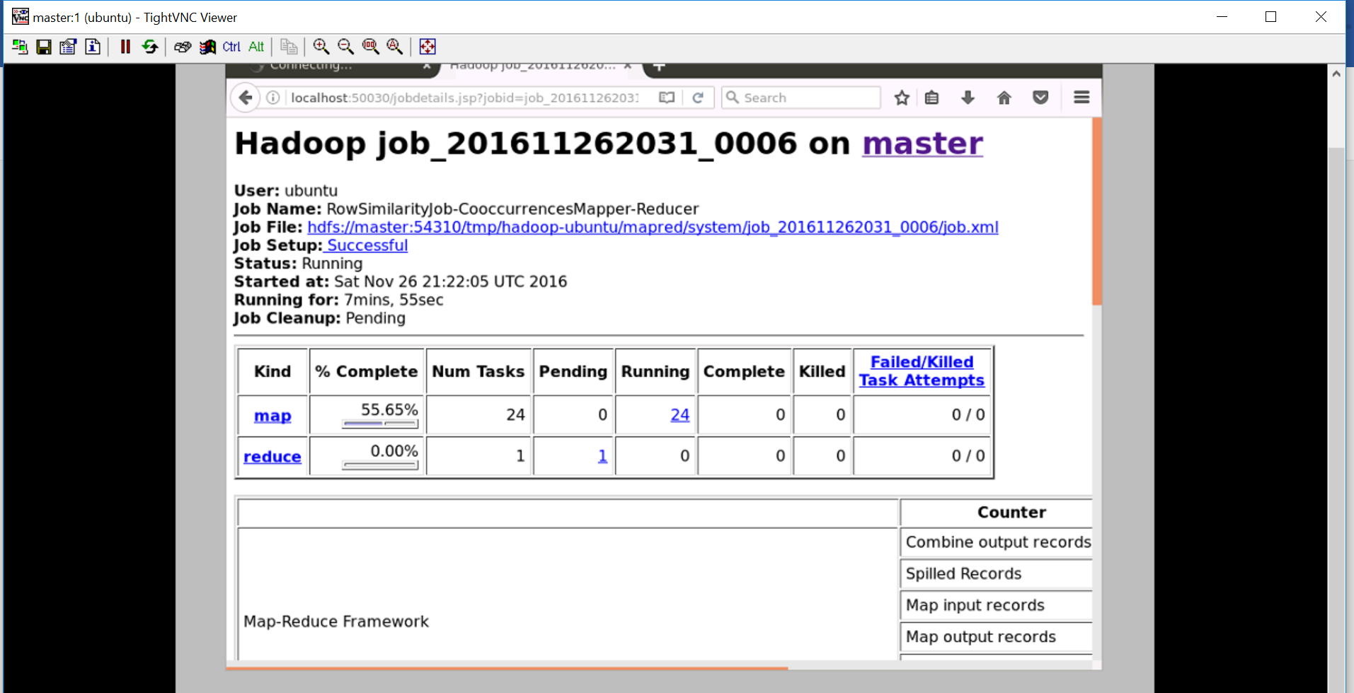

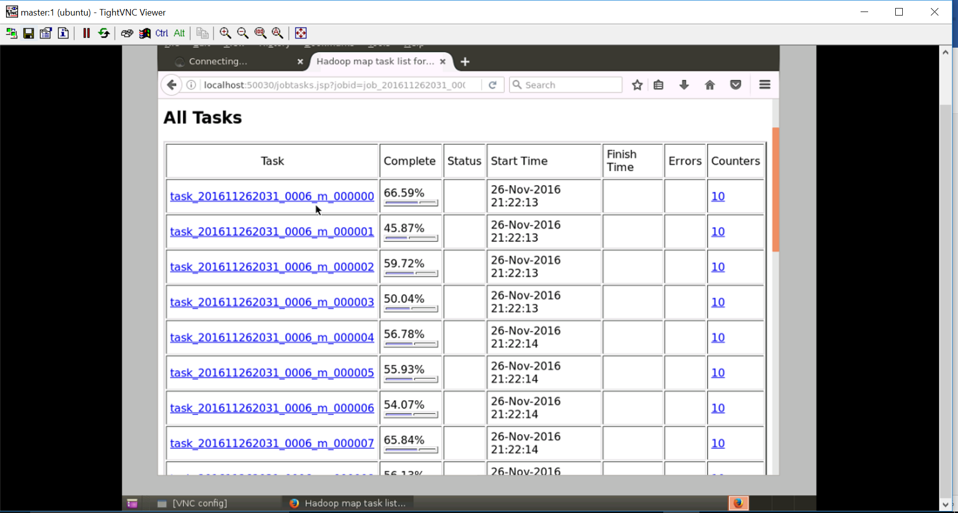

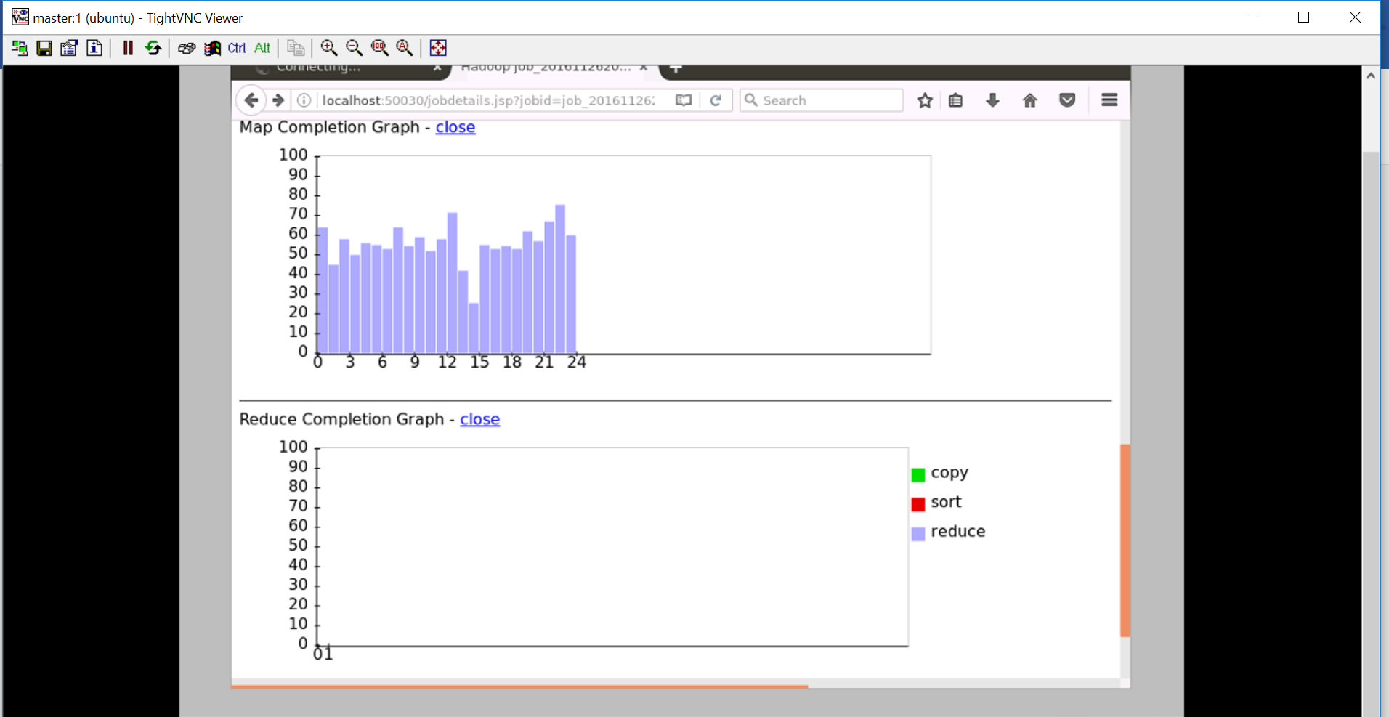

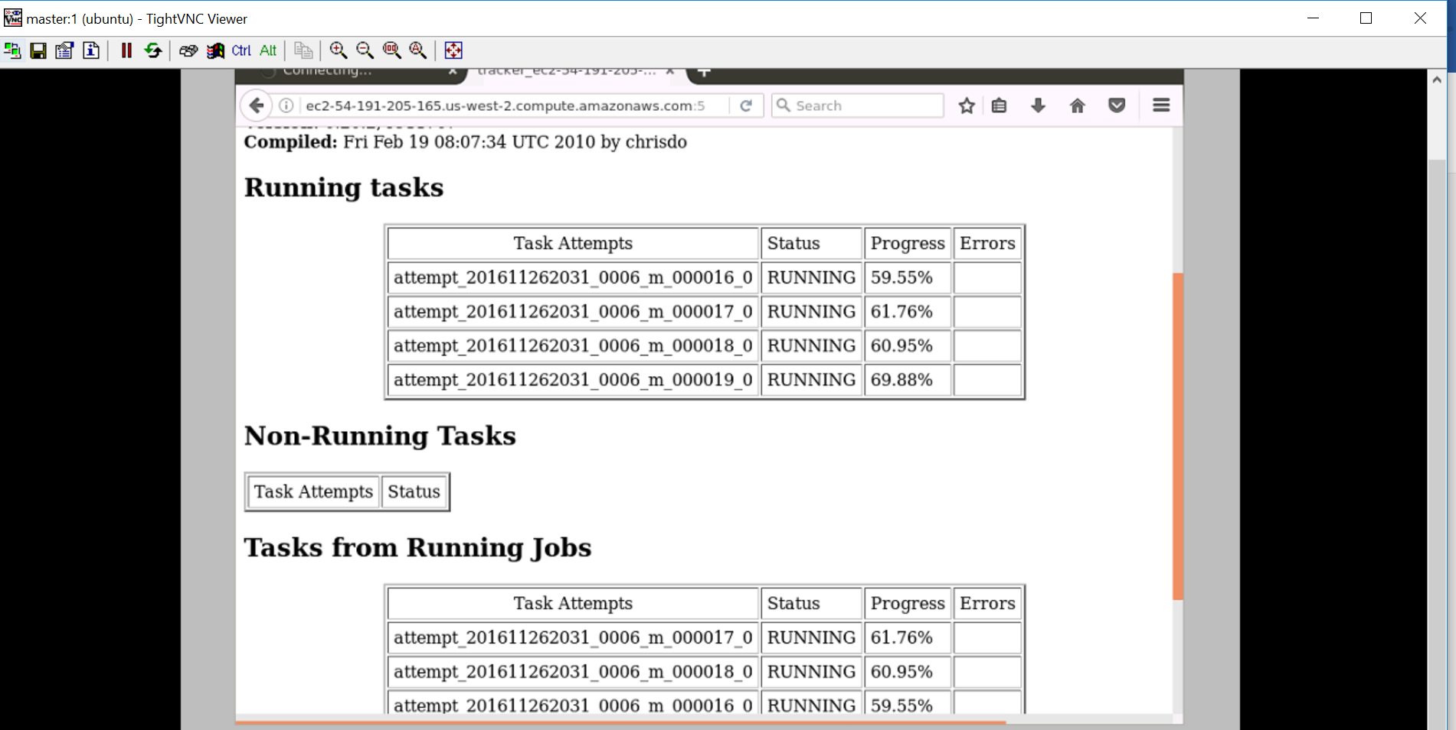

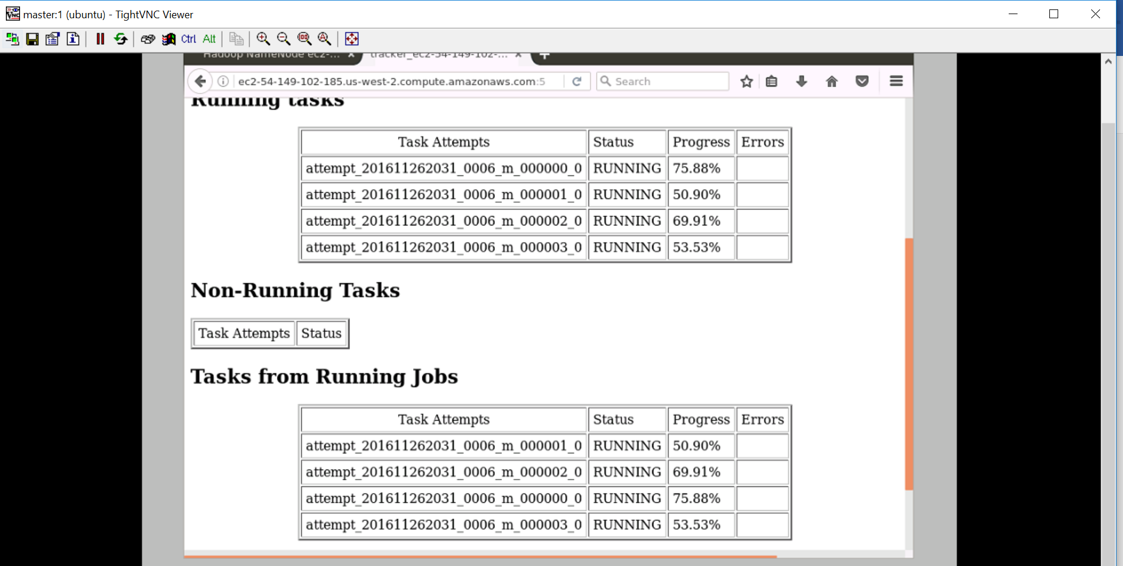

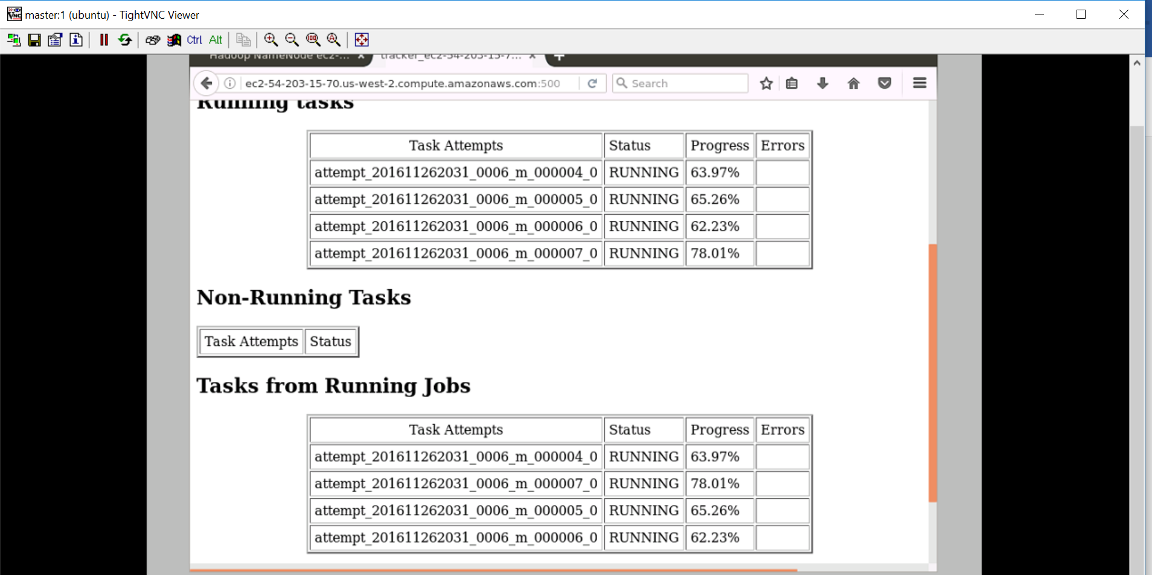

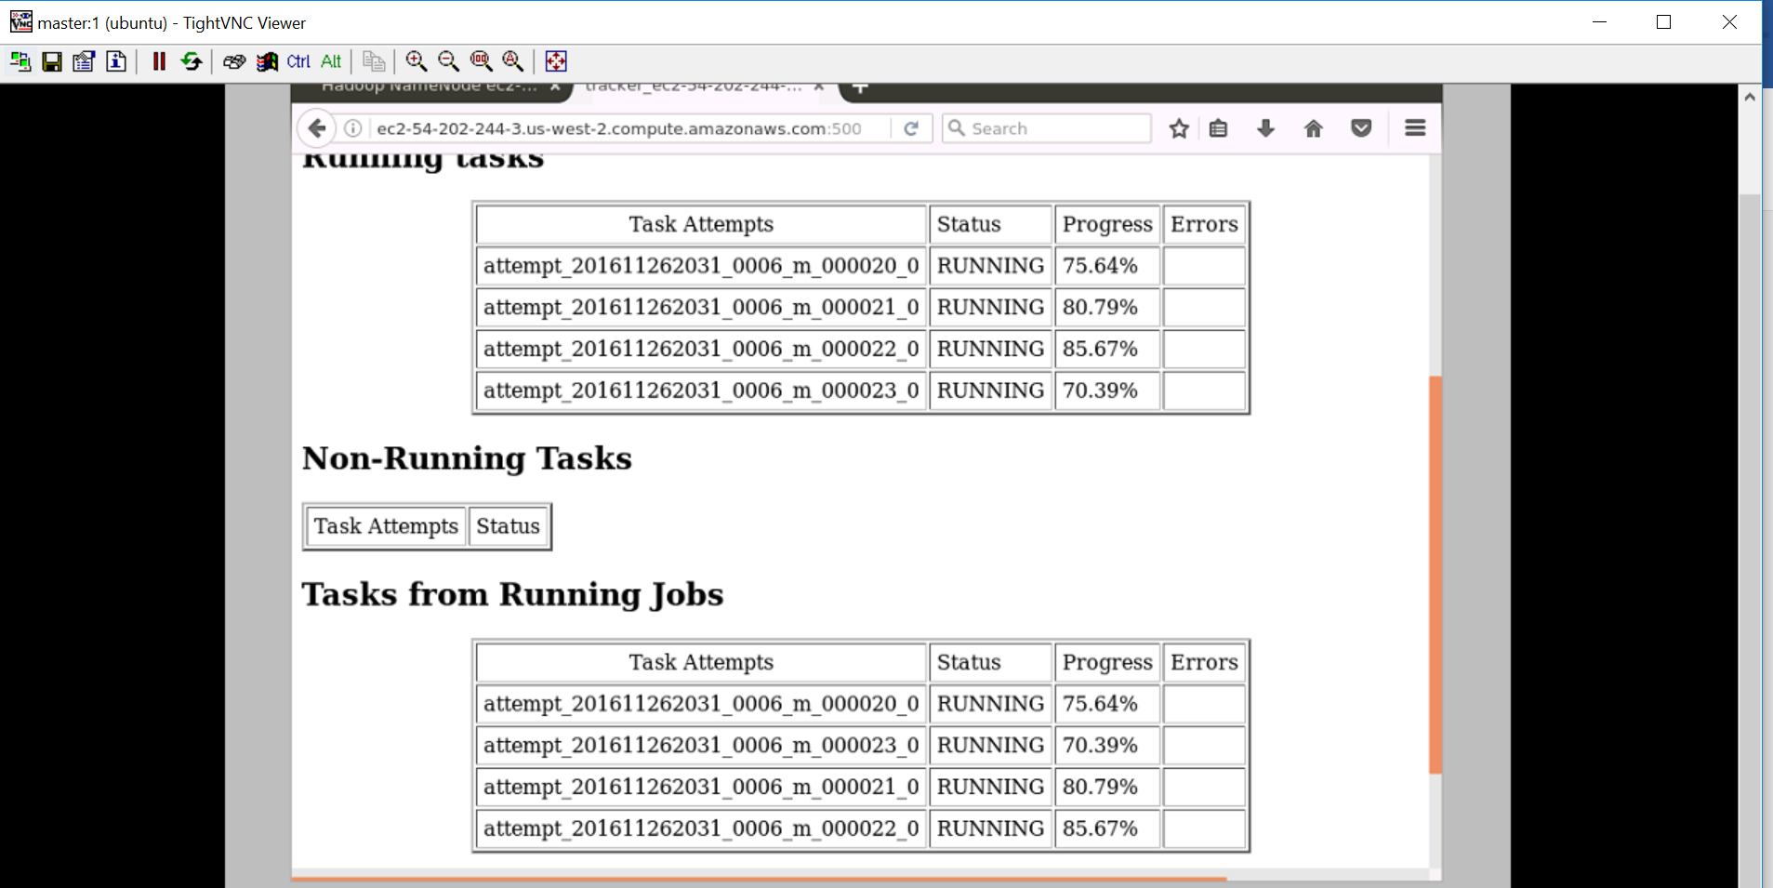

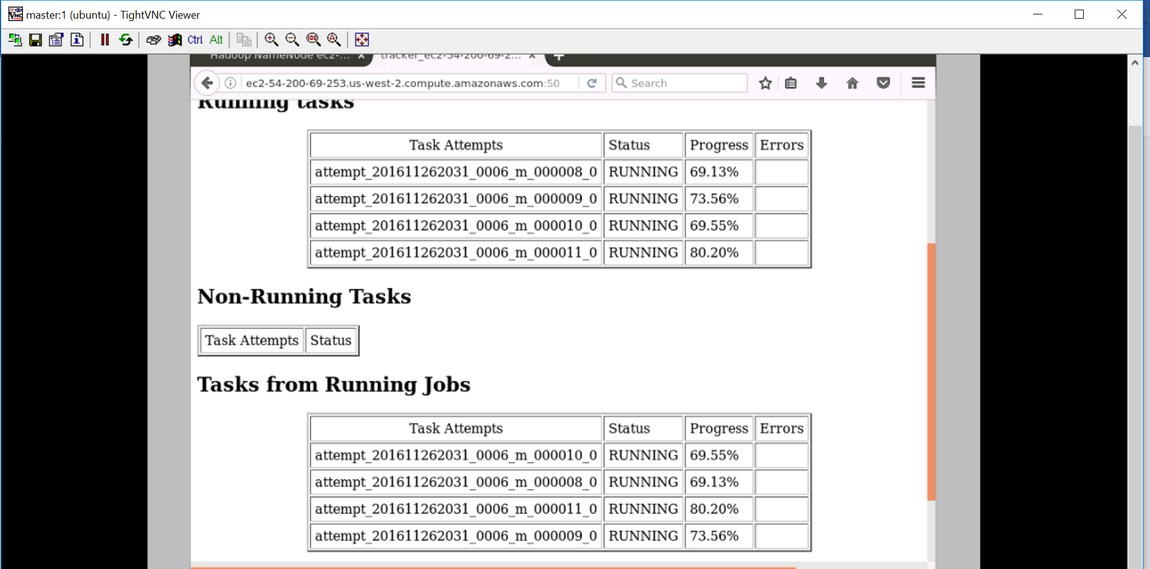

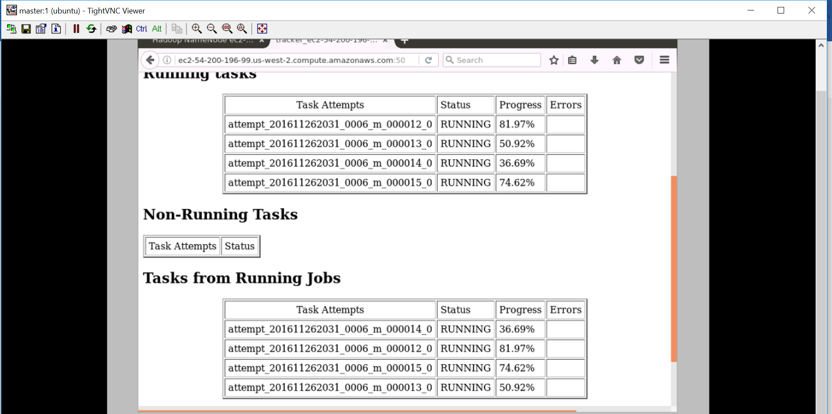

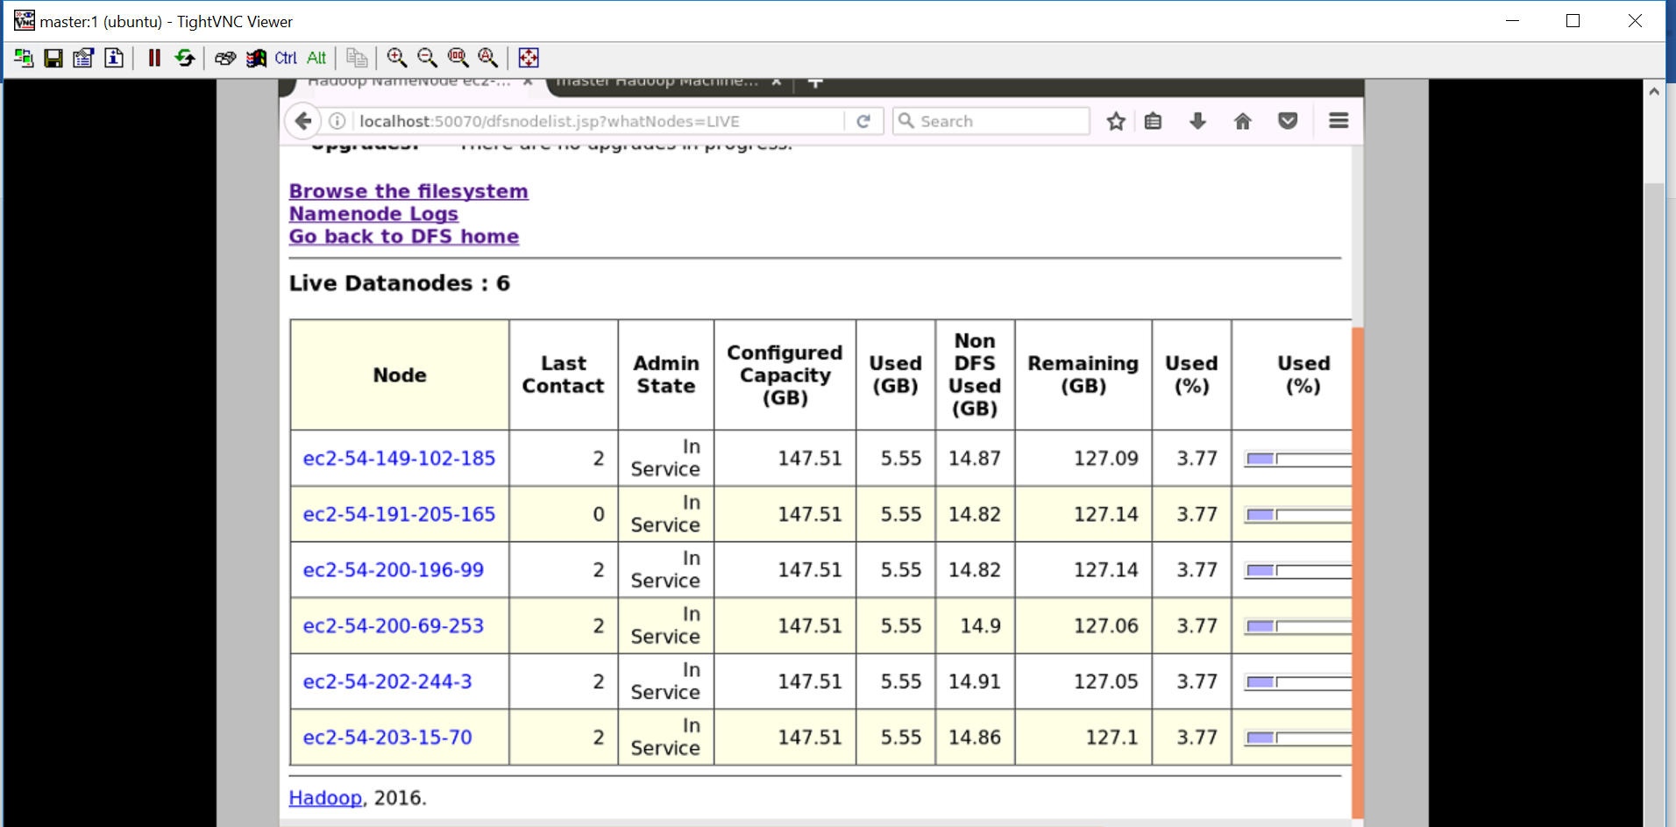

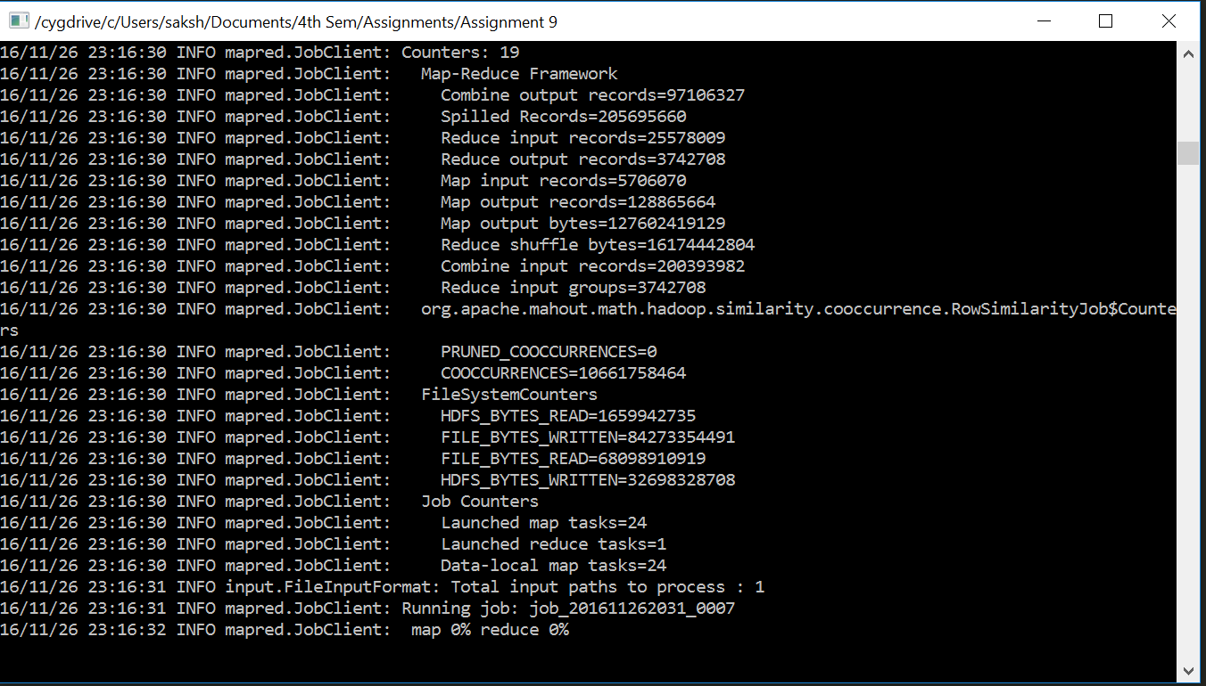

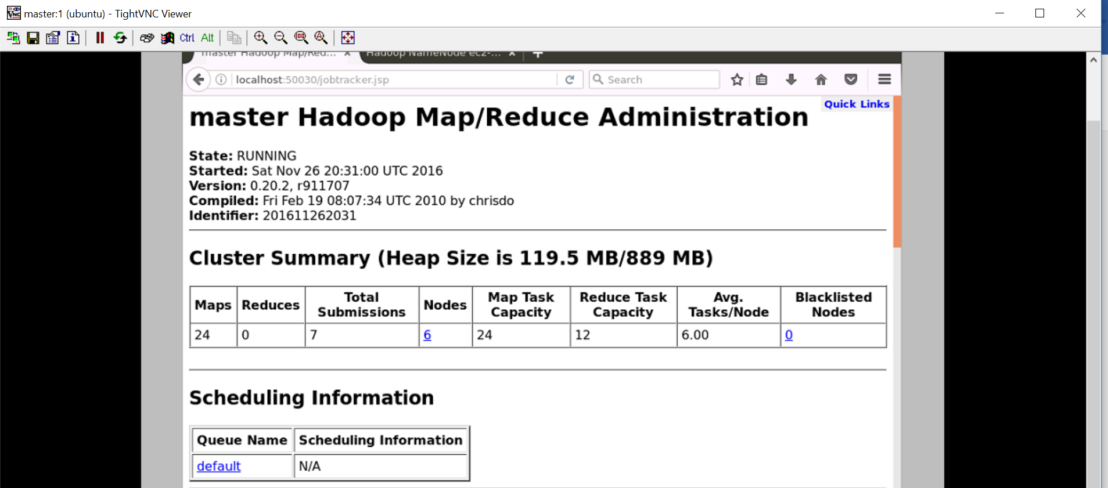

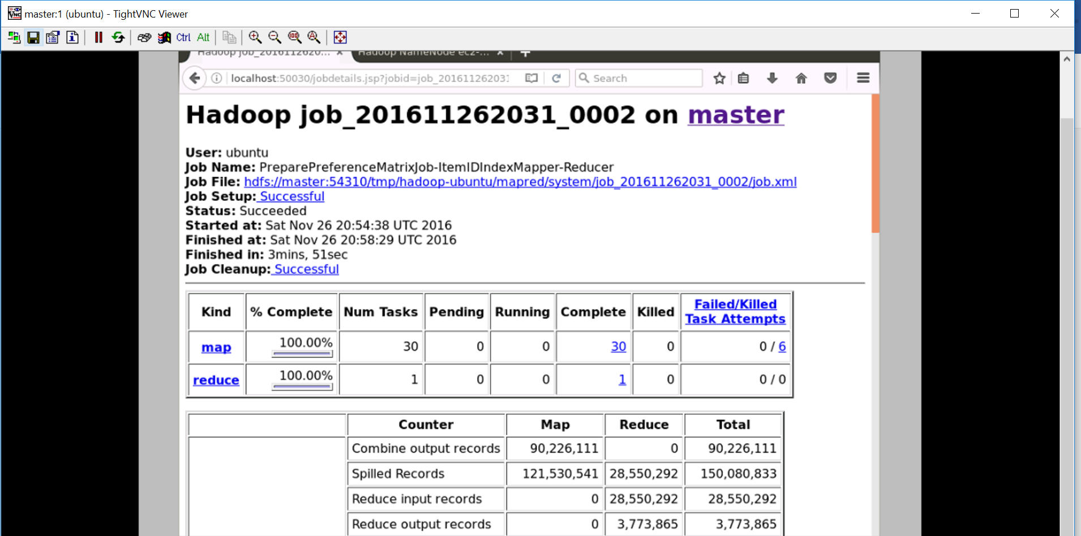

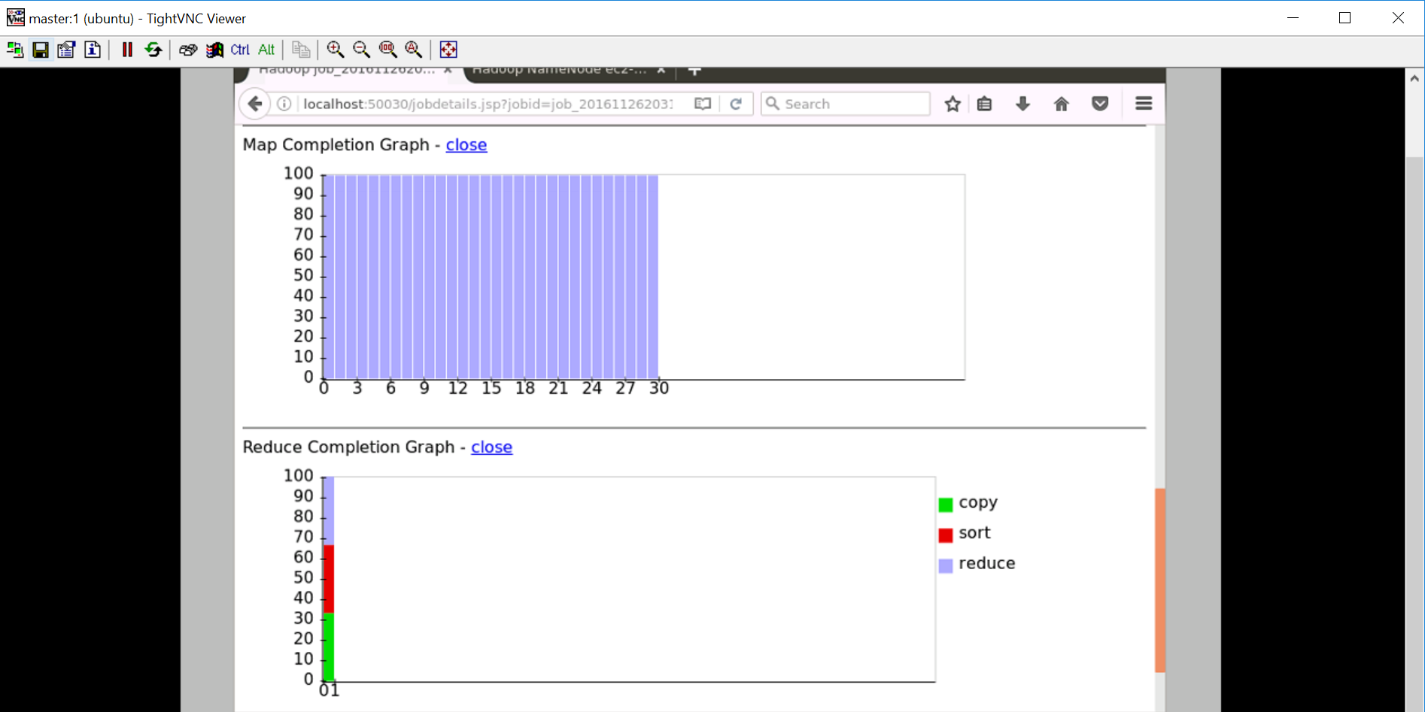

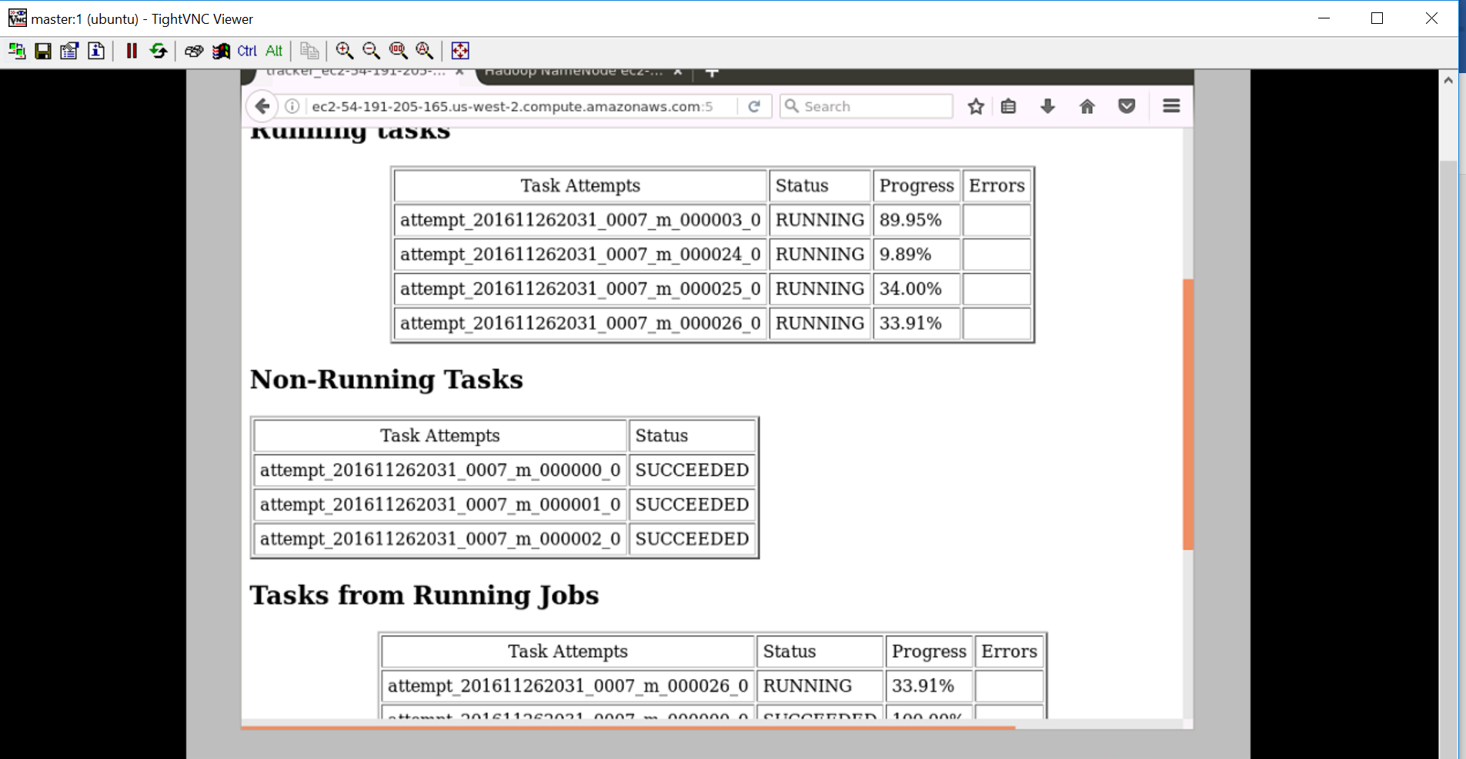

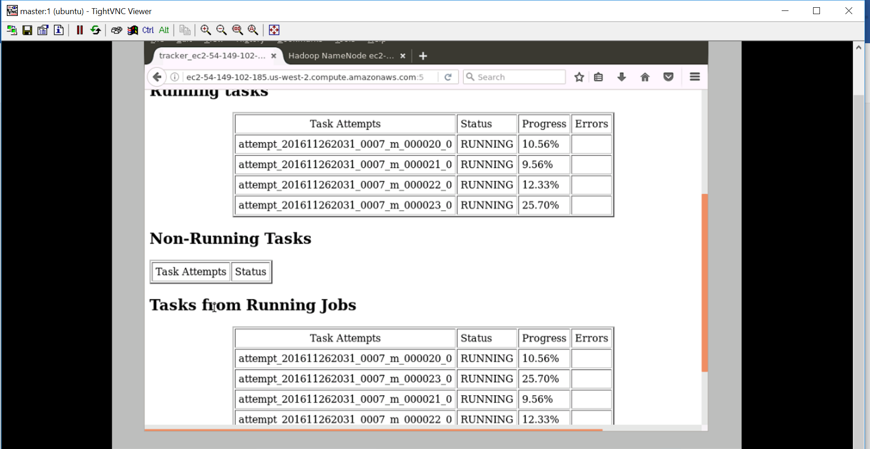

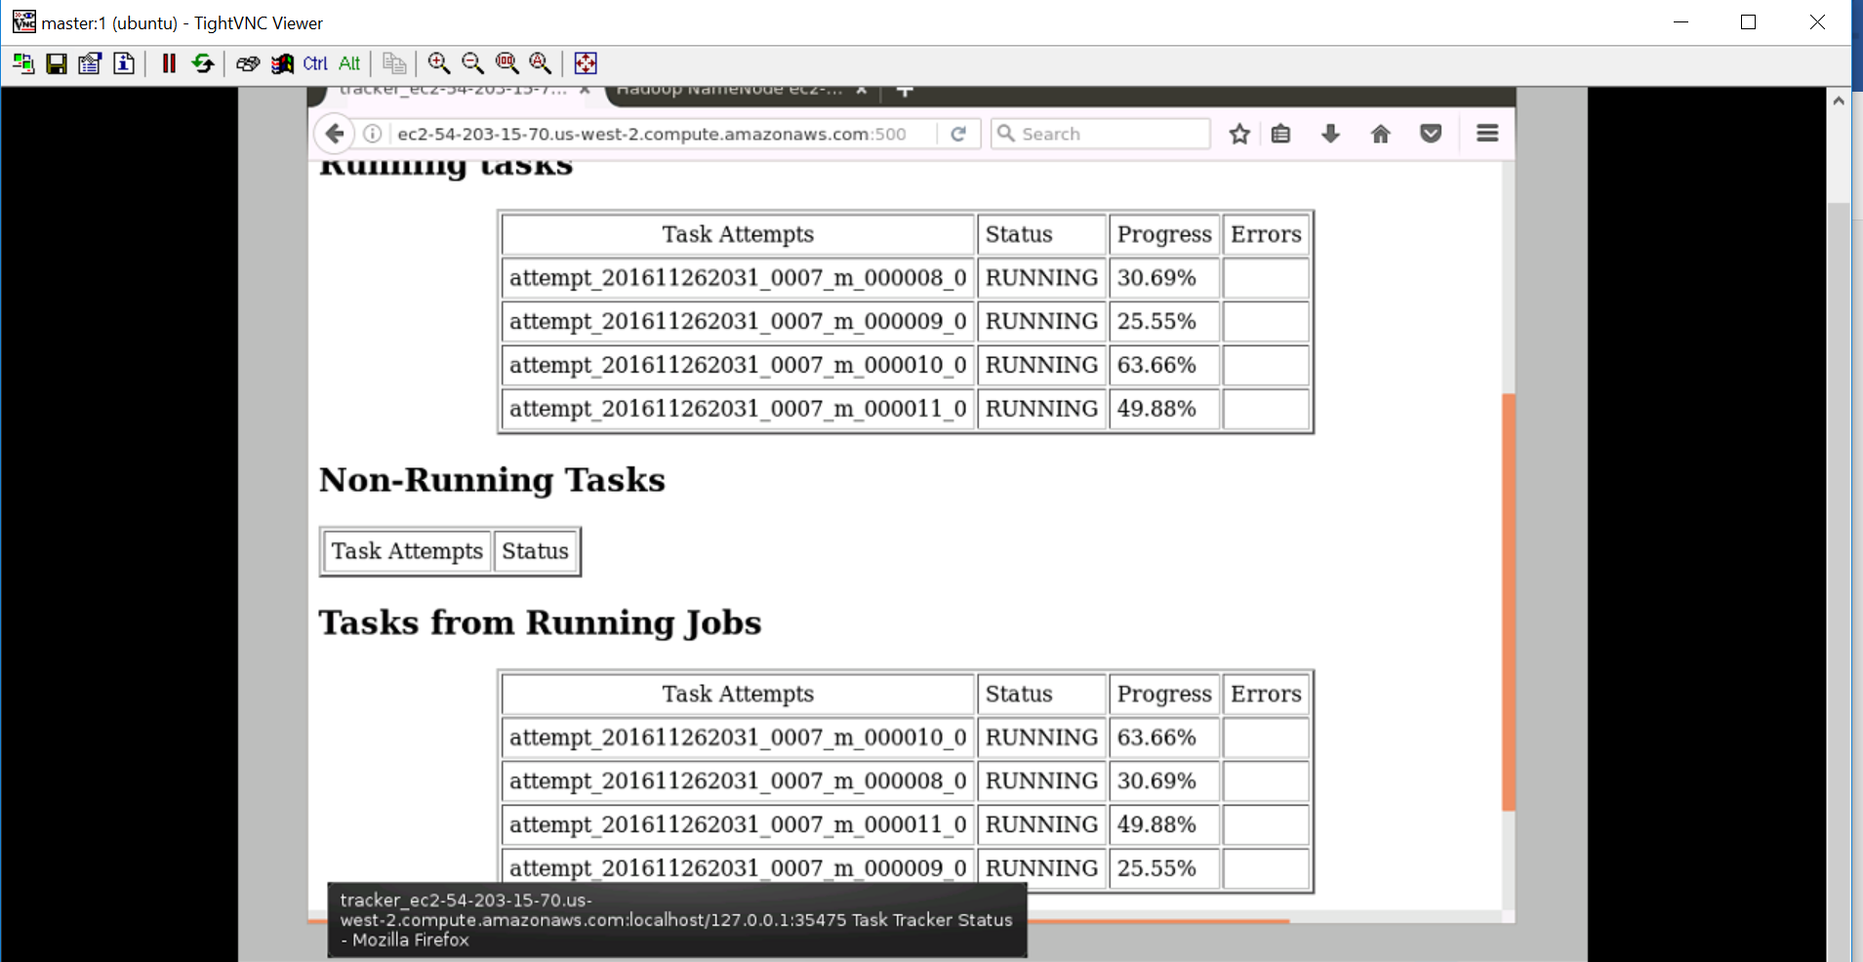

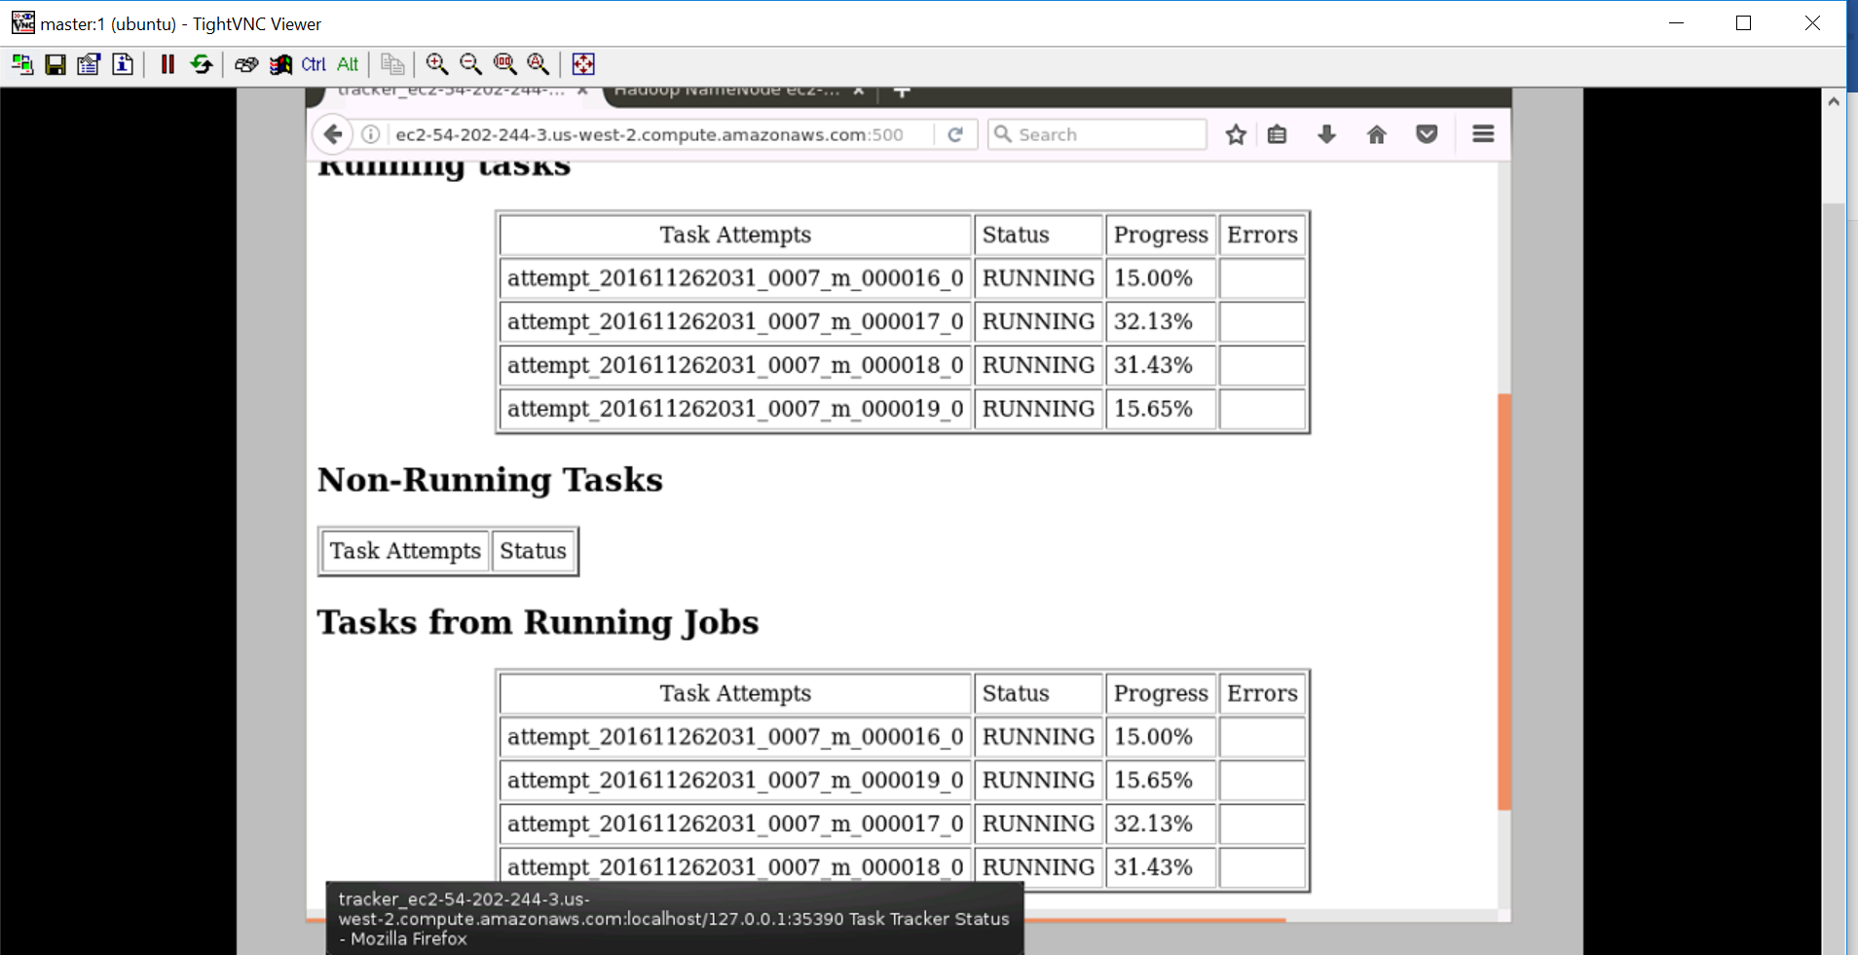

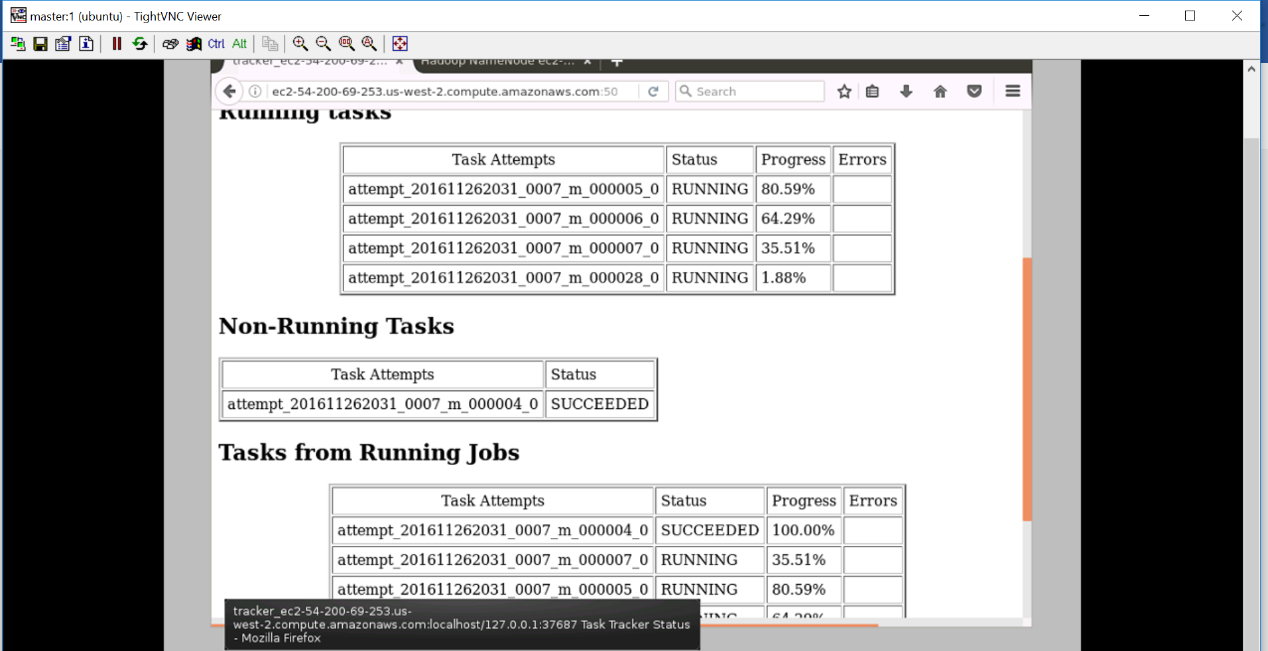

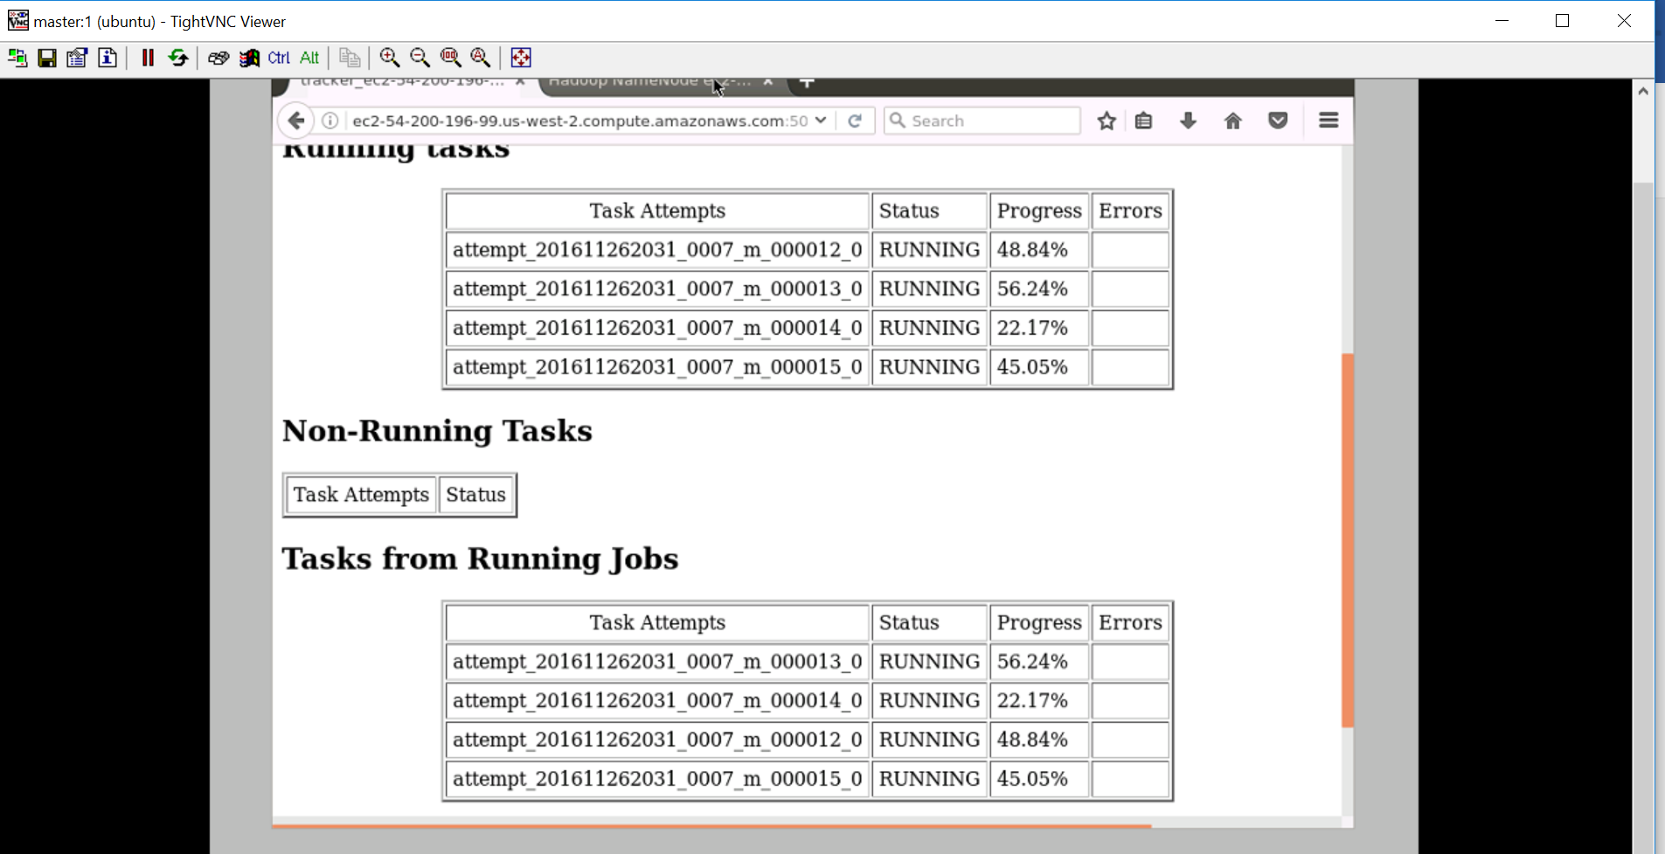

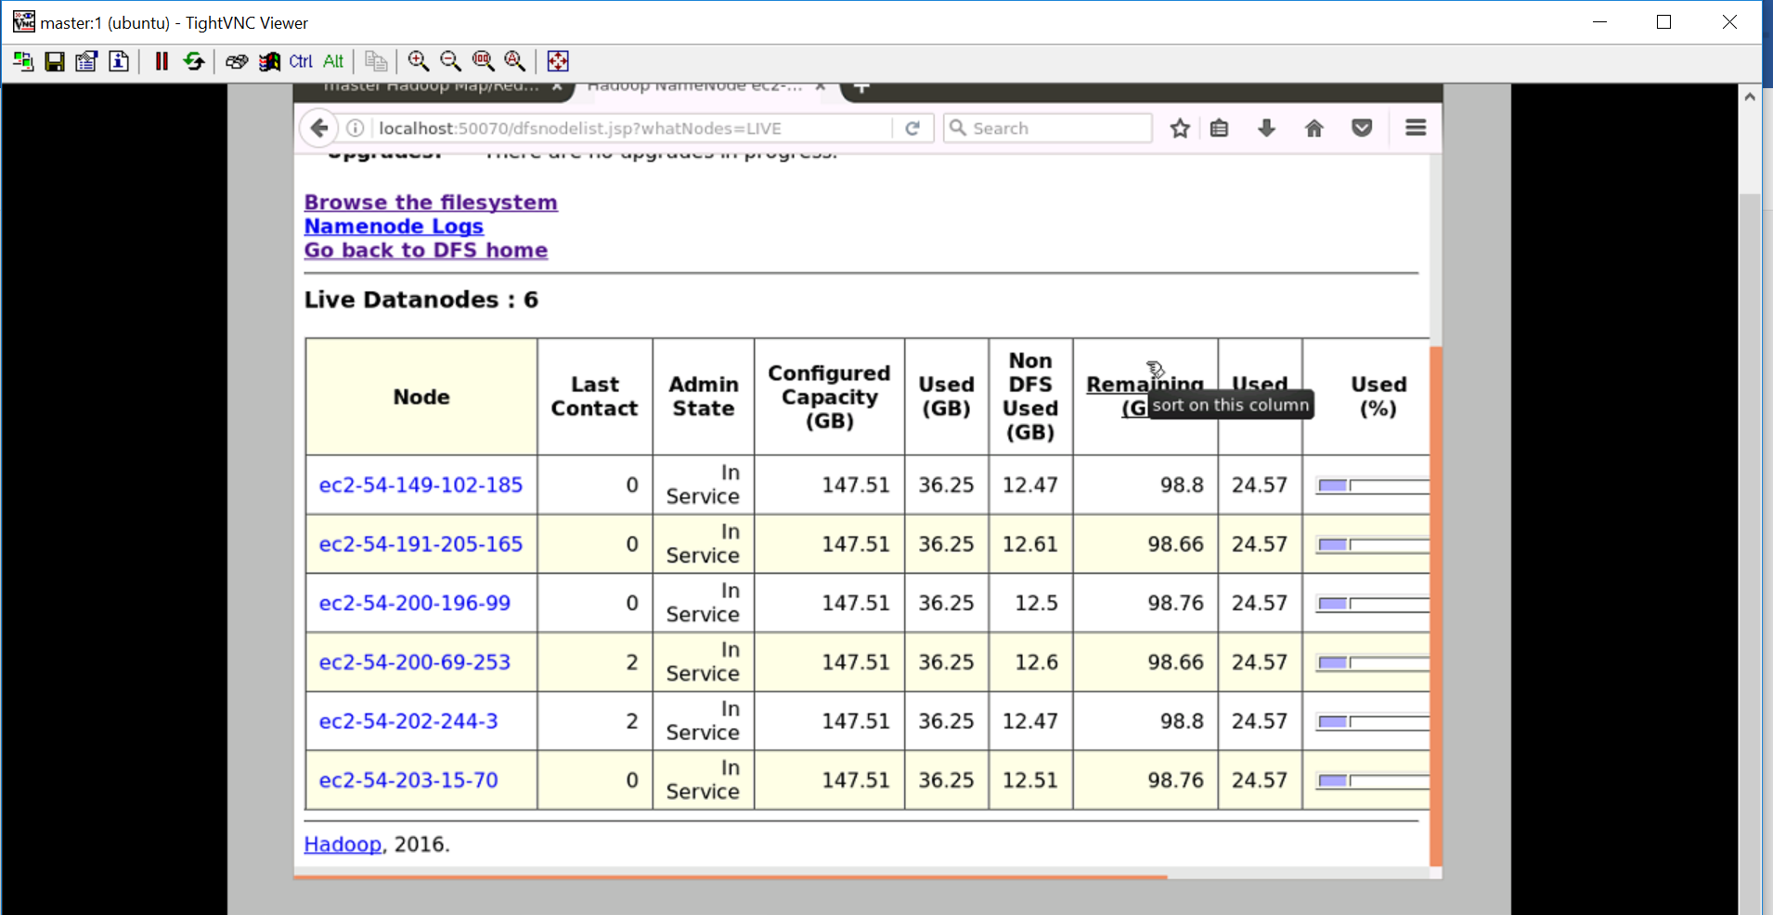

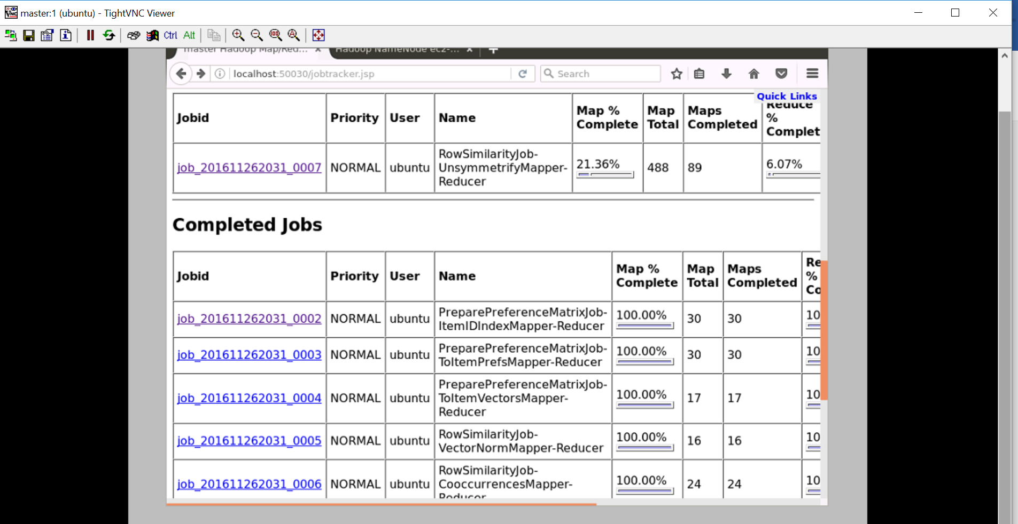

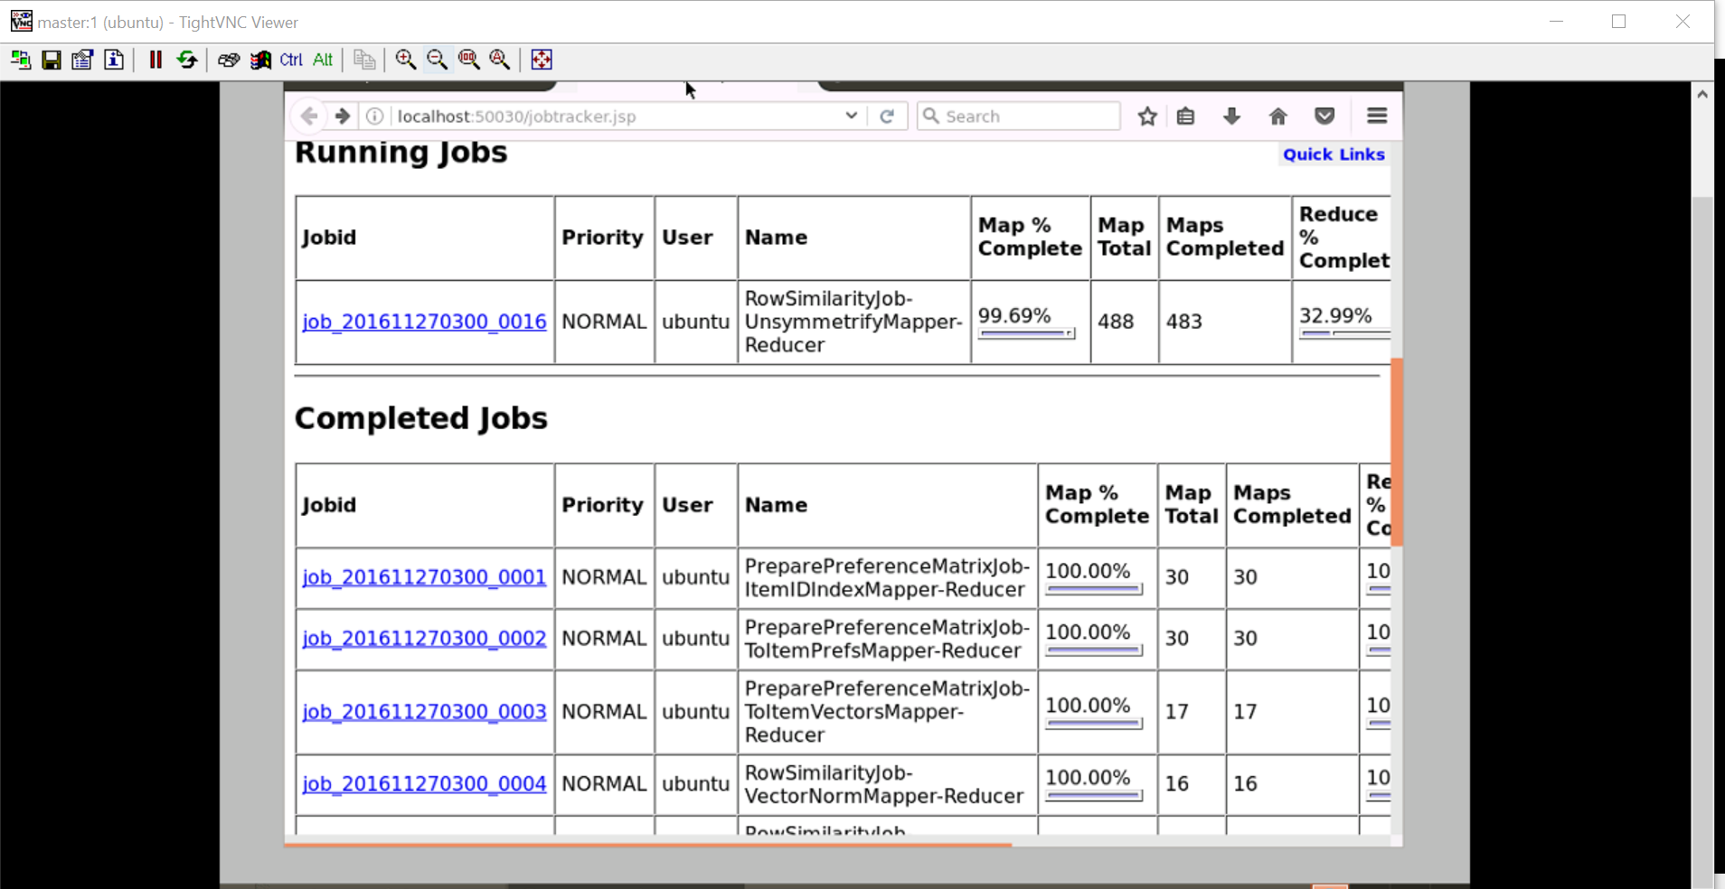

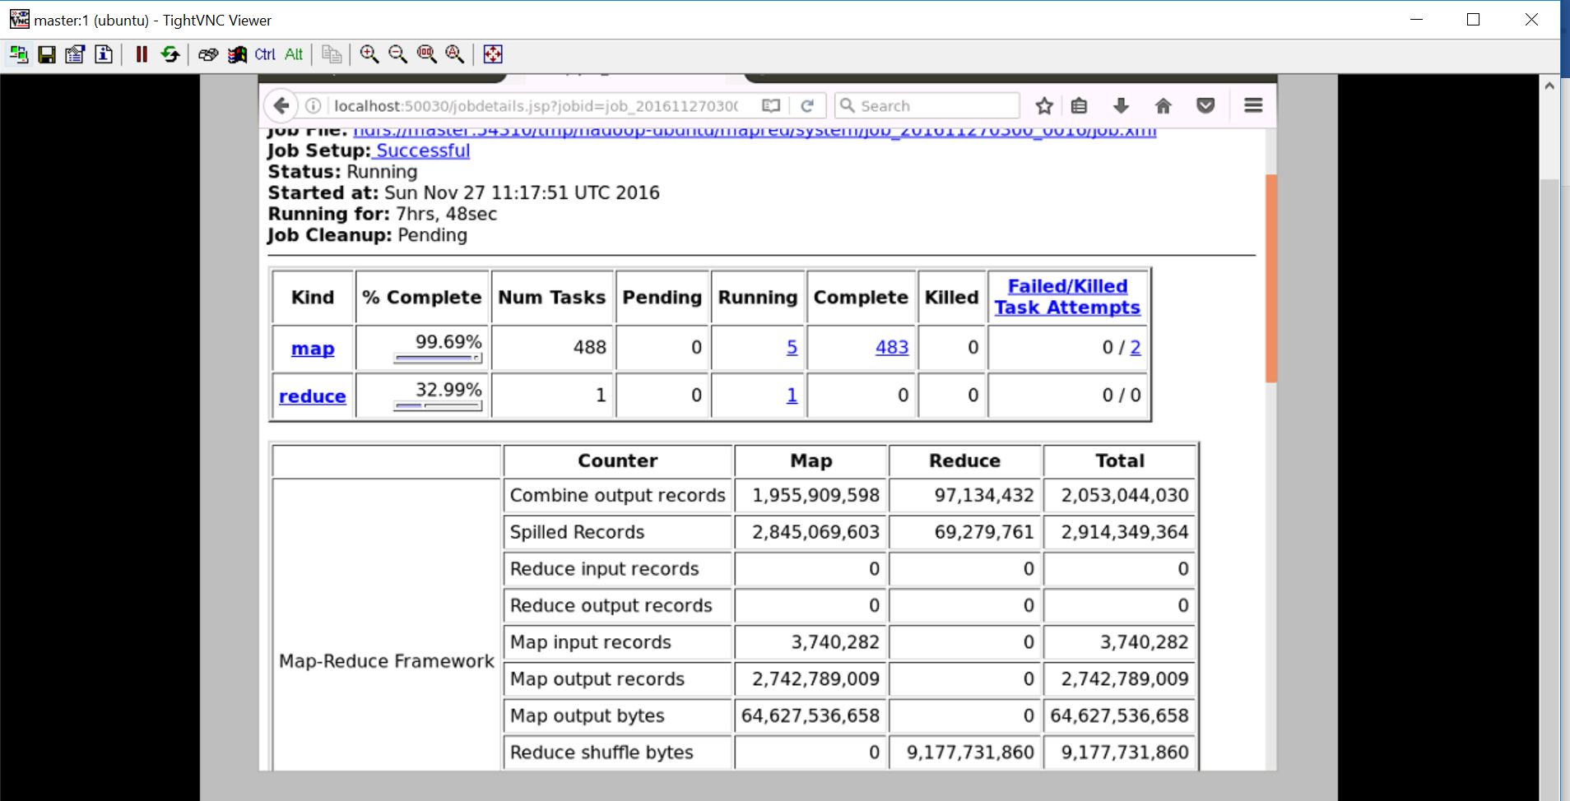

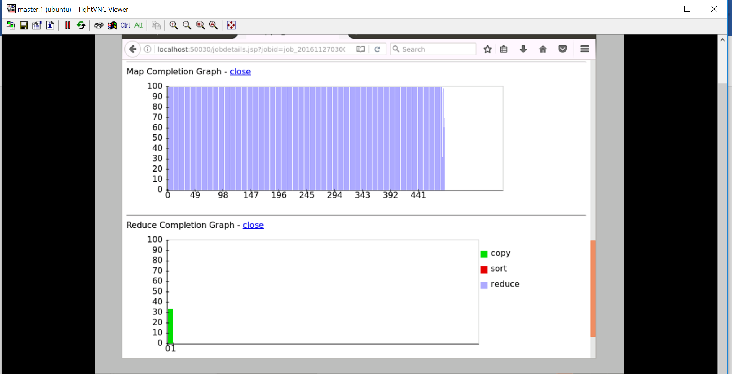

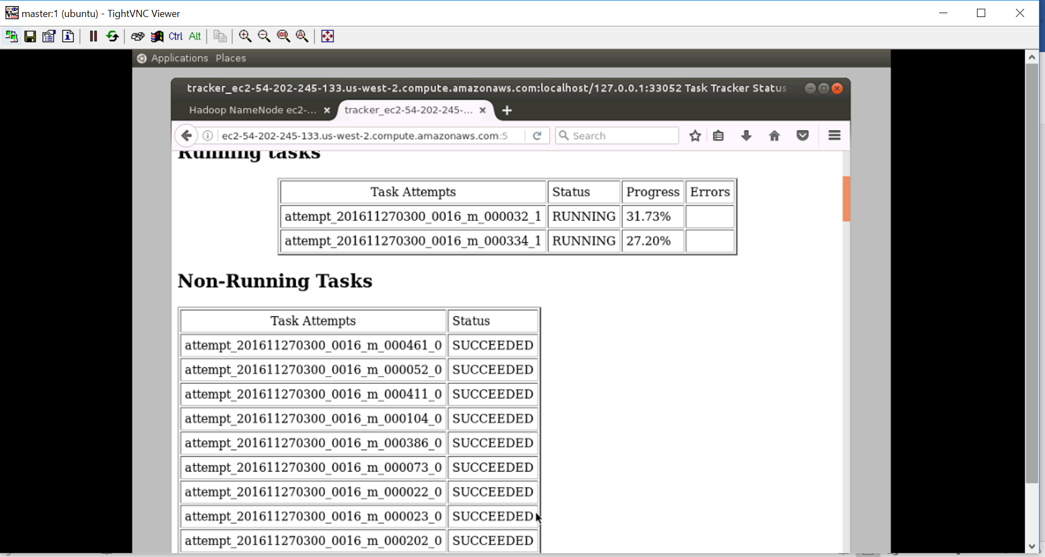

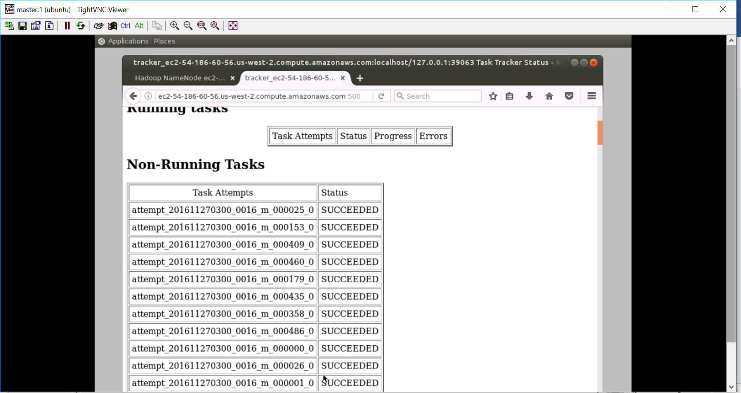

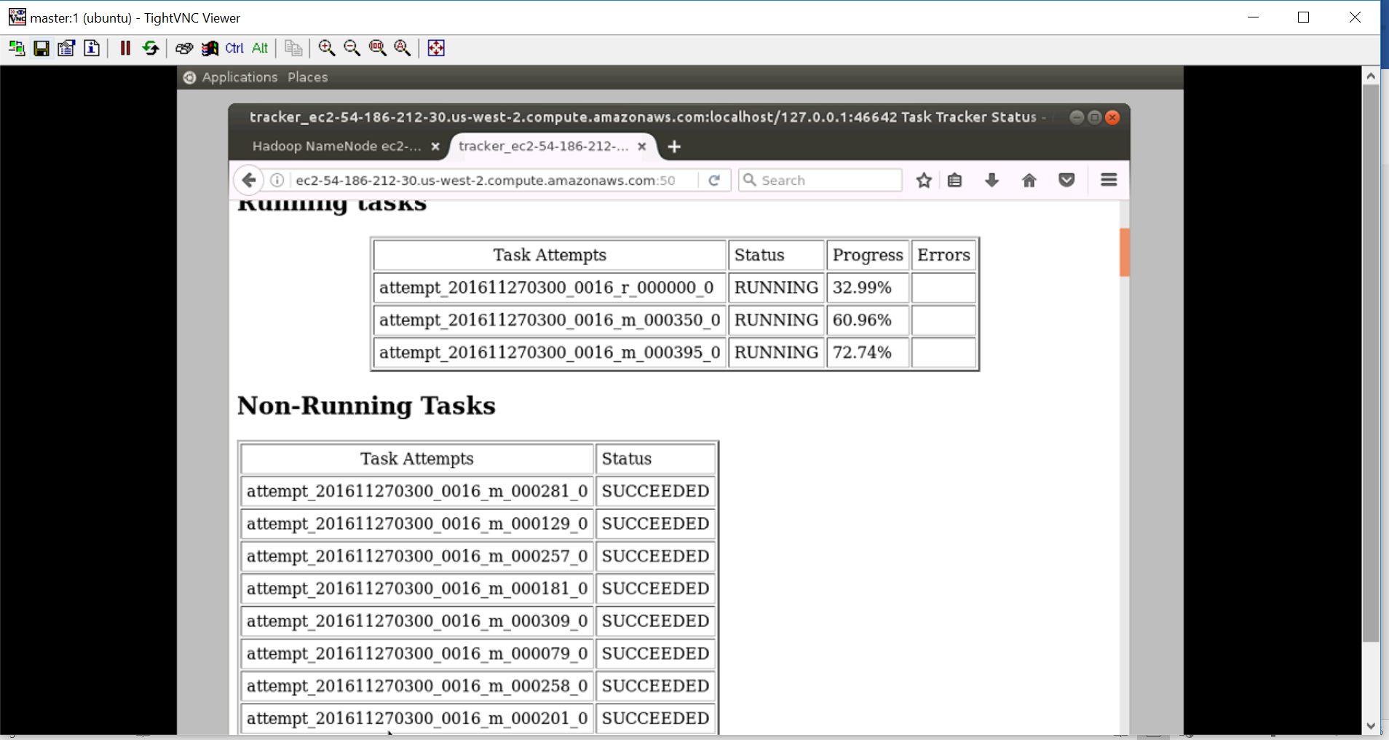

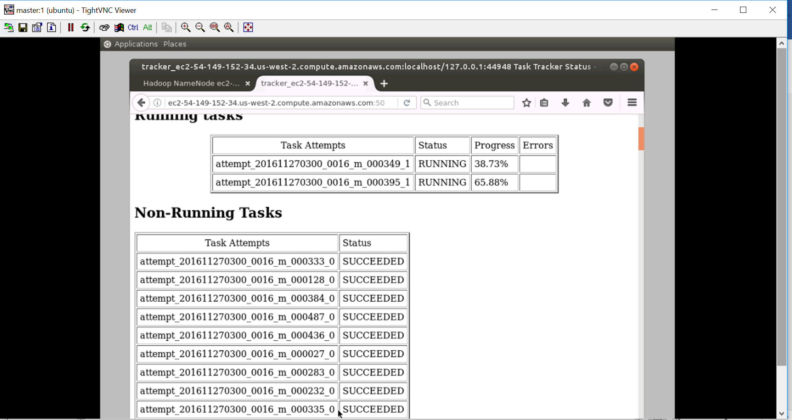

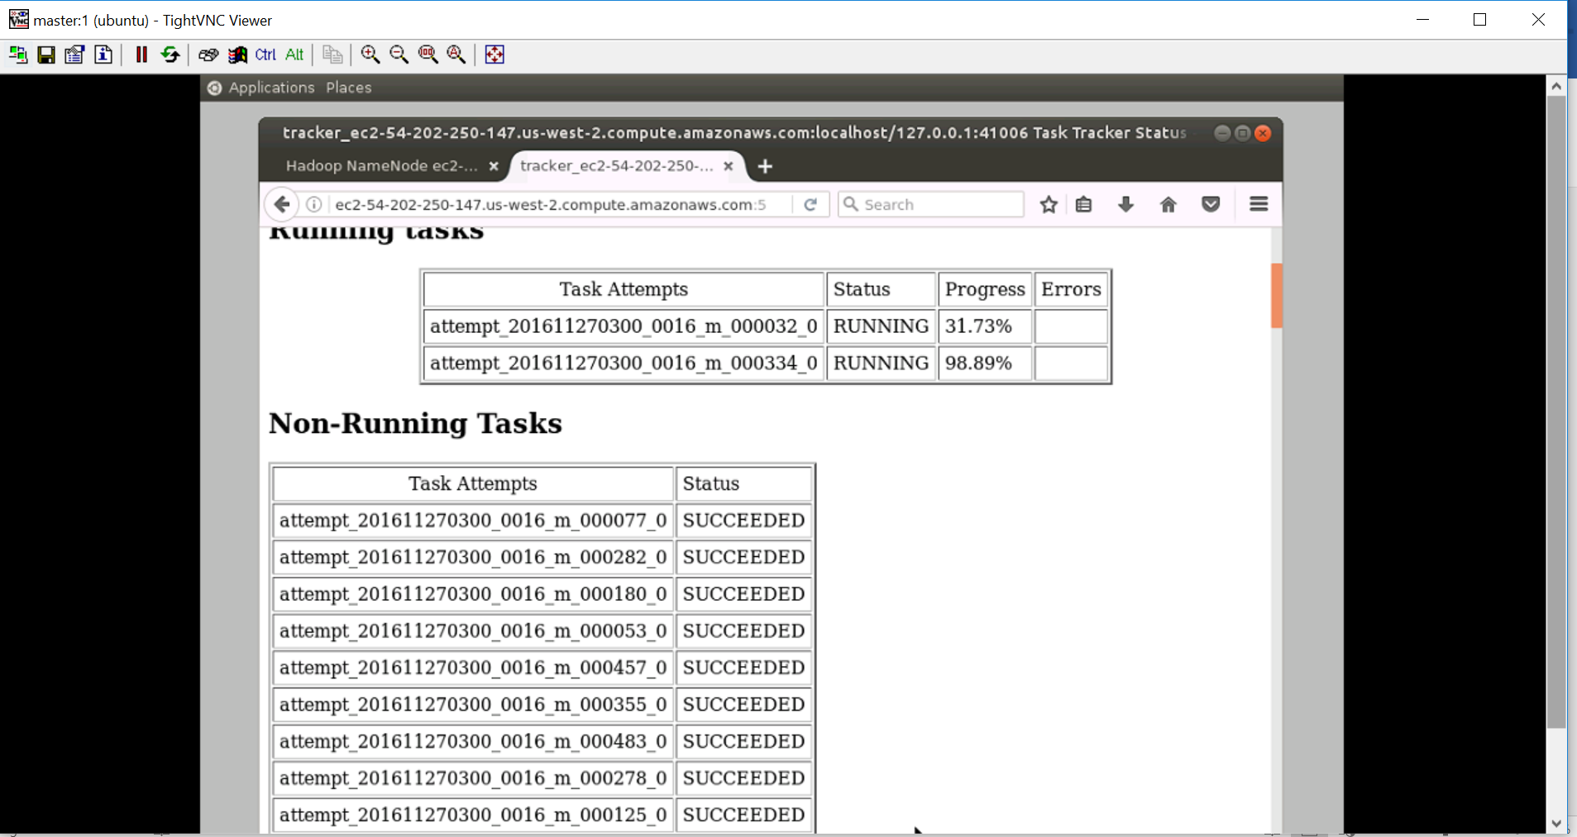

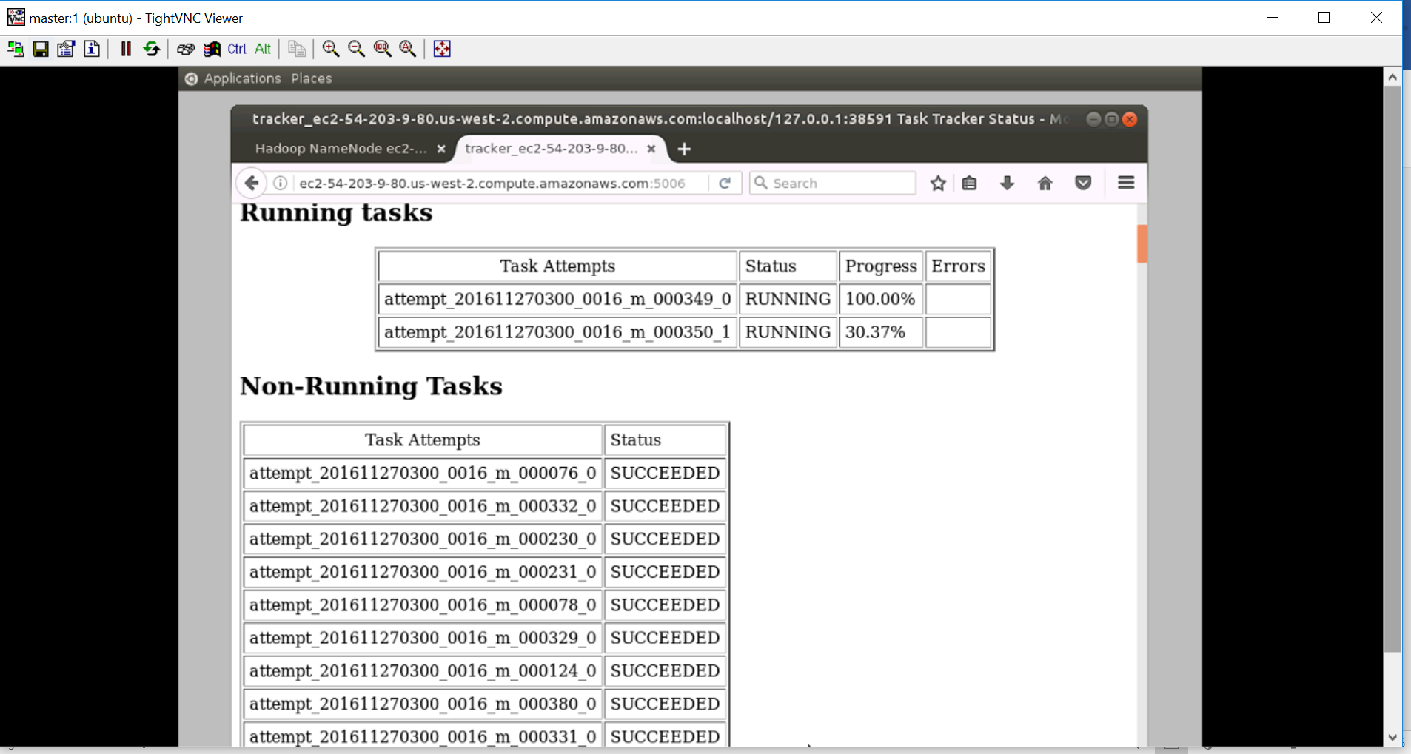

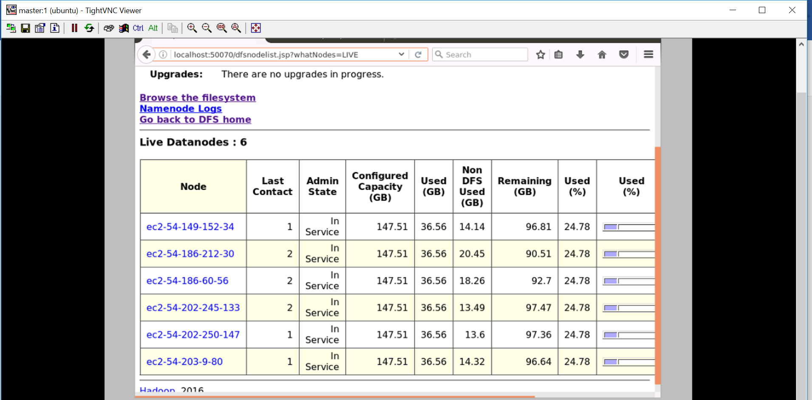

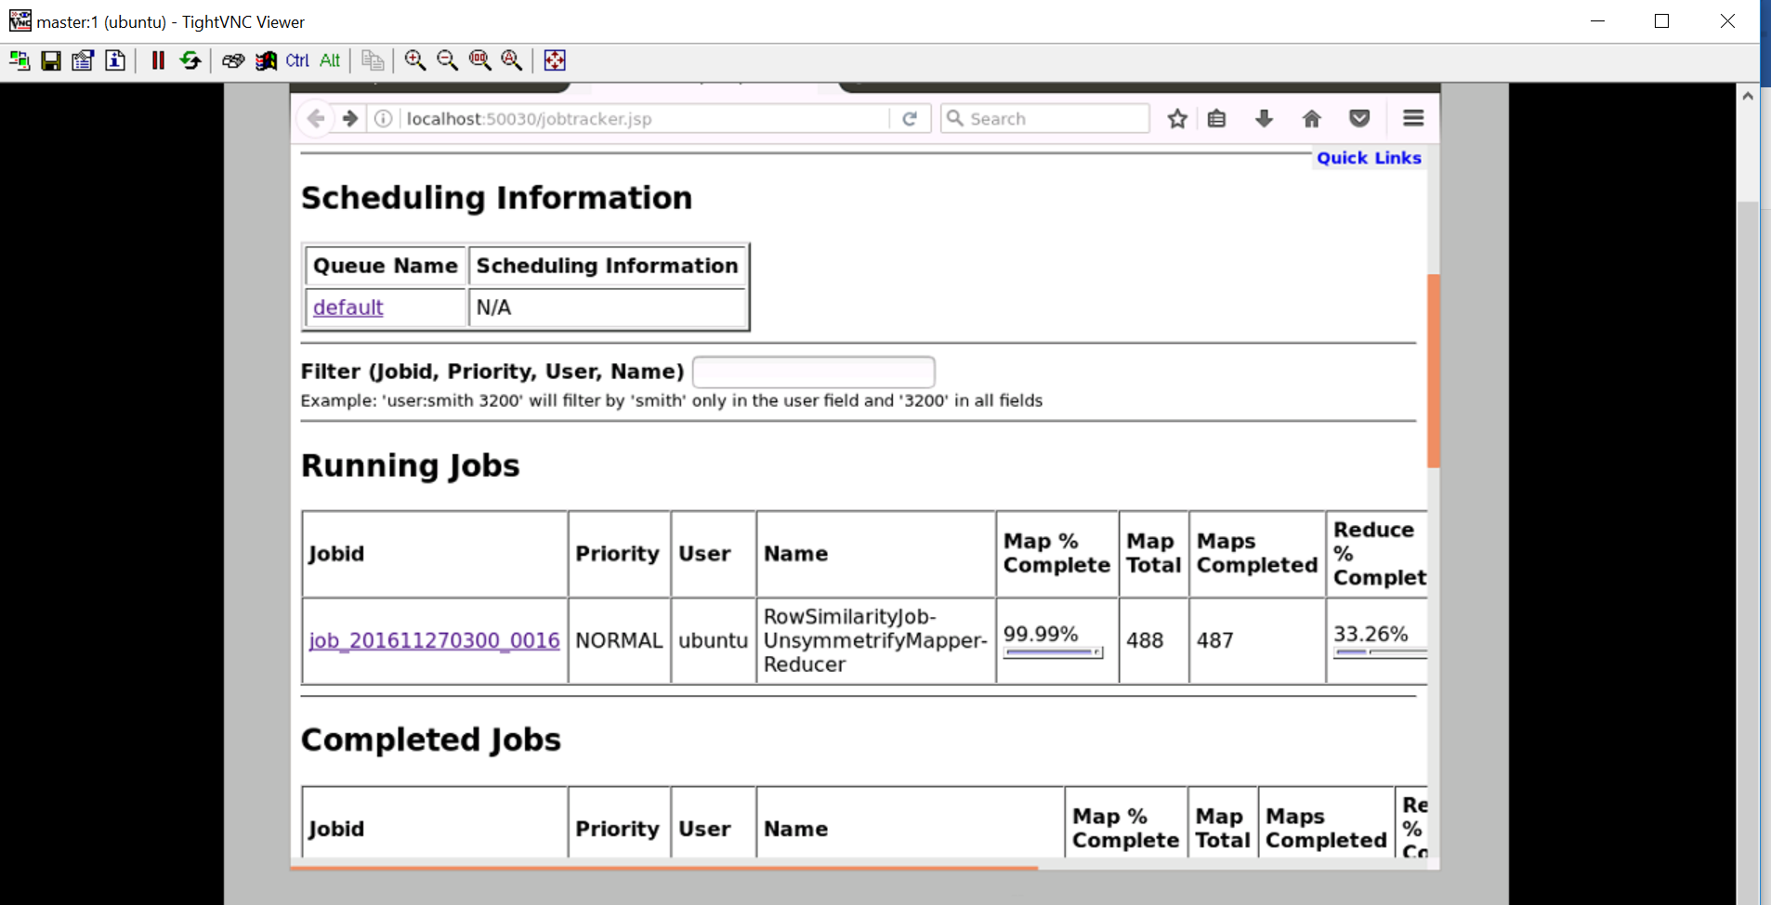

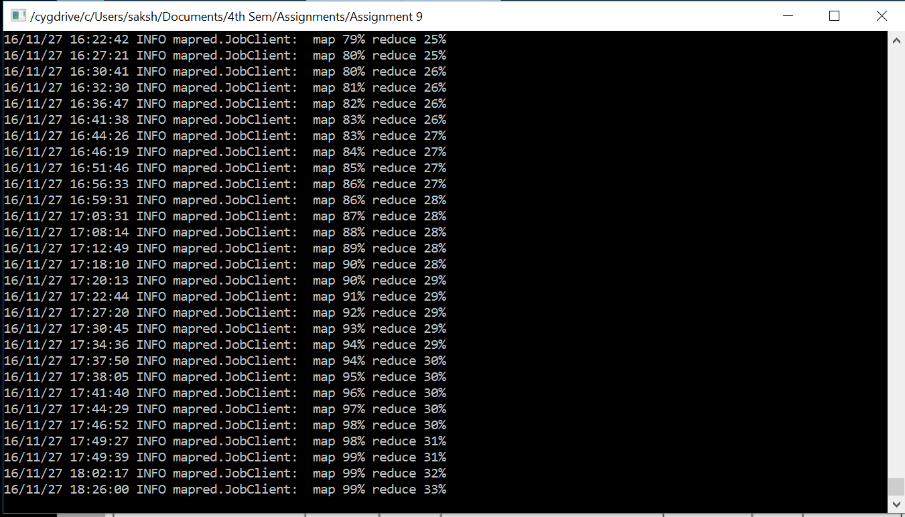

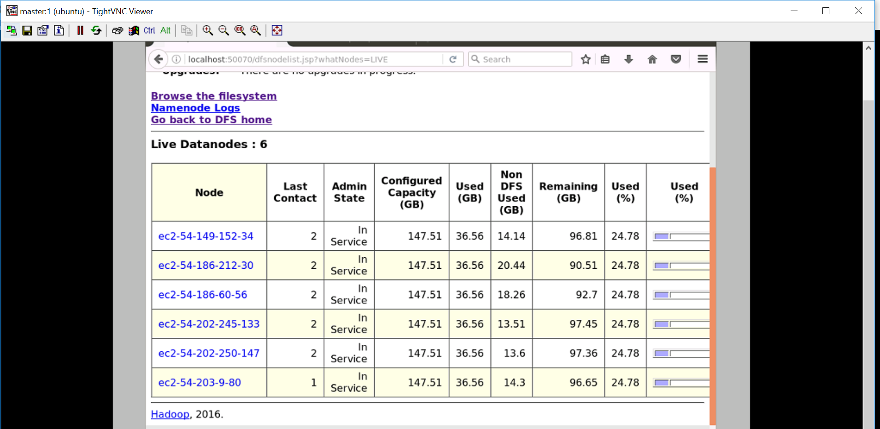

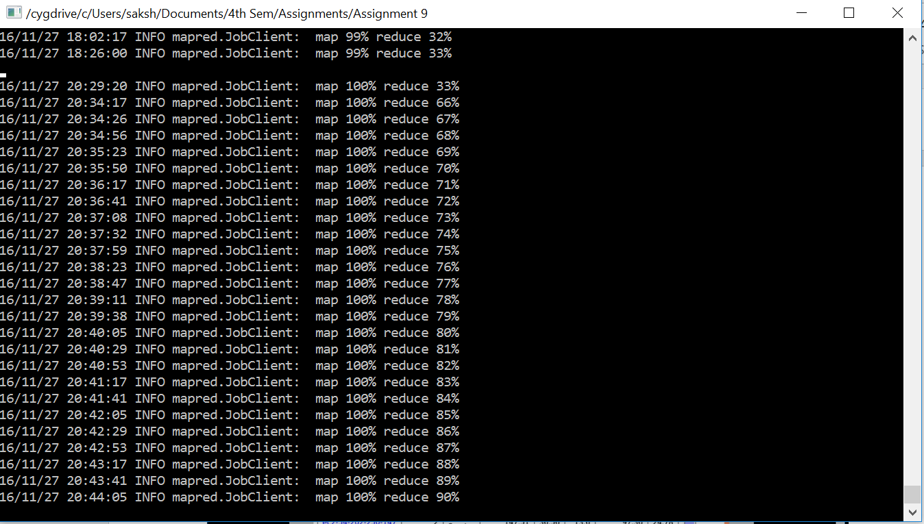

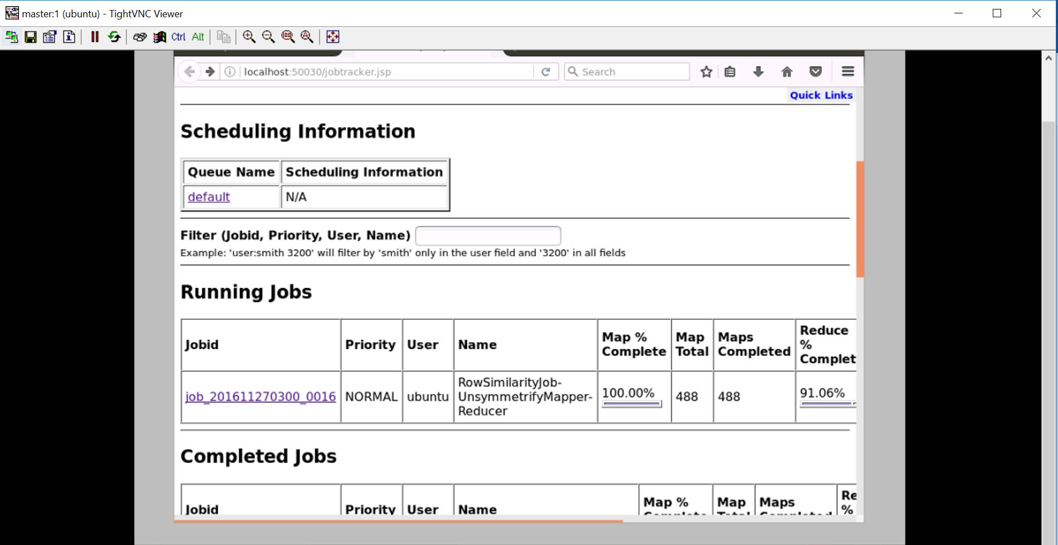

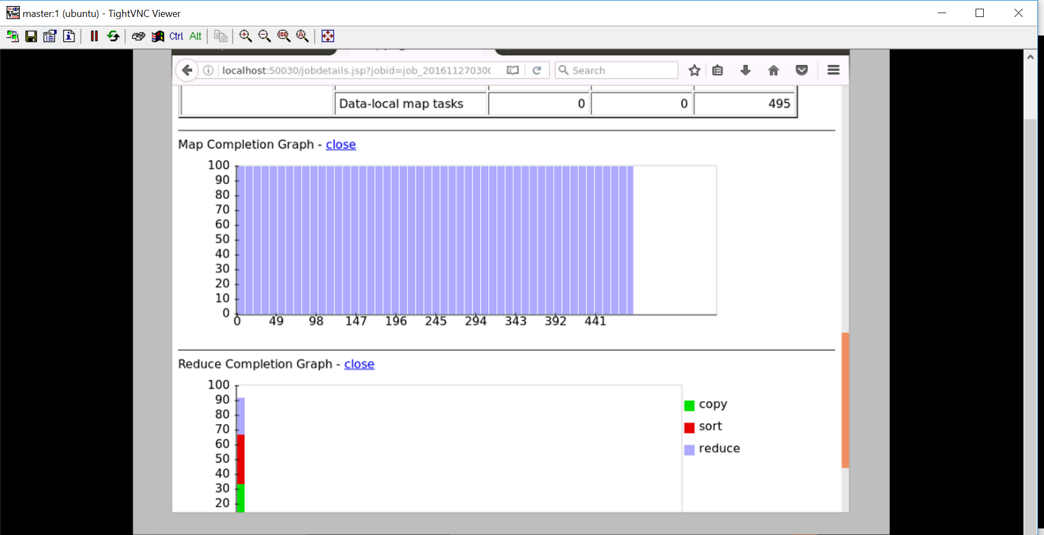

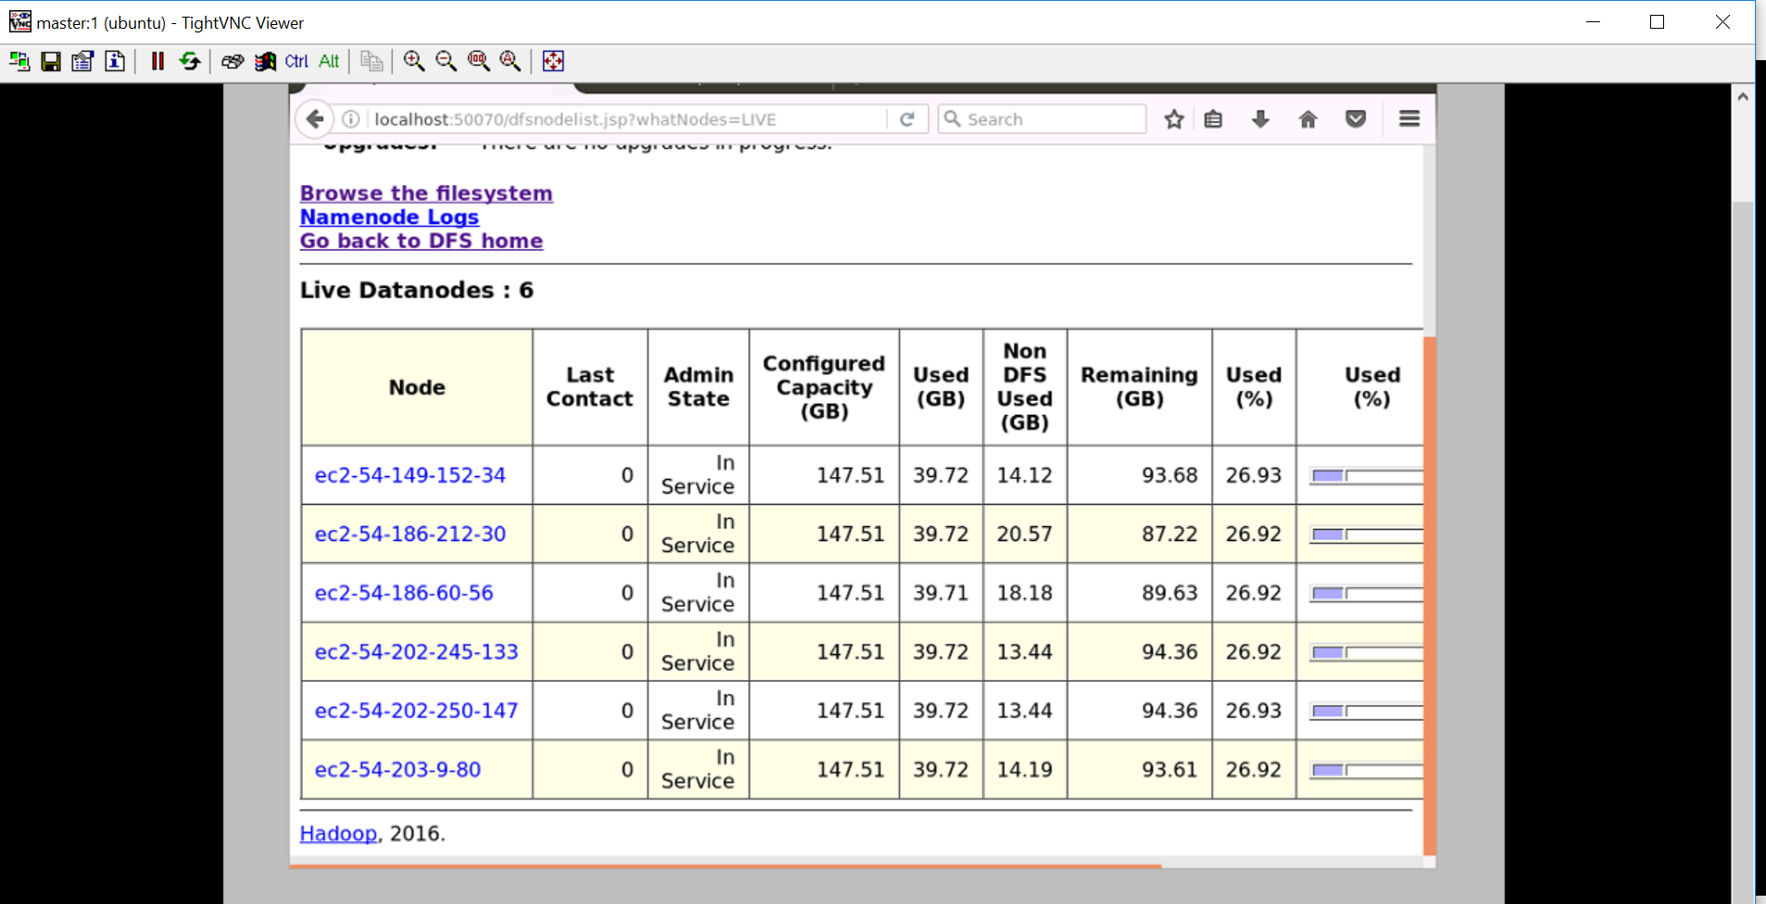

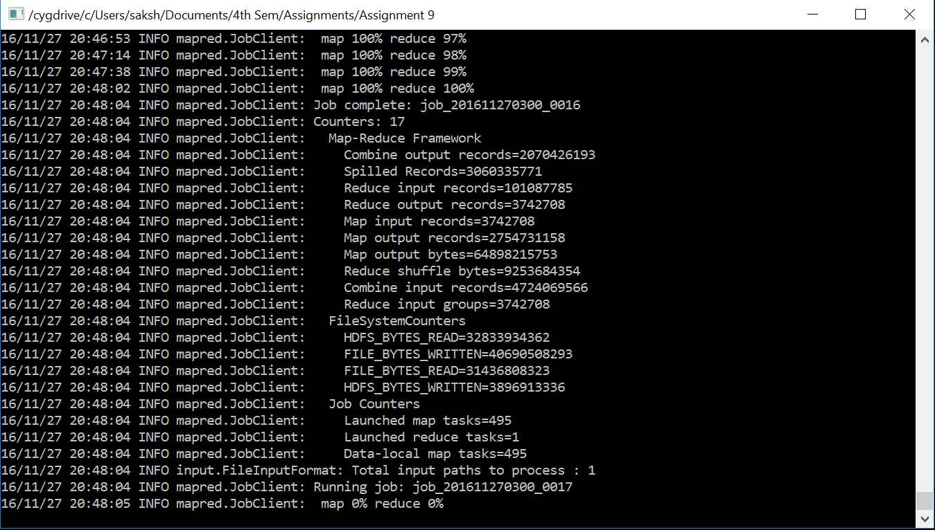

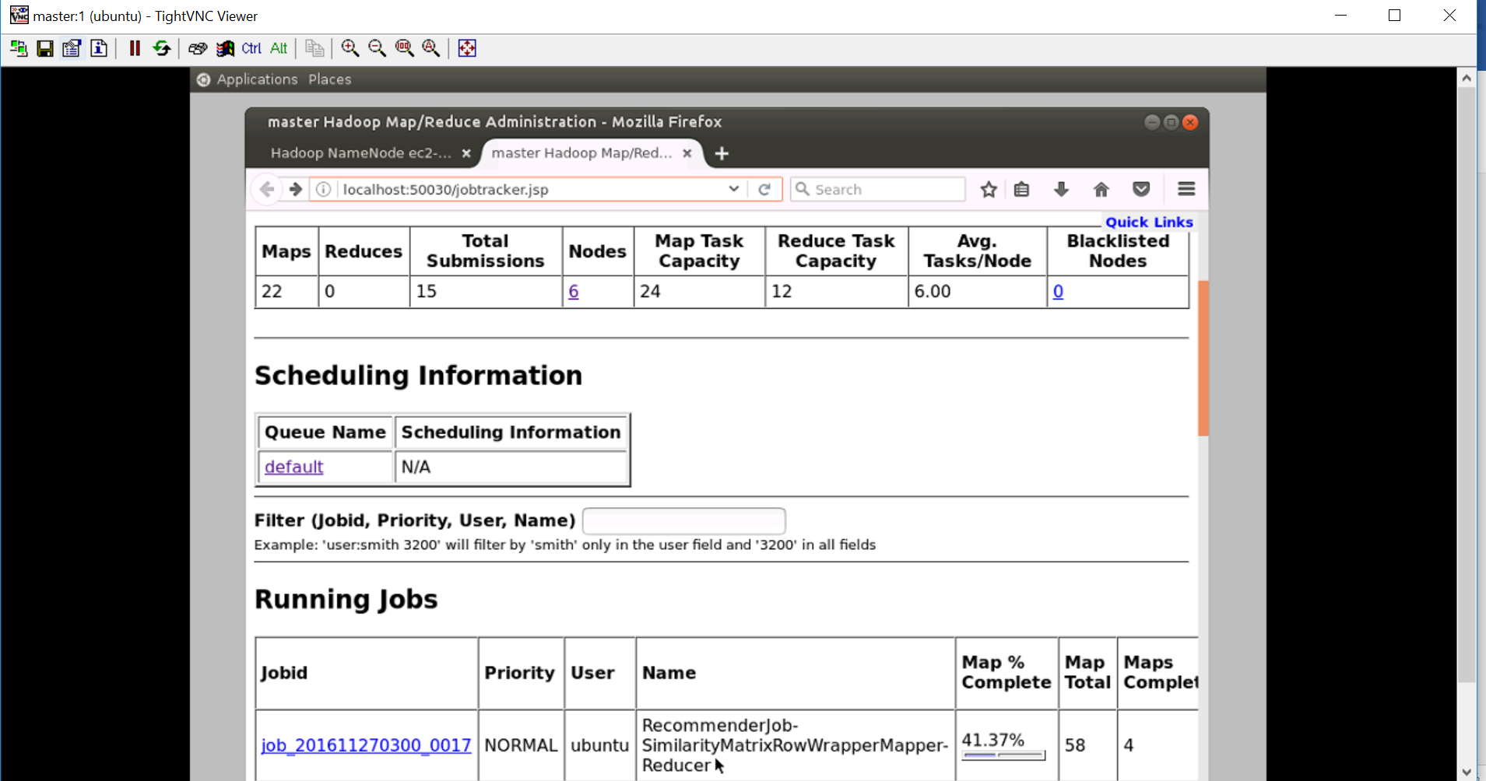

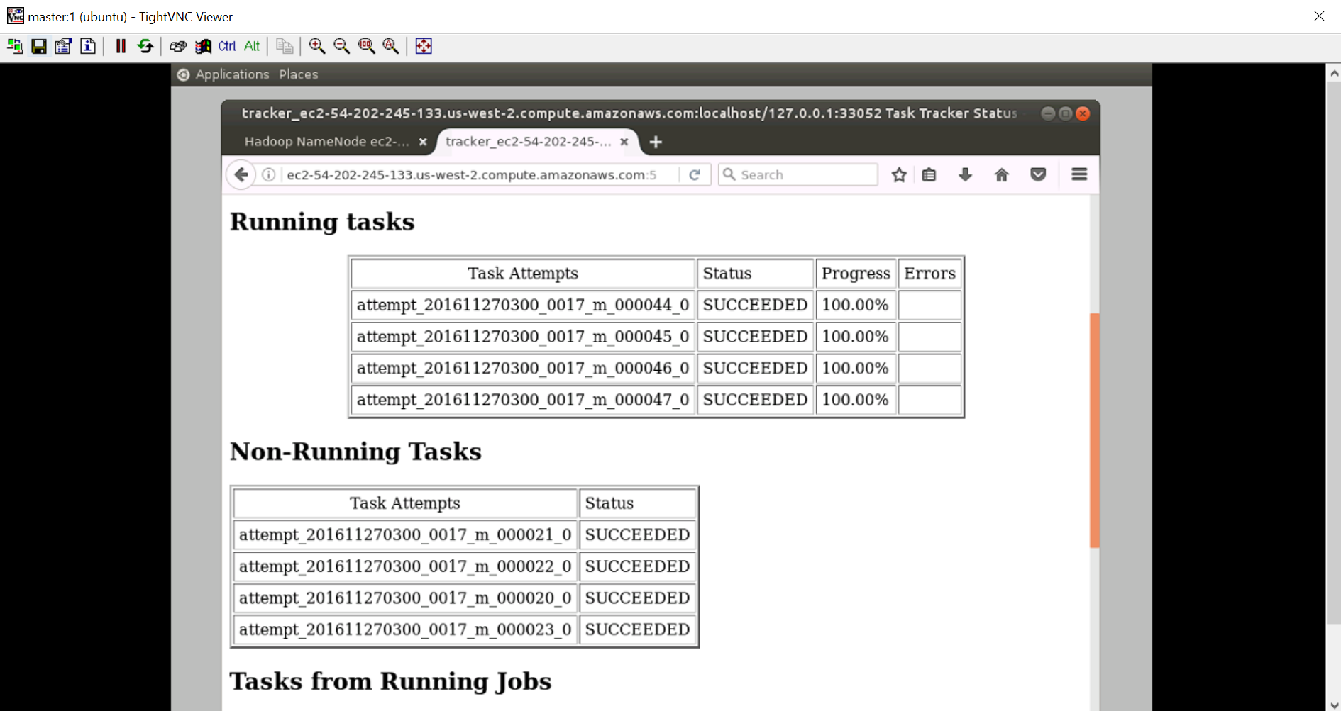

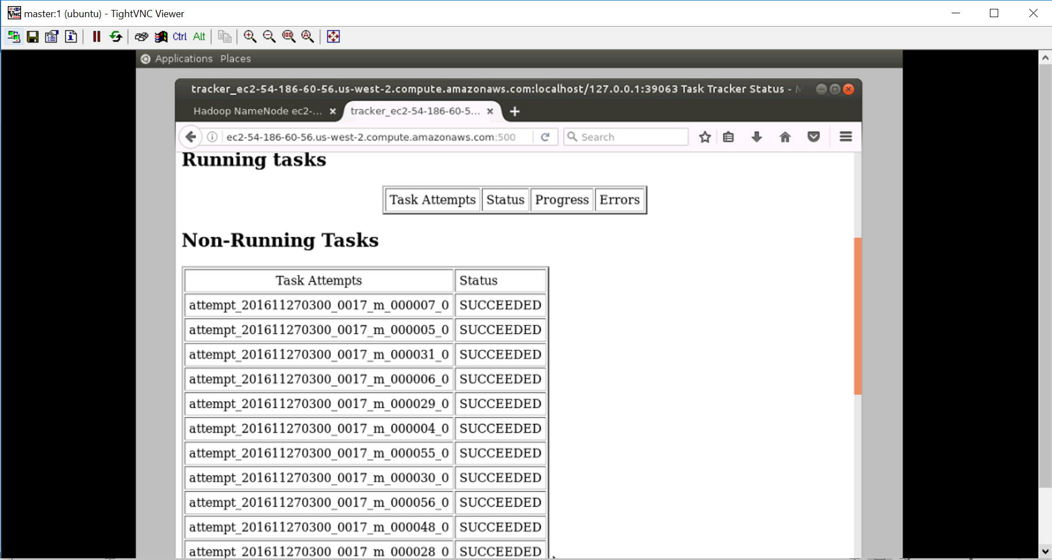

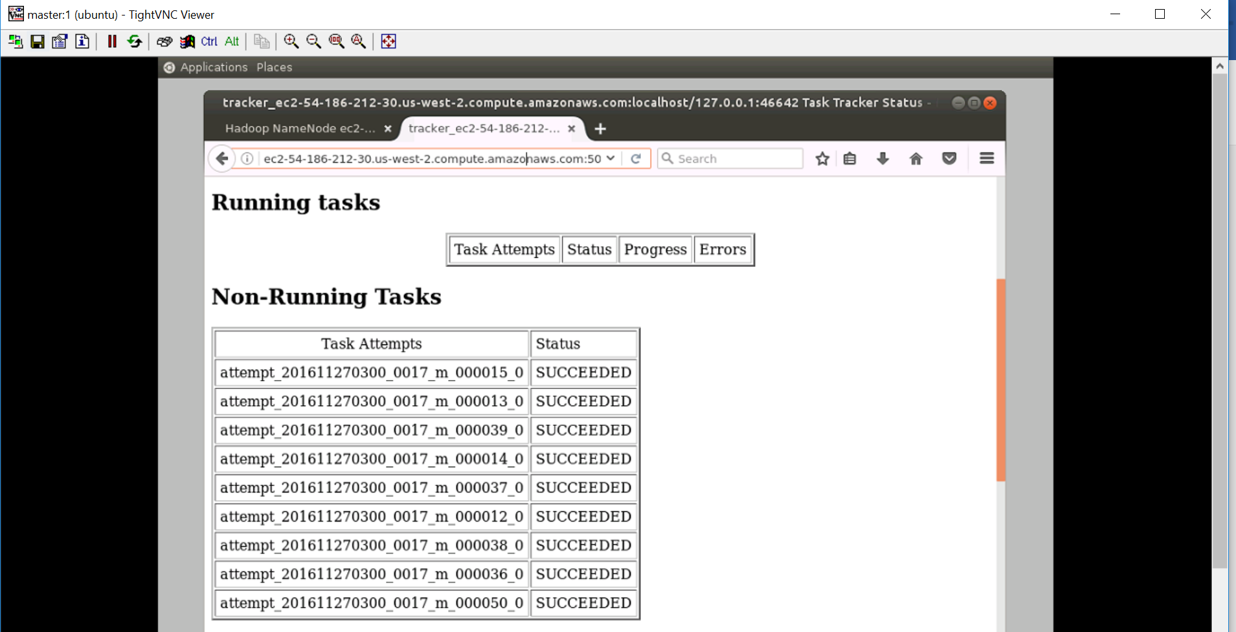

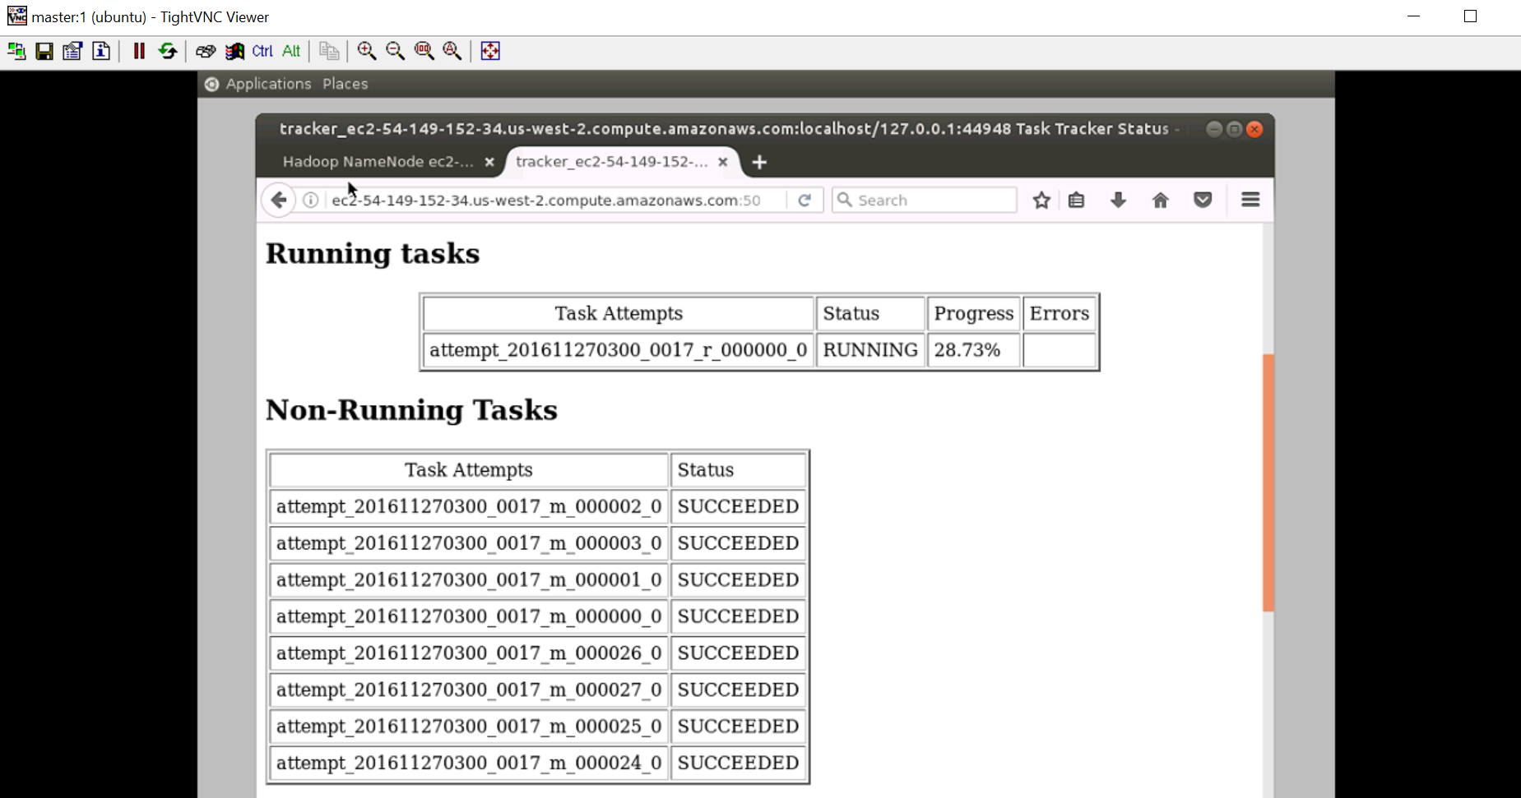

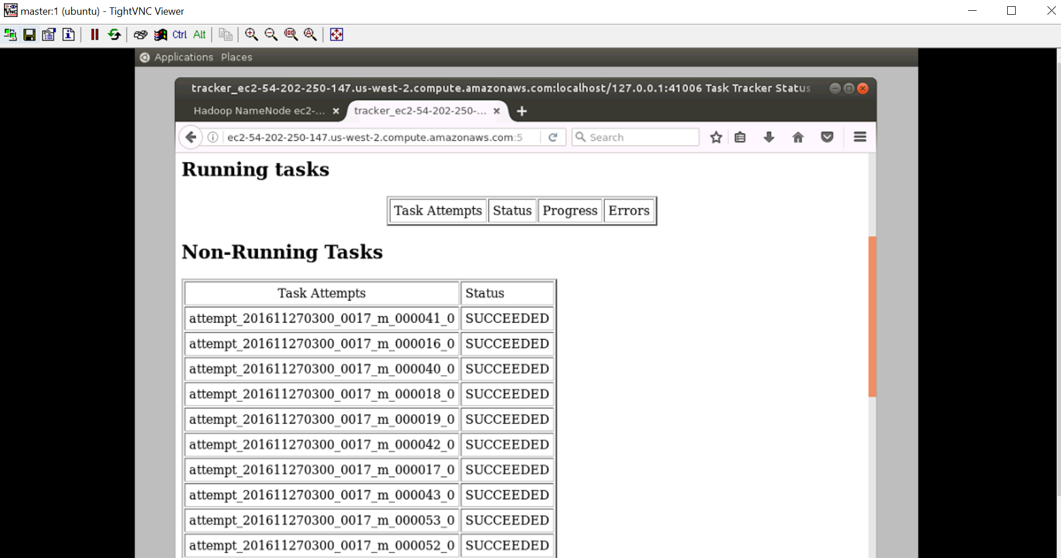

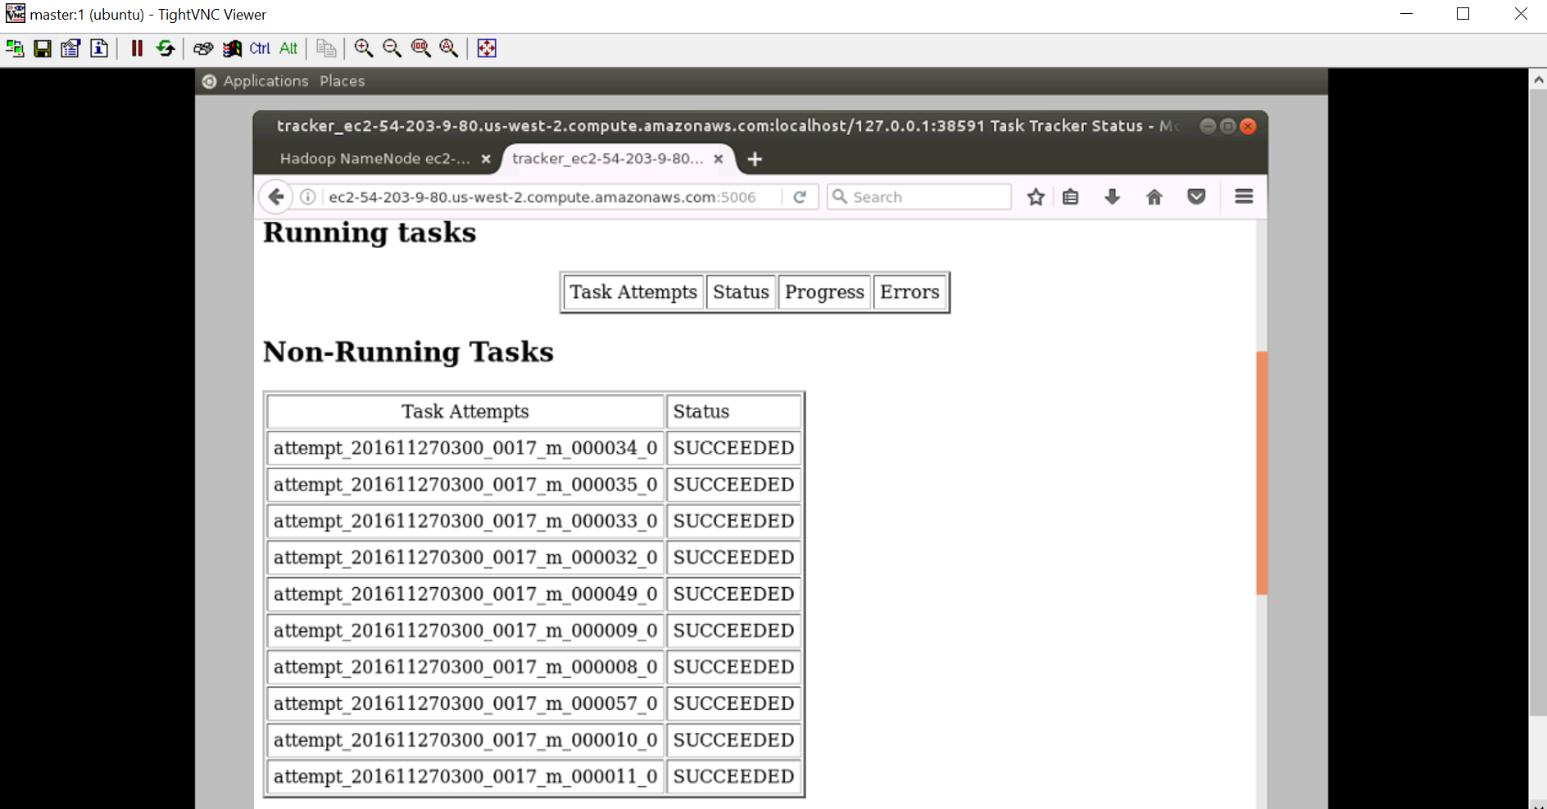

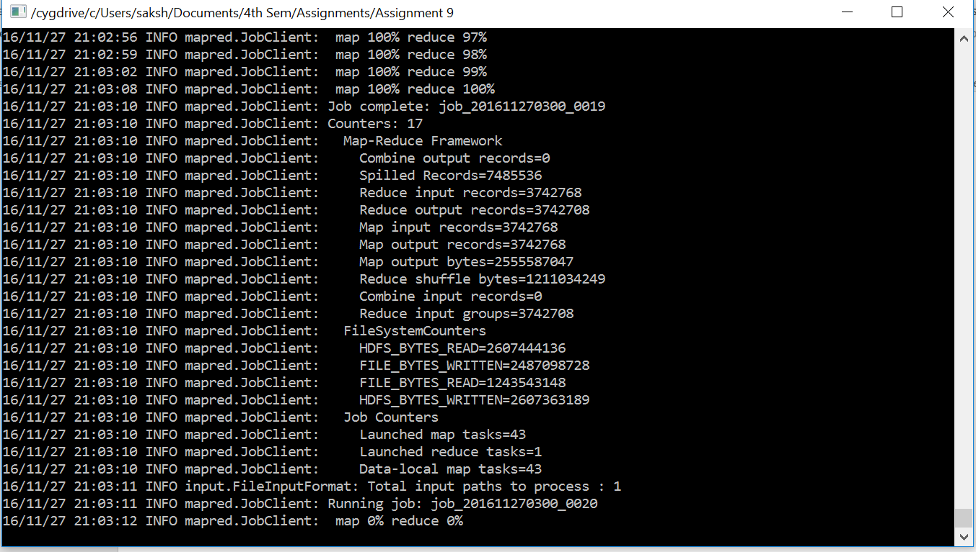

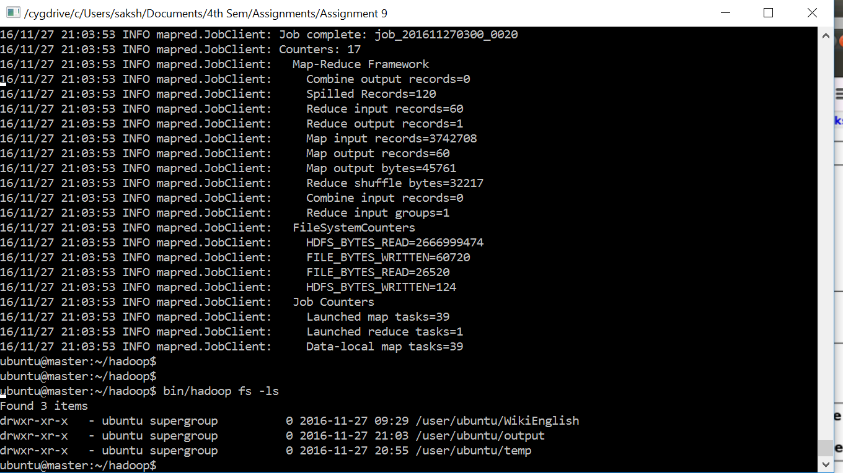

The execution of jobs are completed. Although you will see there are 18 job submissions because earlier when I was running without adding the preference value my job is failing after 5 map reduce, later I included the preference value for all the records and ran the job again my execution was successful after 12 hours. The longest was the 6th job with 488 map and 1 reduce. Below is the screenshot for all the jobs which ran for the recommendation system.

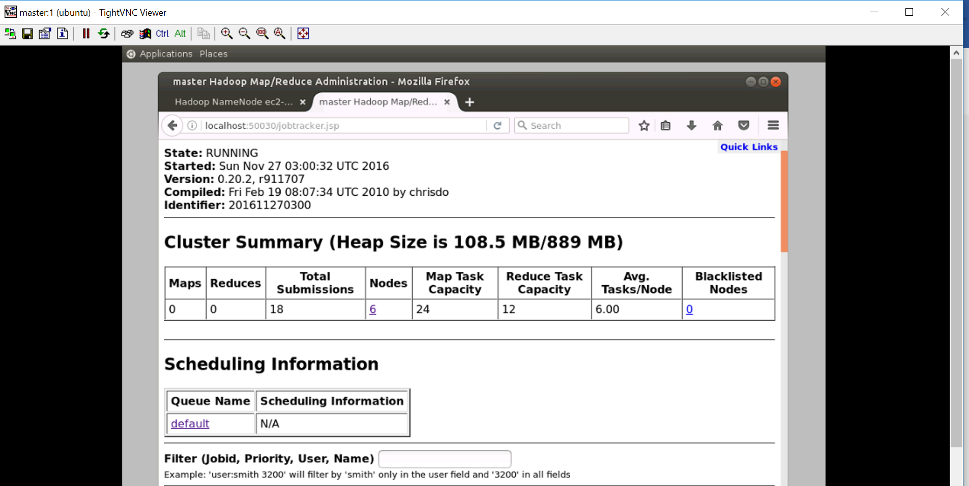

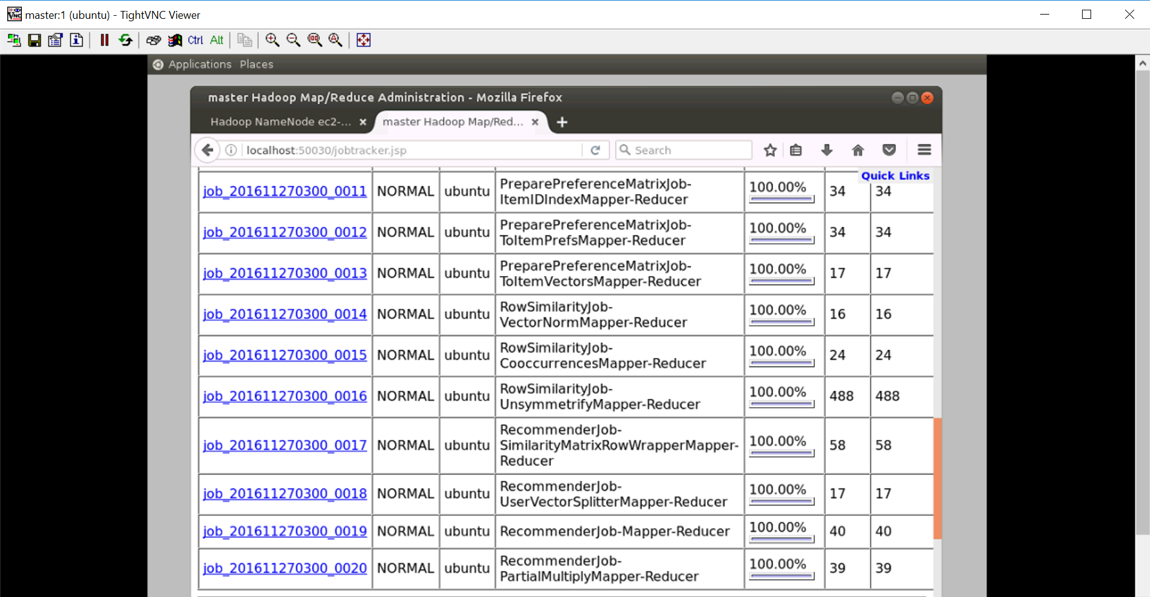

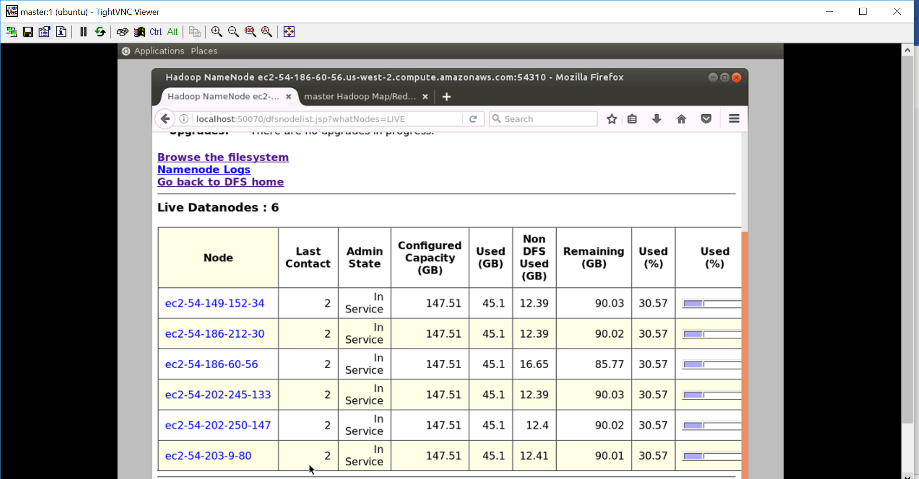

The hdfs filesystem look like below image, where in WikiEnglish directory has input.txt and users.txt file. Temp directory was generated while doing the recommendation system and output directory has the recommendation for all the users which are included in users.txt file

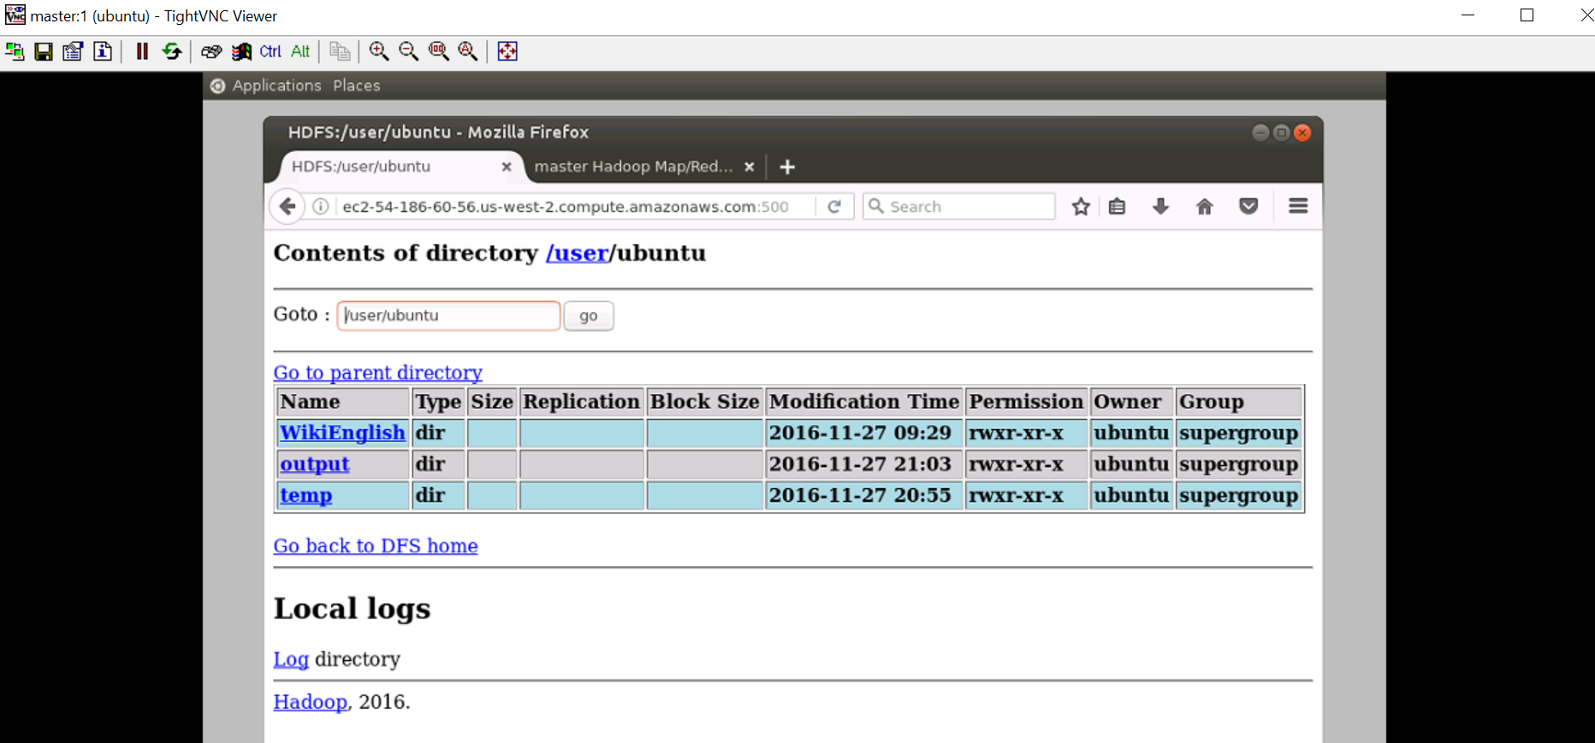

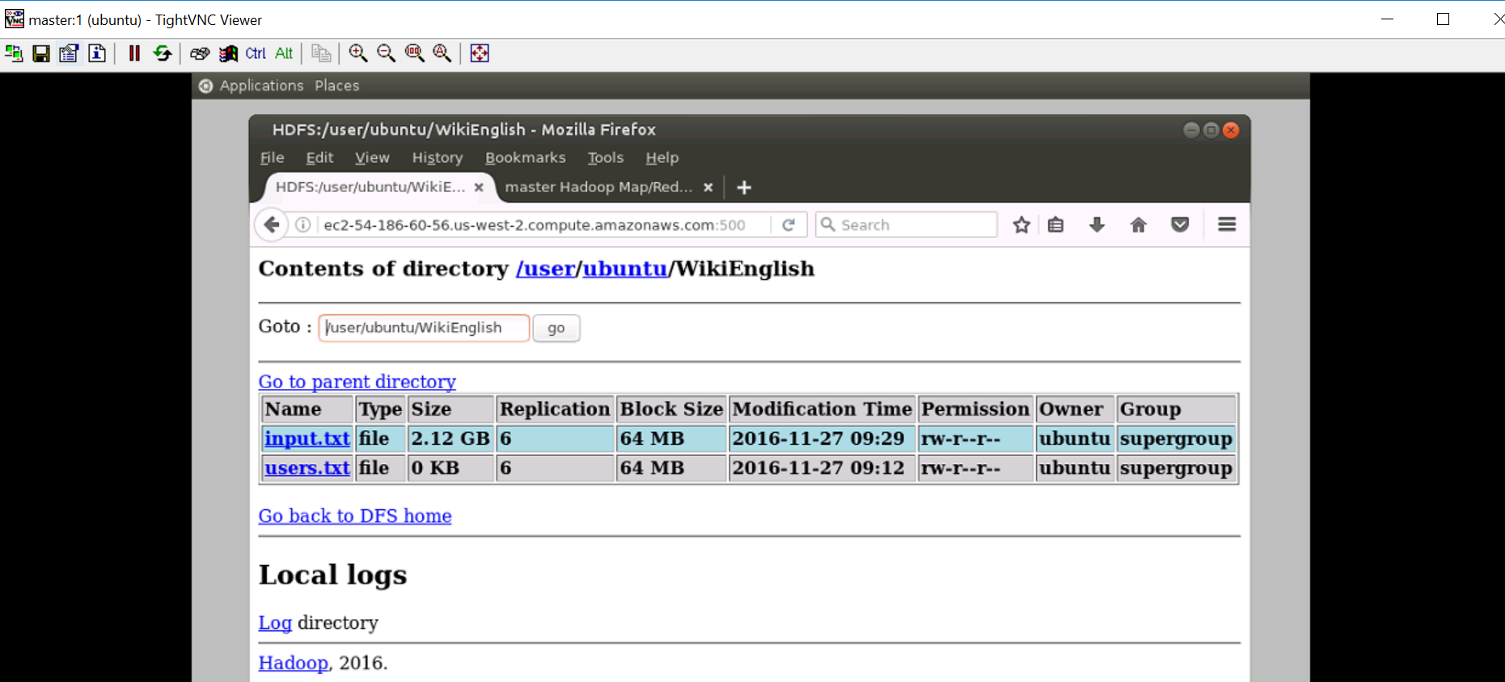

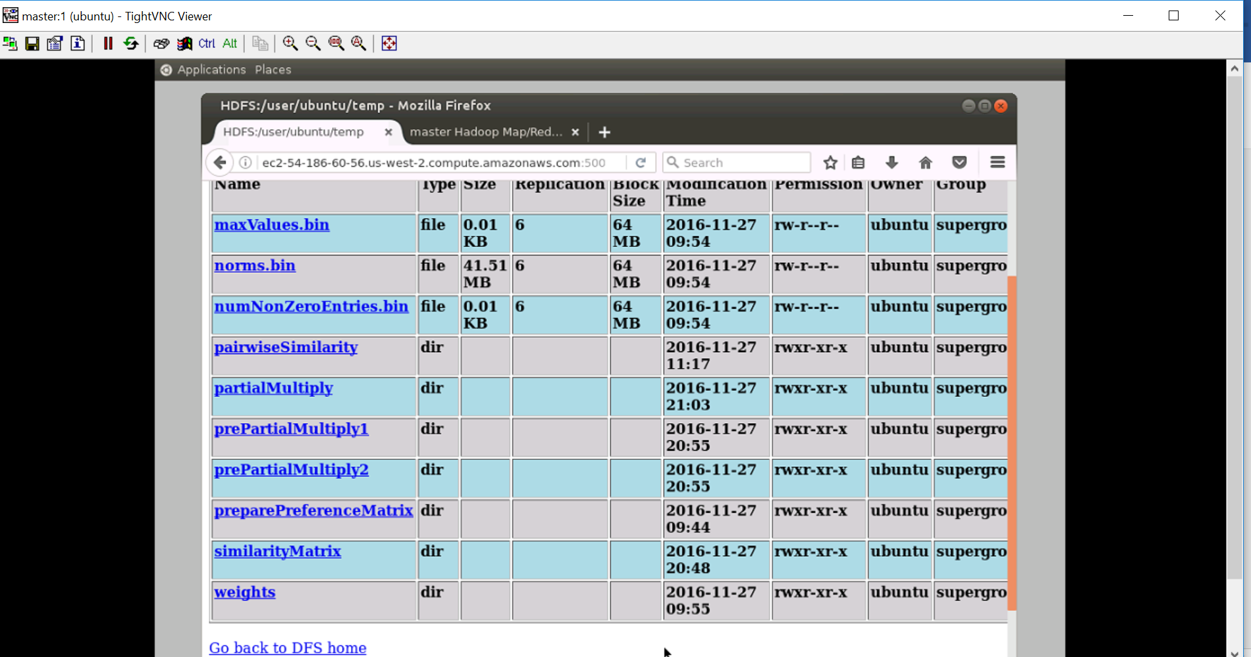

The output, i.e., the recommendation for user 3 is:

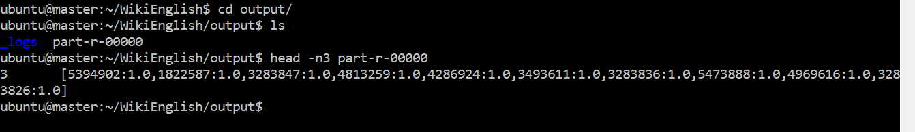

I copied the file to local and below is the files in each directory

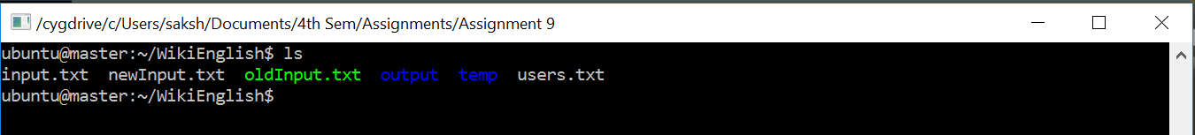



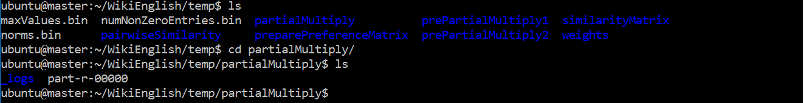

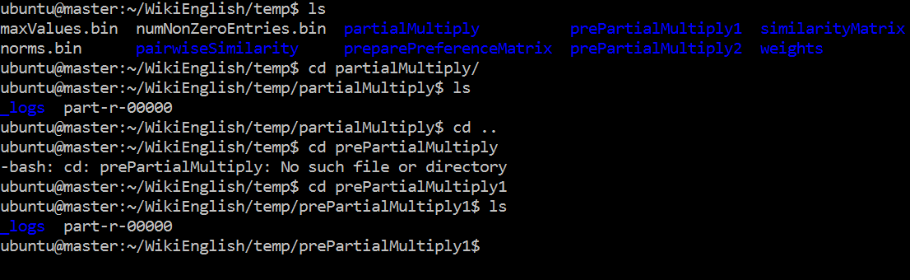

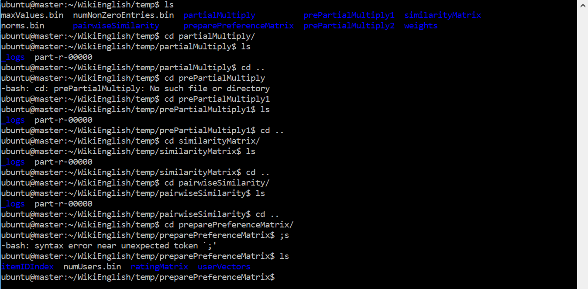

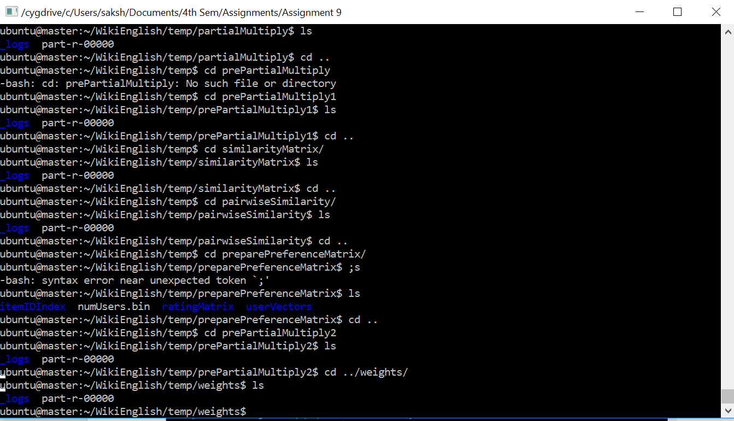



Note:

Although my complete job ran in 12 hours but my machine was running for more than 2 days since I was making mistakes, therefore I could able to copy the complete **temp** directory in my local machine.